市南区2008~2009学年度第一学期二年级英语期末练习一
Class（班级）：_____________Name（姓名）：______________ Assessment（评价）：______________

听力部分
I Listen and number. 根据听到的句子，给图片标序号。（10%）

（ ） （ ） （ ） （ ） （ ）

II Listen and choose. 听录音，在符合录音内容的图片下的字母标号上画圈。 （10%）
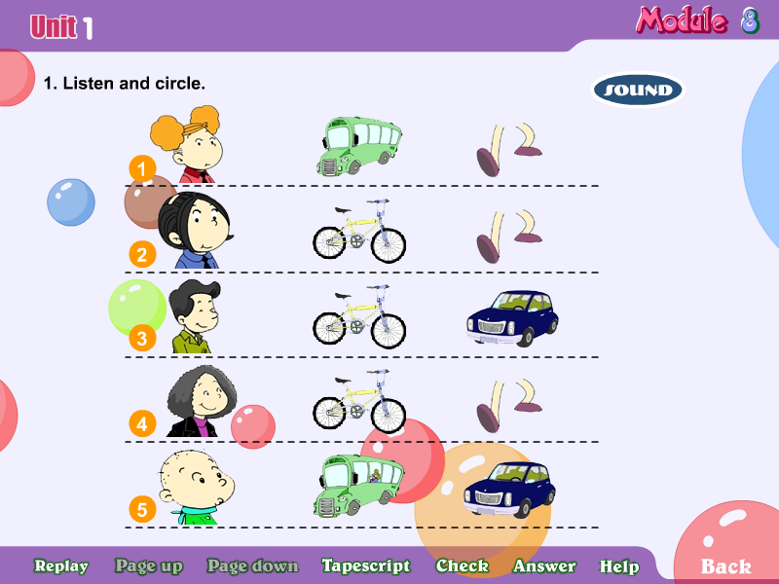
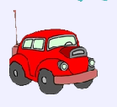
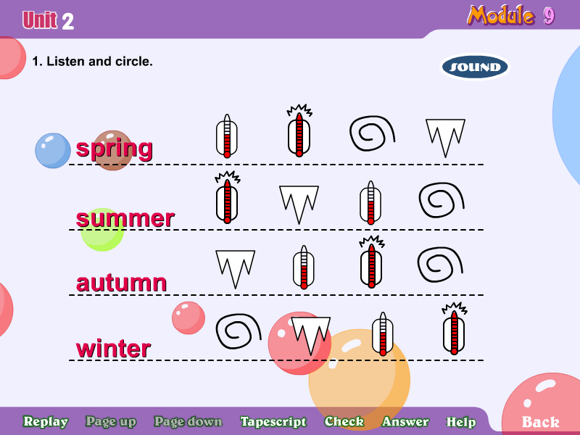
1. 2.

A B A B
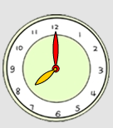
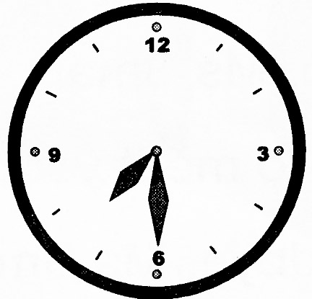
3. 4.


A B A B

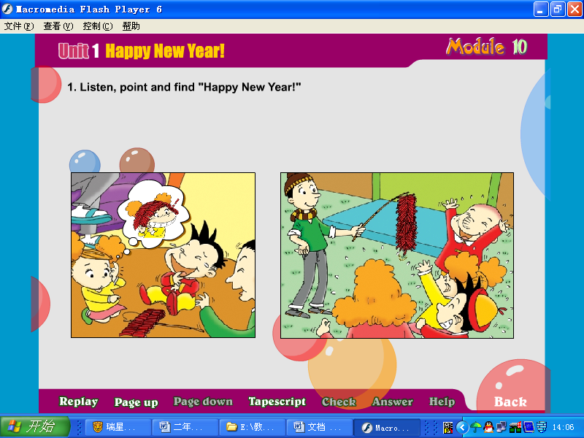
5. 
A B
III Listen and circle. 听录音，圈出句中的单词。（10%）
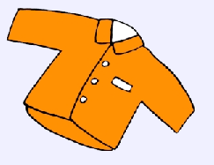
- He doesn’t like this(shirt/T-shirt).

2. We have Christmas (trees/dumplings).

- ---How does your father go to work?
---He goes to work by (bike/ bus).


4. She (go/goes) swimming at the weekend.

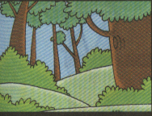
- It’s (spring/summer).
We wear jackets.

IV Listen and tick. 听录音，选出符合图片内容的句子。（10%）
- （ ）A. We have firecrackers.
（ ）B. We have a big dinner.

2． （ ）A. He goes to work by bus.
（ ）B. He walks to school.
3． （ ）A. How do you go to school?
（ ）B. How does your father go to work?.
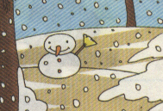
4． （ ）A. I like autumn. It’s cool.
（ ）B. I like winter. It’s cold.
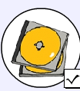
5． （ ）A. Does he play the flute?
（ ）B. Does he listen to CDS?
V Listen and match. 听短文，连线。（10%）
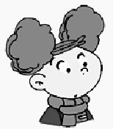
My name is Amy. I like Christmas. I have Chirstmas presents. Christmas is in winter. My friend Lingling likes winter. It’s cold. Look, this is my mother, Ms Smart. She likes summer. She eats icecream in summer. My friend Daming likes Chinese New Year. He has firecrackers at New Year. My Dad plays yoyo at Chinese New Year.
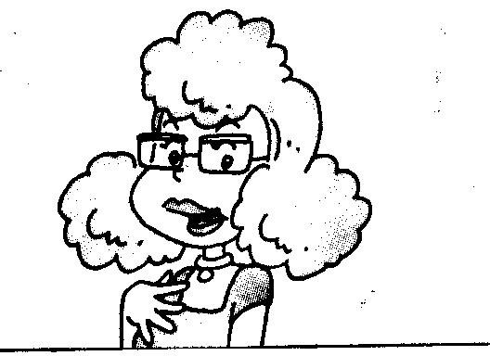
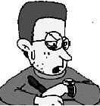



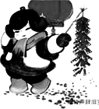
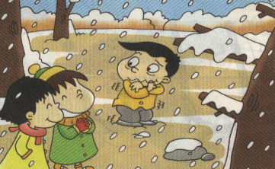
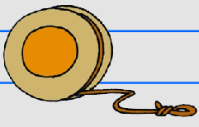

VI Listen and write. 听一听，在四线格内填上缺少的字母。（10%）
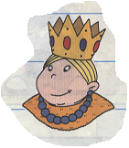
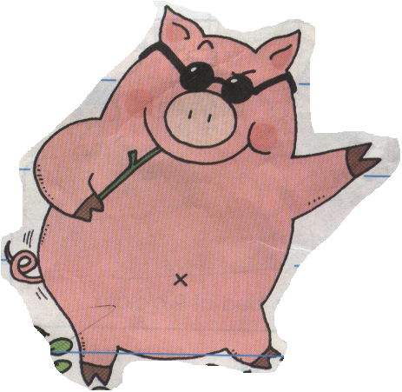

1. 2. 3.

ig ueen eddy
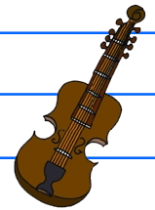
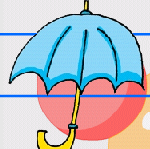
4. 5.

mbrella iolin

笔试部分
VII Read and match. 读一读，将句子与相应的图片连线。（10%）
1. I play football at the weekend.


2. Qingdao is a big city.

3.We go to China on holiday. We go by train .
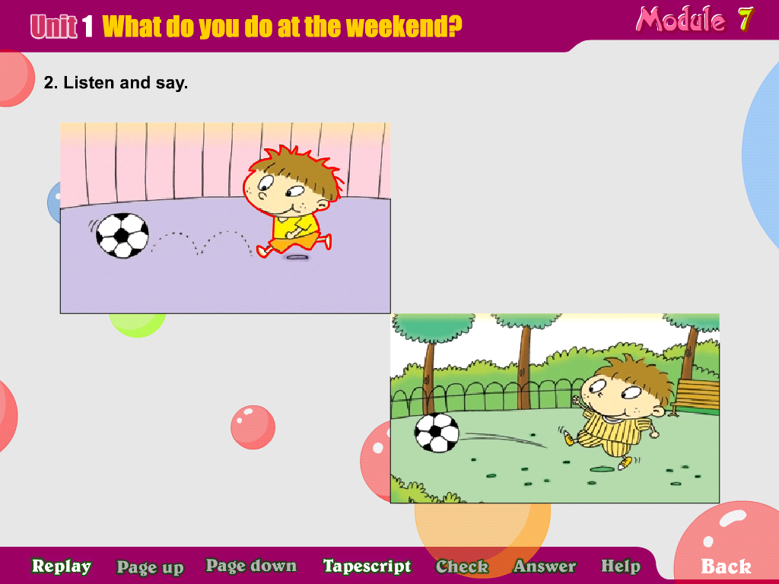

- S is for sweets.
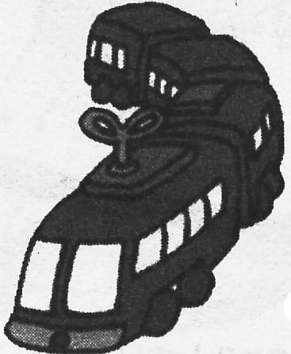

5. Do we have Music at school?

VIII Look and match. 看一看，将图片与首字母连线。（10%）
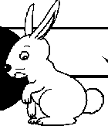
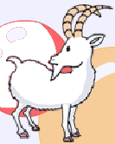
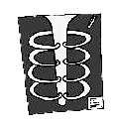
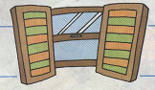


Rr Ww Jj Xx Gg
市南区2008~2009学年度第一学期二年级英语期末 练习一
听力内容
I Listen and number.根据所听到的句子，给图片标序号。
1、I eat dumplings at Chinese New Year.
2、I go to Shanghai by plane.
3、She reads books at the weekend.
4、We go to China on holiday. We go by ship.
5、We wear sunglasses in summer.

II Listen and choose. 听录音，在符合录音内容的图片下的字母标号上画圈。
- I go to school by car.
- I like autumn. It’s cool.
- Sam plays the drums at the weekend.
- What’s the time? It’s half past 7.
- We have firecrackers at Chinese New Year.

III Listen and circle. 听录音，圈出句中的单词。
- He doesn’t like this shirt.
2. We have Chirstmas trees.
3. ---How does your father go to work?
---He goes to work by bike.
4. She goes swimming at the weekend.
5. It’s spring. We wear jackets.

IV Listen and tick. 听录音，选出符合图片内容的句子。
1．We have a big dinner.
2. He goes to work by bus.
3. How do you go to school?
4. I like winter. It’s cold.
5. Does he listen to CDS?

V Listen and match. 听小短文，连线。
My name is Amy. I like Christmas. I have Chirstmas presents. Christmas is in winter. My friend Lingling likes winter. It’s cold. Look, this is my mother, Ms Smart. She likes summer. She eats icecream in summer. My friend Daming likes Chinese New year. He has firecrackers at New Year. My Dad plays yoyo at Chinese New Year.

VI Listen and write. 听一听，在四线格内补上缺少的字母。（10分）
- P is for pig.
- Q is for queen.
3. T is for teddy.
4. U is for umbrella.
5. V is for violin.

