市南区2008~2009学年度第一学期二年级英语期末练习三

Class（班级）：_____________Name（姓名）：______________ Assessment（评价）：______________

听力部分
I Listen and number. 根据听到的句子，给图片标序号。（10%）
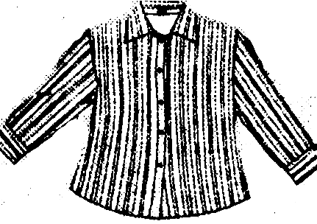

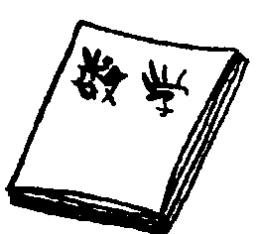


（ ） （ ） （ ） （ ） （ ）

II Listen and choose. 听录音，在符合录音内容的图片下的字母标号上画圈。 （10%）
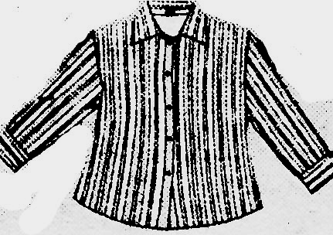
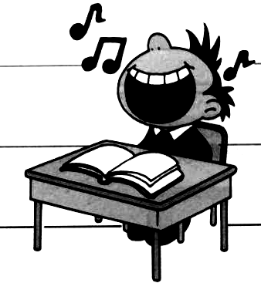
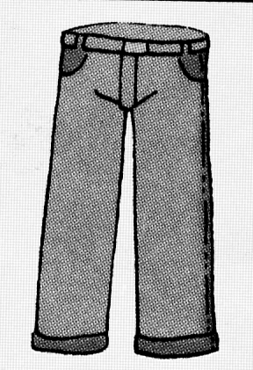
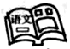
1. 2.

A B A B
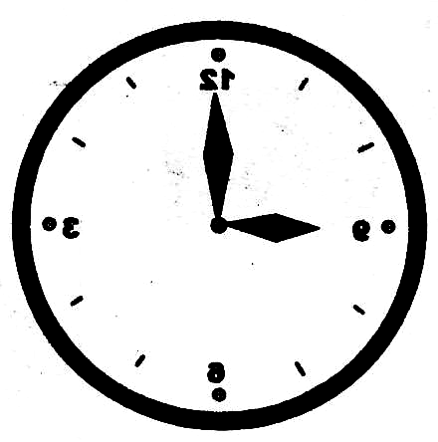
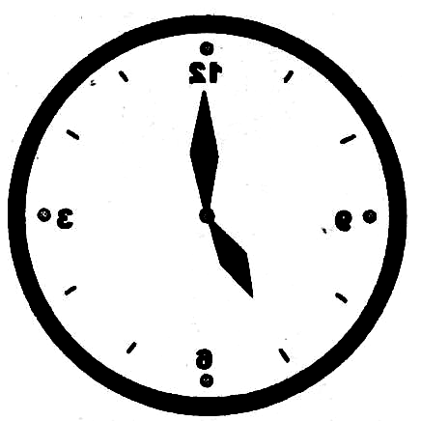
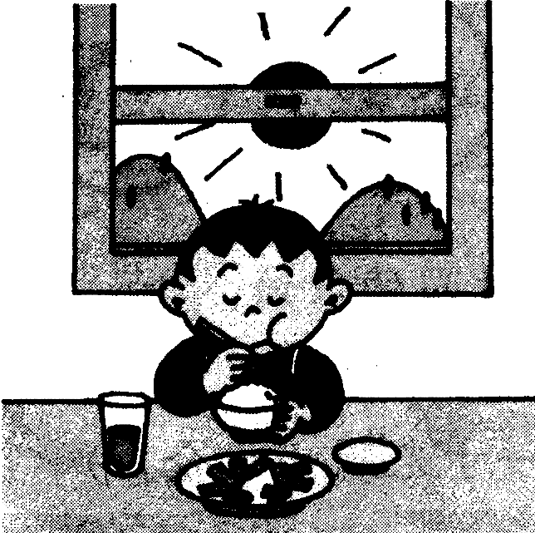
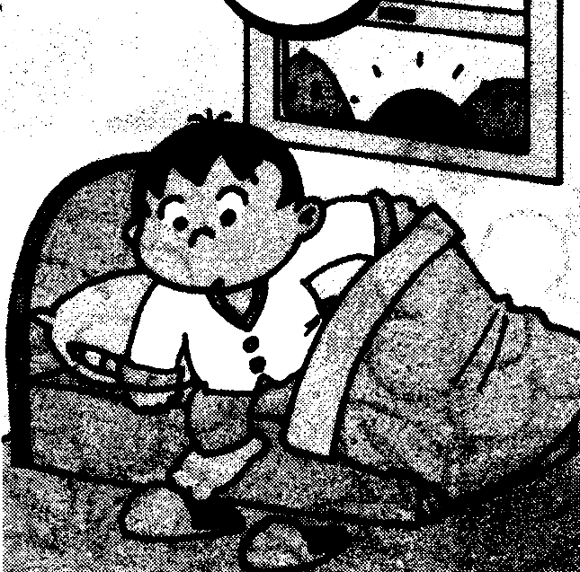
3. 4.

A B A B
5.

A B
III Listen and circle. 听录音，圈出句中的单词。（10%）

- We have English in the (morning/afternoon).

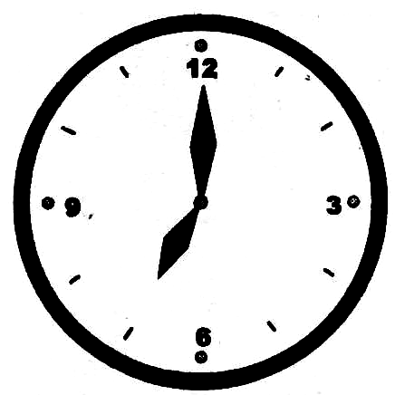
2. ---Is it 8 o’clock?
--- Yes, it is./ No, it isn’t.

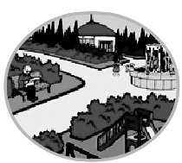
- ---Where do you play football?
---I play at the (park/school).


- ---How does your father go to work?
---He goes to work by bike/ bus.

5. Happy New Year./ Merry Christmas.

IV Listen and tick. 听录音，选出符合图片内容的句子。（10%）
- （ ）A. At Christmas we have sweets.
（ ）B. At Christmas we have firecrakers.


2． （ ）A. They like these shirts.
（ ）B. They like these shoes.
3． （ ）A. Sam goes to the park at the weekend.
（ ）B. Sam goes to school by bike.
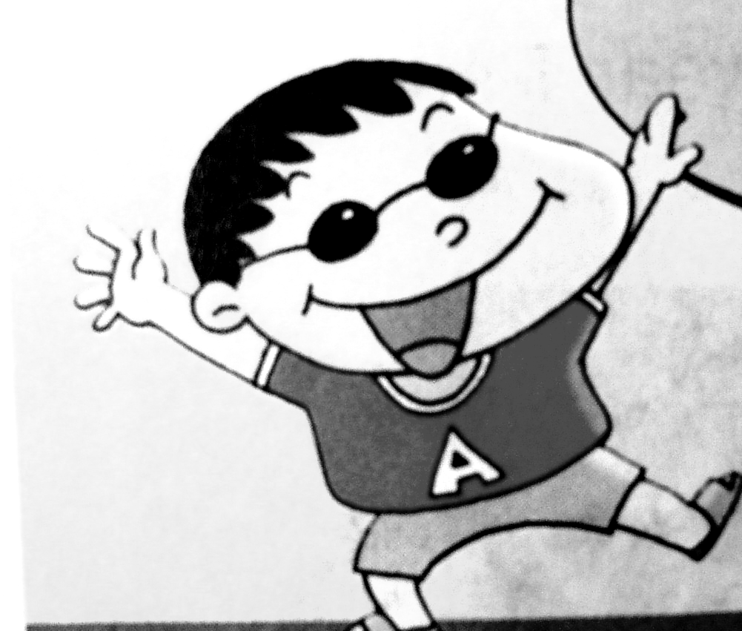
4． （ ）A. I like winter. It’s cold.
（ ）B. I like summer. It’s hot.

5． （ ）A. He plays the drums.
（ ）B. She plays the flute.
V Listen and match. 听短文，连线。（10%）
Hi, I’m Panpan. I eat breakfast at seven o’clock. Look! This is my friend, Sam. He plays the drums at the weekend. My friend Amy goes to school by car. His mother likes spring. It’s warm. His father likes Chinese New Year. He likes firecrackers.

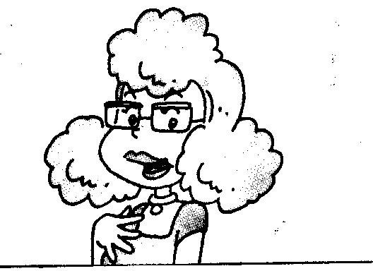

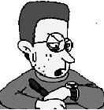


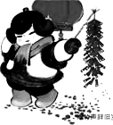
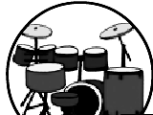

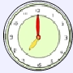


VI Listen and write. 听一听，在四线格内填上缺少的字母。（10%）

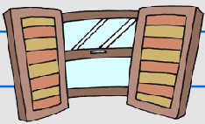
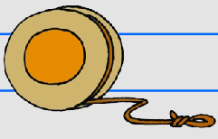
1. 2. 3.

ilk indow oyo


4. 5.

octor at
笔试部分
VII Read and match. 读一读，将句子与相应的图片连线。（10%）

1. My grandpa lives in Beijing.


2. He goes to school at half past seven.


3. She reads books at the weekend.
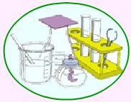

- It’s cold.
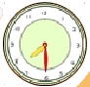
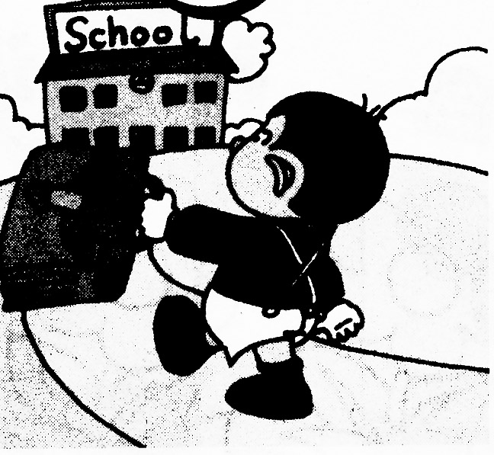
5. Science is my favorite subject.

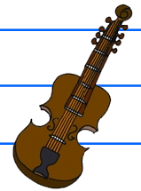
VIII Look and match. 看一看，将图片与首字母连线。（10%）


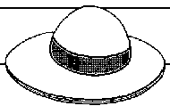
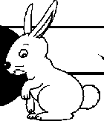

Rr Vv Hh Gg Ff

市南区2008~2009学年度第一学期二年级英语期末练习三
I Listen and number.根据所听到的句子，给图片标序号。
1、I go to school at eight o’clock.
2、We have maths in the morning.
3、He watches TV at the weekend.
4、I like this shirt.
5、Look! That is a big city.
II Listen and choose. 听录音，在符合录音内容的图片下的字母标号上画圈。
- Music is my favorite subiect.
- We wear trousers.
- I go home at 5 o’clock.
- He gets up late!
- I go to Hainan by plane.
III Listen and circle. 听录音，圈出句中的单词。
- We have English in the morning.
2. ---Is it 8 o’clock?
--- No, it isn’t.
3. ---Where do you play football?
---I play at the park.
- ---How does your father go to work?
---He goes to work by bus.
5. Merry Christmas.
IV Listen and tick. 听录音，选出符合图片内容的句子。
1．At Christmas we have sweets.
2. They like these shirts.
3. Sam goes to school by bike.
4. I like summer. It’s hot.
5. She plays the flute.
V Listen and match. 听小短文，连线。
Hi, I’m Panpan. I eat breakfast at seven o’clock. Look! This is my friend, Sam. He plays the drums at the weekend. My friend Amy goes to school by car. His mother likes spring. It’s warm. His father likes Chinese New Year. He likes firecrackers.
VI Listen and write. 听一听，在四线格内补上缺少的字母。（10分）
- milk 2. window 3. yoyo 4. doctor 5. bat

