市南区2008~2009学年度第一学期二年级英语期末练习二
Class（班级）：_____________Name（姓名）：______________ Assessment（评价）：______________

听力部分
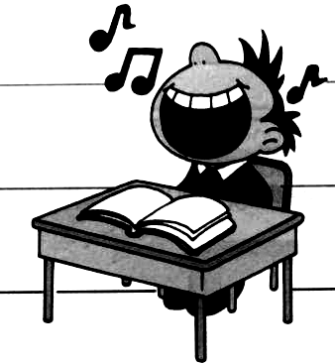
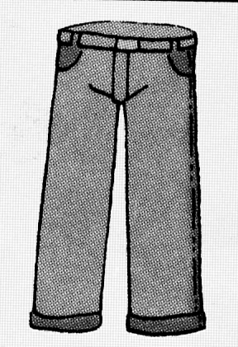
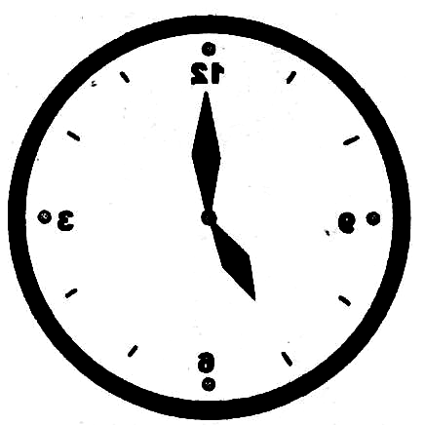
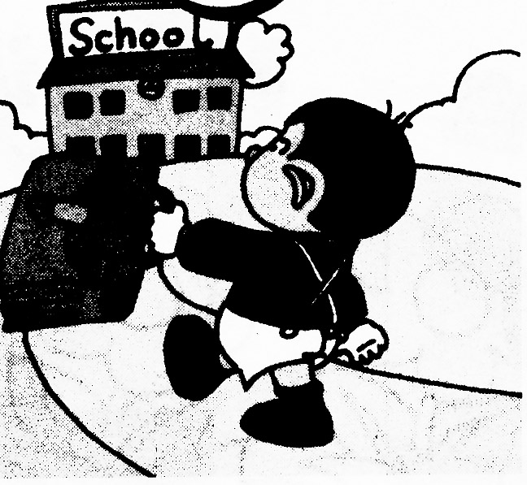
I Listen and number. 根据听到的句子，给图片标序号。（10%）


（ ） （ ） （ ） （ ） （ ）

II Listen and choose. 听录音，在符合录音内容的图片下的字母标号上画圈。 （10%）
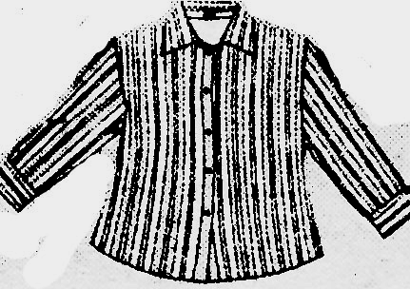
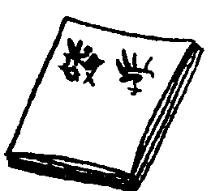
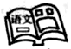
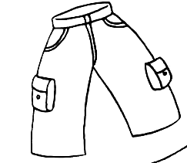
1. 2.

A B A B
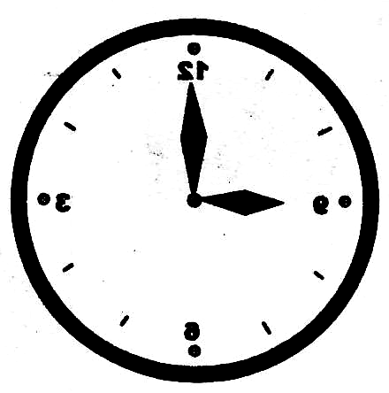
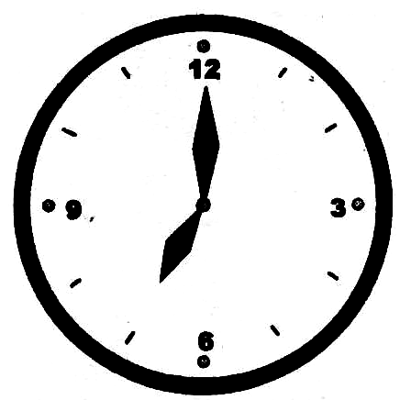
3. 4. 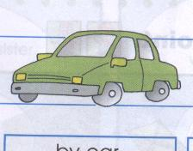 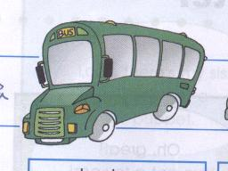

A B A B
5.  
A B
III Listen and circle. 听录音，圈出句中的单词。（10%）
1.We have English\Chinese in the morning.

2. ---Is it 6 o’clock?
--- Yes, it is./ No, it isn’t.


- ---Where do you play basketball?
---I play at the (park/school).

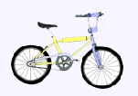
- ---How does your mother go to work?
---She goes to work by bike/ bus.

5. Happy New Year./ Merry Christmas.

IV Listen and tick. 听录音，选出符合图片内容的句子。（10%）
- （ ）A. I walk to school in the morning .
（ ）B. I go to school by bus.

2． （ ）A. My father goes to work by bus.
（ ）B. My father goes to work by bike .


3． （ ）A. We wear T- shirts in summer .
（ ）B. We don’t wear jackets.
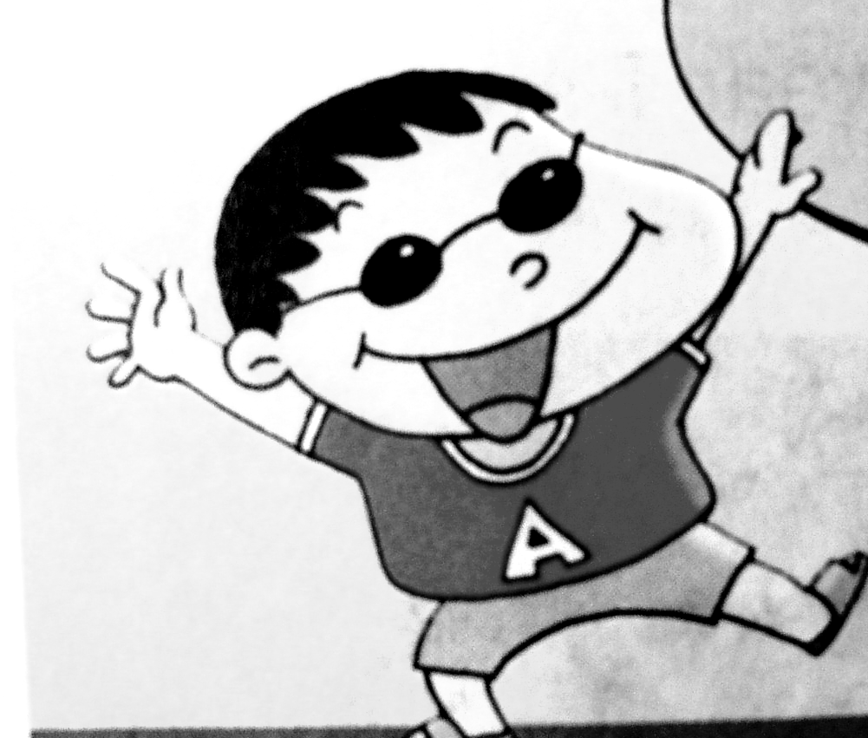
4． （ ）A. I like winter. It’s cold.
（ ）B. I like summer. It’s hot.

5． （ ）A. He watches TV
（ ）B. He plays football..
V Listen and match. 听短文，连线。（10%）
Hi, I’m Amy . I eat breakfast at seven o’clock. Look! This is my friend, Sam. He likes English,He likes the ABC song. My friend Daming likes sweats. Her mother goes to work by car. His father is a PE teacher . He likes PE.

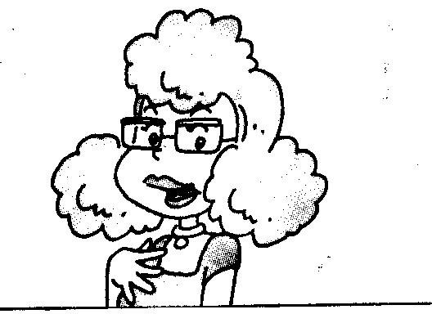

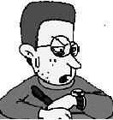



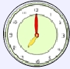
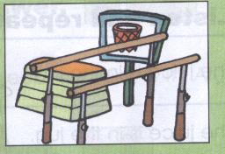

VI Listen and write. 听一听，在四线格内填上缺少的字母。（10%）
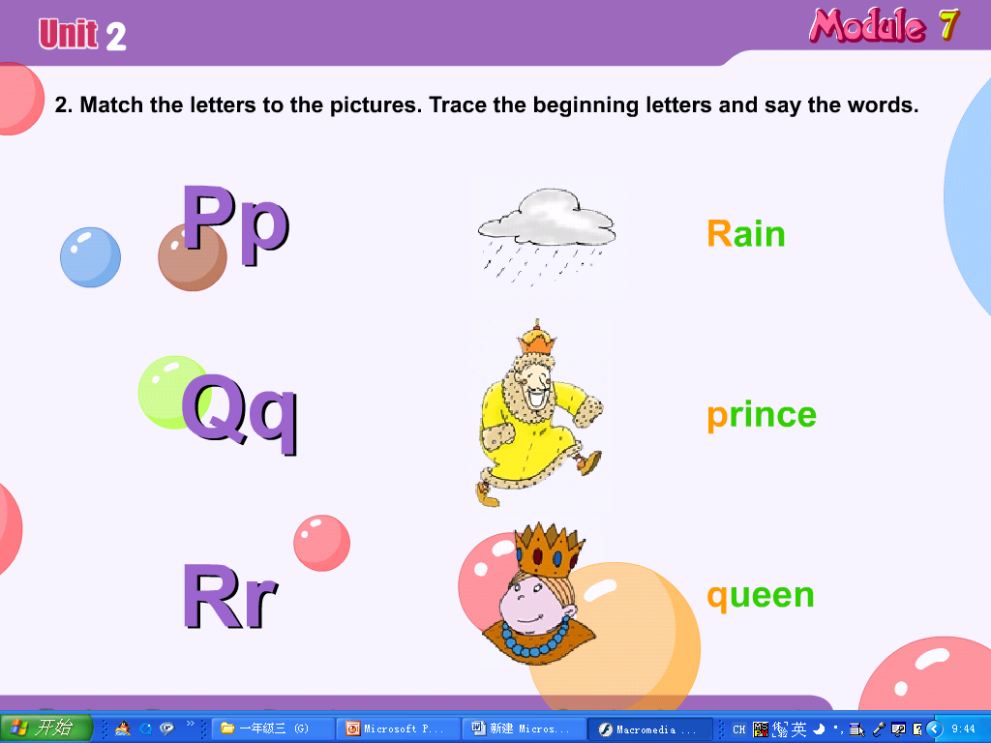
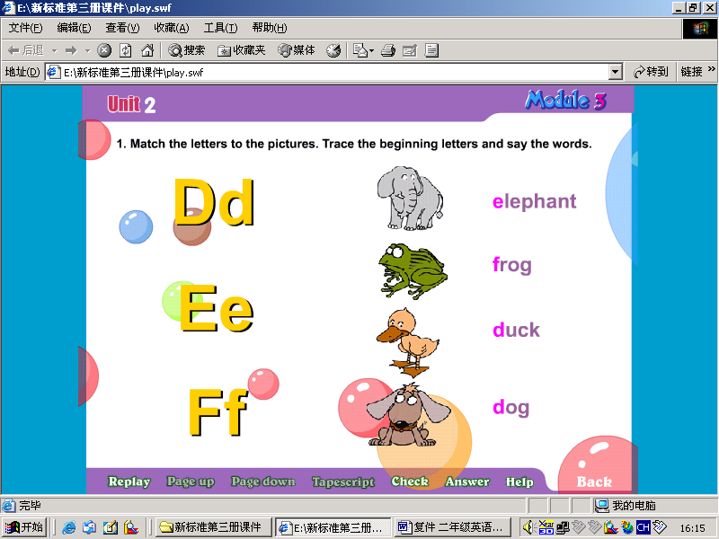
1. 2. 3. 

uck ueen pple
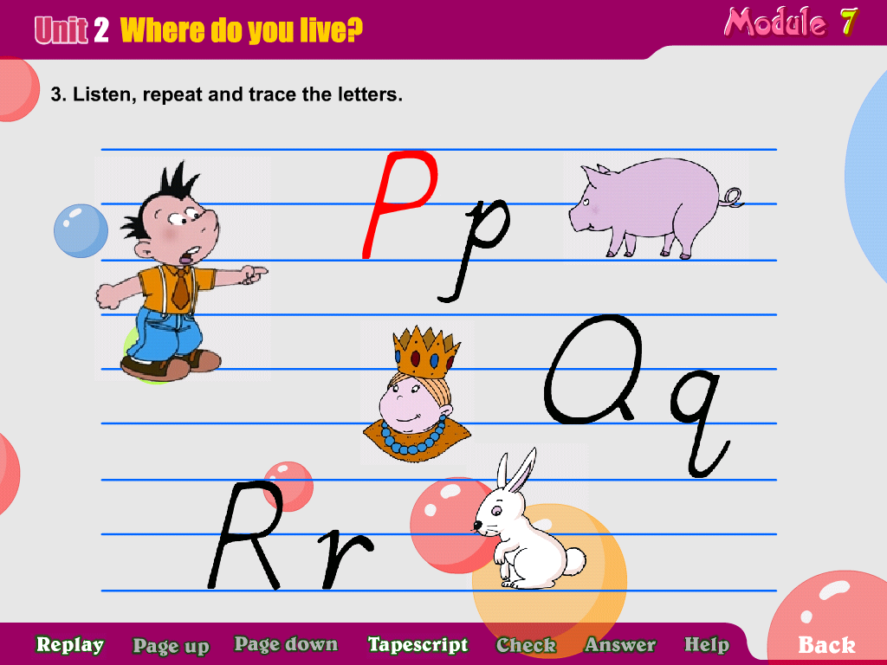
4. 5.

cecream abbit
笔试部分
VII Read and match. 读一读，将句子与相应的图片连线。（10%）
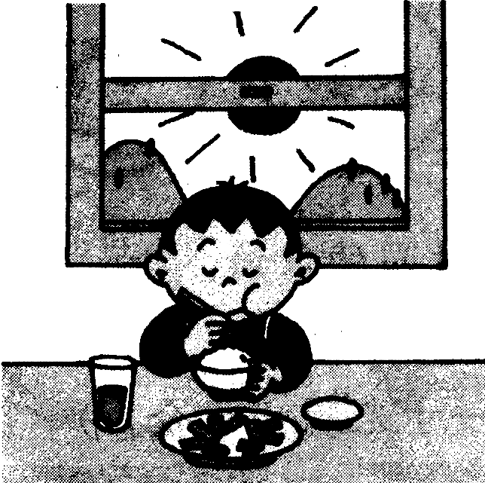
1. My sister lives in Beijing.

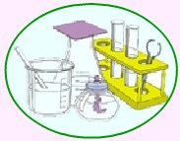
2. Amy goes to Hainan by plane.


3. She rides a bike at the weekend.

- I have breakfast at seven o’clock in the morning.

5. Science is my favorite subject.

VIII Look and match. 看一看，将图片与首字母连线。（10%）

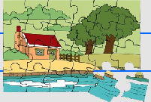

Jj Cc Aa Ii Ee

市南区2006~2007学年度第一学期二年级英语期末练习二
I Listen and number.根据所听到的句子，给图片标序号。
1、I go to school at eight o’clock.
2、We have music in the morning.
3、He likes these trousers
4、We wear T-shirts in summmer
5、What ‘s the time ? It’s five o’clock..
II Listen and choose. 听录音，在符合录音内容的图片下的字母标号上画圈。
- Chinese is my favorite subiect.
- Daming likes this shirt..
- I have dinner at 7 o’clock.
- How do you go to school ? I go to school by bus.
- It’s winter .We wear coats and gloves .
III Listen and circle. 听录音，圈出句中的单词。
- We have Chinese in the morning.
2. ---Is it 6 o’clock?
--- No, it isn’t.
3. Where do you play basketball?
---I play at the park
4. -- How does your mother go to work?
---She goes to work by bike
5. Merry Christmas.
IV Listen and tick. 听录音，选出符合图片内容的句子。
1．I walk to school in the morning .
- My father goes to work by bus.
- We wear T- shirts in summer .
- I like summer. It’s hot.
- He watches TV.
V Listen and match. 听小短文，连线。
Hi, I’m Amy . I eat breakfast at seven o’clock. Look! This is my friend, Sam. He likes English,He likes the ABC song. My friend Daming likes sweets. Her mother goes to work by car. His father is a PE teacher . He likes PE.

VI Listen and write. 听一听，在四线格内补上缺少的字母。（10分）
- duck 2. queen 3. apple 4. icecream 5. rabbit

镇江路小学 李占芳

