2008—2009学年度第一学期四年级英语期末练习二

学校： 班级： 姓名： 成绩：

Ⅰ. Listen and number.(请根据听到的内容为下列图片排序。) 10’
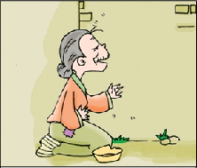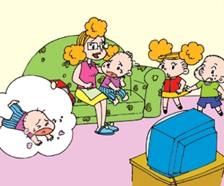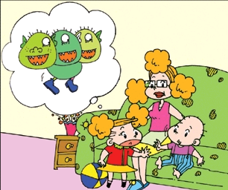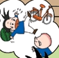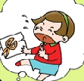

( ) ( ) ( ) ( ) ( )
Ⅱ.Listen and tick.(听音找出相应的图片，并在括号里画“√” 表示。)10’
1. 2.
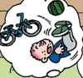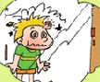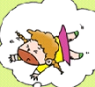

( ) ( ) ( ) ( )
3. 4.
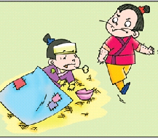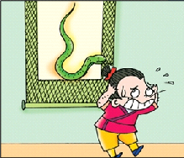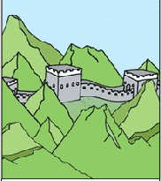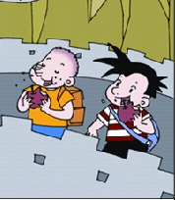
( ) ( ) ( ) ( )
5.
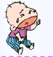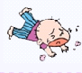
( ) ( )

Ⅲ. Listen and match.（请根据听到的内容将人物与相应词组连线。）10’

has got a headache has got a fever

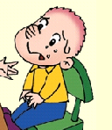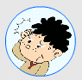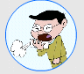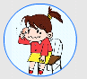

has got a cold has got a stomach ache has got a toothache

Ⅳ.Listen and fill in the blanks.（请根据听到的内容填上缺少的单词。）10’

1. The _______ _______ didn’t make gold.
2.Tom saw a _________ _______ on the TV.
3. Some English children __________ to China ______ week.
4.We were hungry and ______. So we _______ a watermelon.
5. I’ve ________ a __________ ache.

Ⅴ. Listen and put the words in the right order.（听音连词成句。）12’
1.didn’t \ ride her bike \ yesterday \she

2.apples \ ate \ we \ biscuits\ and

3. fell on \ Daming \ the \ watermelon

4 . paper and printing\ Chinese \ invented\ people

5. didn’t \ bad man \ the \help \ people

6.where \ go \ did \ yesterday \did

Ⅵ.Listen and circle.（请根据听到的内容圈出正确答案前的标号。）8’
1. 1)Did the monster have three heads?
A. Yes, it did. B. No, it didn’t.
2) Did the children run away?
A. Yes, they did. B. No, they didn’t.

2. 1) What did he see?
A. He saw monkeys and tigers. B. He saw lions and tigers.
2)Where did Tingting go?
A. She went to the zoo. B. She stayed at home.

笔答部分

Ⅶ.Read and match.（读一读, 连一连。）10’

A B
Where did you go? He came to China last Wednesday.
What did you see? I went to the park.
When did he come to China? I saw many animals.
What did she play? They ate bananas.

What did they eat? She played the flute.

Ⅷ.Read and choose. （读一读,选一选，将标号写在括号里）10’
( )1. This old woman didn’t ____ food .
A. have B. had
( )2. Yesterday, Amy ____ a gold cup .
A. win B. won
( )3. I can __________ flute.
A. play B. play the
( )4.What did you ______? I _____ lions and tigers
A. see…saw B. saw…see
( )5. What did she _________ last Wednesday?
A. play B. played

Ⅸ.Read，choose and write.（读一读,选择单词补全句子。）10’
helped , stayed, was, watched, made,

Yesterday __________ a special day. I usually go to school. But yesterday I didn’t go. There was no school. There was lots and lots of snow. I _________ at home. I ________ TV and finished my homework. I _________ my mum . We didn’t go to the park. And we didn’t go to the supermarket. We played with the snow. We ________ a snowman(雪人).

Ⅹ.Read and draw“√”or “× ” （读一读,判断句子是否符合短文大意,如符合用“√”表示,反之用“× ” 表示。）10’
My name is Amy. My friends are all very happy today, because(因为) they are having a picnic now. But I have to stay at home. Because I feel sick. My throat(嗓子) is sore(痛). My nose hurts. My father takes me to see the doctor. I get the flu(感冒). The doctor asks me to take some medicine(药), drink some hot drinks, and then stay in bed for a few days. I am so sad.
( ) 1. Amy gets the flu.
( ) 2. Amy has a sore throat.
( ) 3. Her friends are having a party.
( ) 4. Amy’s eyes hurt.
（ ）5. Amy goes to see the doctor with his mother.

2008-2009学年度第一学期四年级期末练习
听力材料
I.
- I cut my finger.
- I fell on the watermelon.
- This old woman didn’t have food.
- Did you see a scary thing? Yes, I did.
- Did you fall? No, I didn’t.
II.
- Sam fell off his bike.
- I bumped my head.
- The bad man didn’t help people.
- We saw lots of mountains.
- Tom is crying.
III.
- Sam’s got a stomach ache.
- Li Jie’s got a headache.
- Wang Fei’s got a cold.
- Shanshan’s got a toothache.
- Mingming’s got a fever.
IV.
1. The magic paintbrush didn’t make gold.
2.Tom saw a scary thing on the TV.
3. Some English children came to China last week.
4.We were hungry and thirsty. So we bought a watermelon.
5. I’ve got a stomach ache.

V.
1. She didn’t ride her bike yesterday.
2. We ate apples and biscuits.
3. Daming fell on the watermelon.
4. Chinees people invented paper and printing.]
5. The bad man didn’t help people.
6.Where did you go yesterday?

VI.
- P28
- P32
莱芜一路小学 于秀霞

