2008—2009学年度第一学期四年级英语期末练习一

Name_________ Class____________ No____
听力部分
Ⅰ. Listen and number.(请根据听到的内容为下列图片排序。) 10’
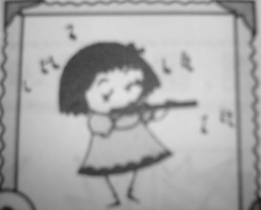

（ ） （ ） （ ） （ ） （ ）
Ⅱ.Listen and tick.(听音找出相应的图片，并在括号里画“√” 表示。)10’
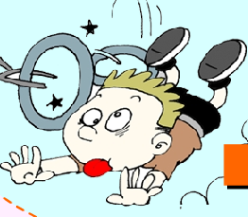
1． 2。
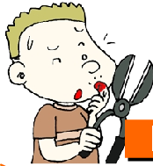
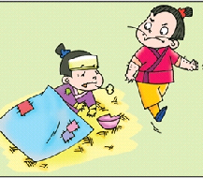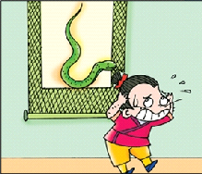
（ ） （ ） （ ） （ ）
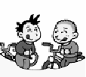
3． 4。
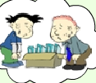

（ ） （ ） （ ） （ ）
5．

（ ） （ ）

Ⅲ. Listen and match.（请根据听到的内容将图片与相应词组、句连线。）10’

bought a new clock. win a gold cup too. What’s the matter?

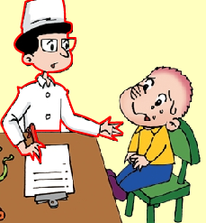
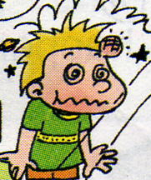
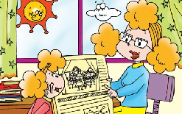
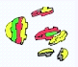
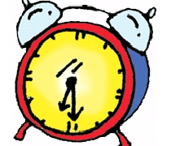

broke her toy bumped his head.

Ⅳ.Listen and fill in the blanks.（请根据听到的内容填上缺少的单词。）10’
1. What _______ to you? I _______ over.
2.What’s the ________? I’ve got a _____________.
3. _______ did they come? They ______ last Wednesday.
4._______ did you go? We ________ to the zoo.
5.The magic paintbrush didn’t ______ gold. It ______ a snake.
Ⅴ. Listen and put the words in the right order.（听音连词成句。）12’
1. scary, see, did, thing, Tom, a

2.help, the bad man, people, didn’t

3. you , did , eat, what, yesterday

4. hungry , we , were , and , thirsty

5. were , three , children , there

6. ate, I, biscuits, chocolate

Ⅵ.Listen and circle.（请根据听到的内容圈出正确答案前的标号。）8’
1. 1)Did the moneter have three heads?
A. Yes, it did. B. No, it didn’t.
2) Did the children run away?
A. Yes, they did. B. No, they didn’t.
2. 1) What did he see?
A. He saw monkeys and tigers. B. He saw lions and tigers.
2)Where did Tingting go?
A. She went to the zoo. B. She stayed at home.
笔答部分
Ⅶ.Read and match.（读一读, 连一连。）10’
The paintbrush only help Maliang. 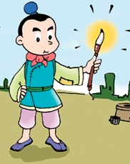

He has got a cold.
The boy fell off the bed.
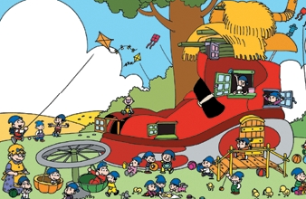 There were twenty-two children in the shoe. 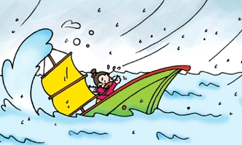

The bad man went to the sea in his ship.

Ⅷ.Read and choose. （读一读,选一选。）10’
( ) 1.What ______ to Daming? He_______ his head.
A. happened, cut B. happened, bumped
( )2. They _______ a bike ride.
A. went to B. went for
( )3. Where did this girl _____ ? She didn’t go out. She ____ at home.
A go/stayed B go/ stay
( )4. _______ worry, Sam. Go home and _____ this medicine.
A Don’t/eat B Don’t/ take
( ) 5 What did you ______? I _____ lions and tigers
A. see…saw B. saw…see

Ⅸ.Read，choose and write.（读一读,选择单词补全句子。）10’

cleaned, fell, made, was, were, washed, are, had, saw, went

Yesterday _____ Sunday. I _____ my room. And I ______ my sweater. Then I _______ for a horse ride with my parents. I ______ a white horse there. I rode it . And I didn’t _____ off the horse. My parents and I _____ very happy. After the horse ride , we went home . Mum _____ a cake for us. At last, we _____ a wonderful cake. And we ________ a good time.
Ⅹ.Read and draw“√”or “× ” （读一读,判断句子是否符合短文大意,如符合用“√”表示,反之用“× ” 表示。）10’
At the doctor’s
Shanshan doesn’t go to school today. She is at the doctor’s. Because she’s got a stomach ache.
Doctor: What did you eat yesterday? Shanshan: I ate some hamburgers.
Doctor: How many hamburgers did you eat? Shanshan: I ate five hamburgers.
Doctor: Five hamburgers! That’s too many! Go home and take this medicine.
Shanshan: I don’t like medicine.
Doctor: But you must take this medicine. You will be fine.
Shanshan: OK! Thank you, doctor.

( )1. Where is Shanshan?
A. She is at the doctor’s..
B. She is at school.
( )2. What’s the matter?
A She’s got a stomach ache.
B She’s got a headache.
( )3. What did she eat yesterday?
A She ate five biscuits.
B She ate five hamburgers.
( )4. Does Shanshan like the medicine?
A Yes, she does.
B No, she doesn’t.
( )5. What will Shanshan do?
A Go home and take the medicine.
B Go home and drink some water.

听力内容
Ⅰ. Listen and number.
  - This little girl can play the flute.
  - Daming is a good boy. He usually helps his mum.
  - He fell off his bike.
  - This boy has got a toothache.
  - Shanshan’s got a stomach ache.
Ⅱ.Listen and tick.
1．The bad man didn’t help people.
2．What happened to this boy? He cut his finger.
3． We went for a bike ride.
4．The monster wanted to eat the children.
5．She ran to the bus. She fell over.
Ⅲ. Listen and match.
1.Amy will win a gold cup too.
2. What’s the matter ,Sam?
3.Fangfang broke her toy last Wednesday.
4.Li Jie fell on the wall. He bumped his head.
5.Yesterday Shanshan bought a new clock.
Ⅳ.Listen and fill in the blanks.
1. What happened to you? I fell over.
2.What’s the matter? I’ve got a stomach ache..
3. When did they come? They came last Wednesday.
4.Where did you go? We went to the zoo.
5.The magic paintbrush didn’t ______ gold. It ______ a snake.
Ⅴ. Listen and put the words in the right order.
- Did you see a scary thing, Tom?
- The bad man didn’t help people.
- What did you eat yesterday?
- We were thirsty and hungry.
- There were three children.
- I ate chocolate biscuits.
VI. Listen and circle.
- P28
- P32

