I. Listen and number.（听句子，给下列图片排序。5%）
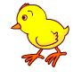
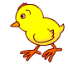
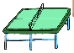

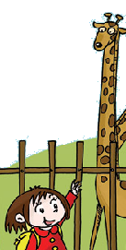
（ ） （ ） （ ）


（ ） （ ）
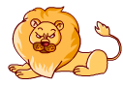

Ⅱ. Listen and circle.（听对话，圈出相应的图片下面的字母标号，10%)
1．




A B

2． 3.

A B A B
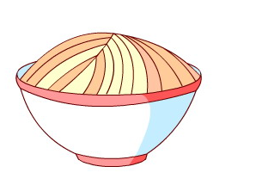
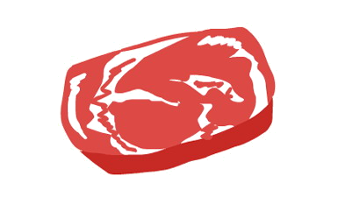
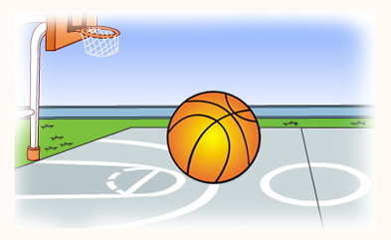
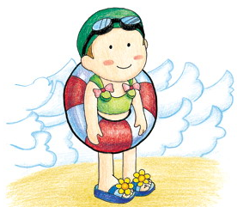
4. 5.

A B A B
III. Listen and judge. (判断下列图片是否与听到的内容相符，相符的用“√”表示，不相符的则用“×”表示。5%)
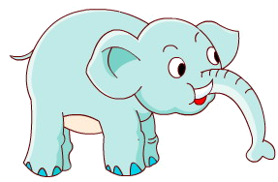
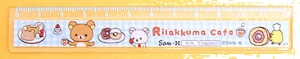

1. 2. 3. 3.

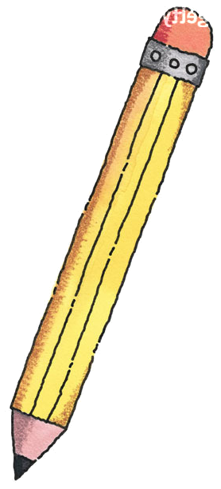

（ ） （ ） （ ）

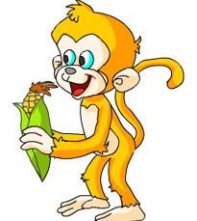
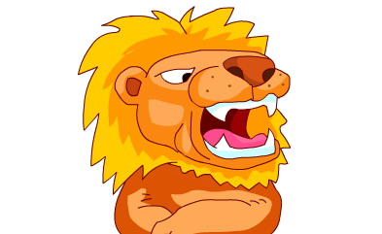

4. 5.

（ ） （ ）

Ⅳ. Listen and circle. (听一听，圈出你所听到的单词。10%）
1. Let’s play basketball .
football
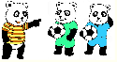
2. We like football.
They

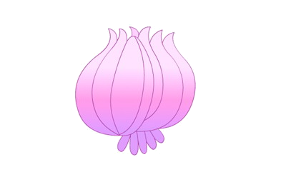
3. I don’t like ginger.
onions
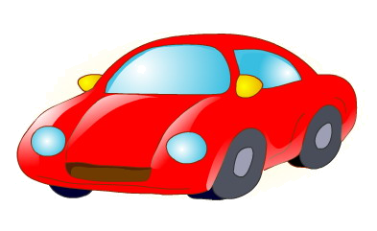
4. Do you like dolls ?
cars
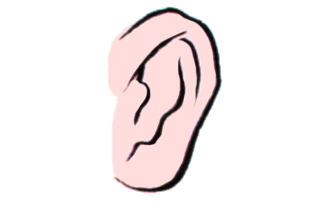
5. This is my eye.
ear

V. Listen and match.（听录音，把句子和对应的图片连接起来。10%）
1．What are they?

They’re cows.

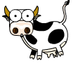
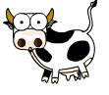
2．The chicken is little.
The tree is big.
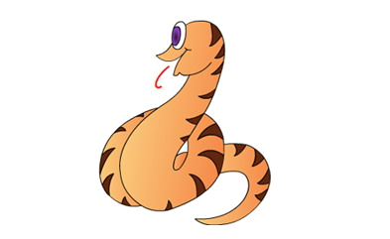
3．What’s your favourite sport?

My favourite sport is ping-pong.

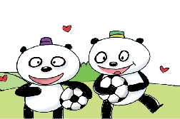
4．The snake is long..

5．We like football.
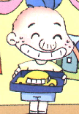
Ⅵ.Listen and answer.（听录音，根据图片回答问题，圈出正确答案前的字母标号。6%）
1.Do you like cars?
A. Yes, I do. B. No, I don’t.
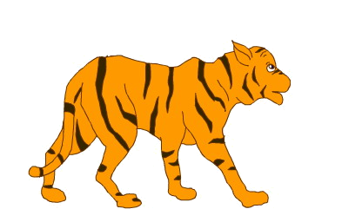
2.What’s your favourite animal?
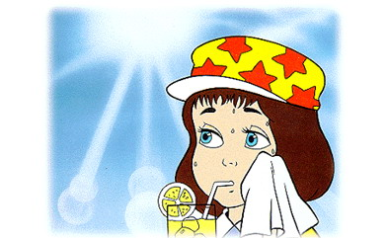
A. A lion. B. A tiger.
3.Let’s play ping-pong！
A. OK! Let’s play! B. No, I’m hot.
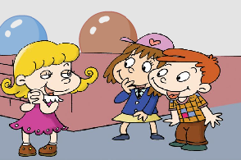
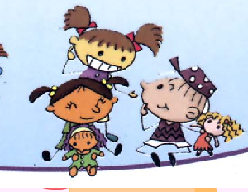
Ⅶ. Sing and order.（听一听，将所听到的儿歌的图片排序。4%）

（ ） （ ）
听力内容：
I. Listen and number.（听句子，给下列图片排序。5%）
1. We like football.
2. Let’s play ping-pong!
3. I like sweets.
4. The giraffe is tall and I am short.
5. What are they? They’re chickens.
Ⅱ. Listen and circle.（听对话，圈出相应的图片下面的字母标号，10%)
1. What’s your favourite animal? A lion.
2. This is my grandpa.
- Let’s sing!
- Do you like noodles? No, I don’t. I like meat.
- Let’s go swimming! Yes! Let’s go!
III. Listen and judge. (判断下列图片是否与听到的内容相符，相符的用“√”表示，不相符的则用“×”表示。5%)
- The cat is big. The elephant is little.
- He’s a driver.
- The ruler is long. The pencil is short.
- The panda is scary. The lion is cute.
- The pig is fat. The monkey is thin.
Ⅳ. Listen and circle. (听一听，圈出你所听到的单词。10%）
- Let’s play football！
- We like football.
- I don’t like onions.
- Do you like cars?
- This is my ear.
V. Listen and match.（听录音，把句子和对应的图片连接起来。10%）
1. What are they?
They’re cows.
2. The chicken is little.
The tree is big.
3.What’s your favourite sport?
My favourite sport is ping-pong.
4.The snake is long..
5.We like football.
Ⅵ.Listen and answer.（听录音，根据图片回答问题，圈出正确答案前的字母标号。6%）
- Do you like cars? Yes, I do.
- What’s your favourite animal? A tiger.
- Let’s play ping-pong！No, I’m hot.
Ⅶ. Sing and order.（听一听，将所听到的儿歌的图片排序。4%）
1.《Toys，toys，toys》
2.《We like swimming.》

此试题由市实验小学王蓓蓓提供

