2009年小学英语六年级毕业练习题（一）
Name：__________ Class：__________ School：__________ Degree：__________
（时间：40分钟 总分:100分）

Listening Part 听力部分
Ⅰ.Listen and choose. （请选出你所听到的单词，并将其前面的字母标号填在题前的括号里） （10%）
( )1. A. her | B. hear | C. hand | D. here
( )2. A. want to | B. wanted to | C. what to | D. went to
( )3. A. played | B. plane | C. play | D. plays
( )4. A. picture | B. photo | C. piano | D. person
( )5. A. why | B. how | C. who | D. where
( )6. A. won’t | B. will | C. want | D. what
( )7. A. play basketball |  | B. play baseball
C .play football |  | D. play ping-pong
( )8. A. bring cups |  | B. wear caps
C . say cups |  | D. see caps
( )9. A. made a video |  | B. wrote a story
C .went into |  | D. worked hard
( )10. A. How many |  | B. How much
C .How long |  | D. How old
II. Listen and tick. (请根据听到的内容，在括号内用“√”划出相应的图片) （10%）


1. 2. 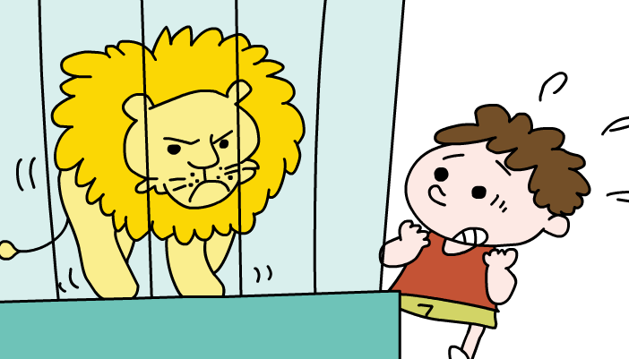 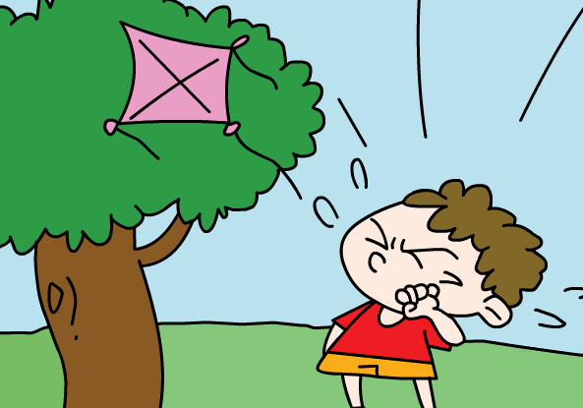
（ ） （ ） （ ） （ ）
3.   4.  
（ ） （ ） （ ） （ ）
5.  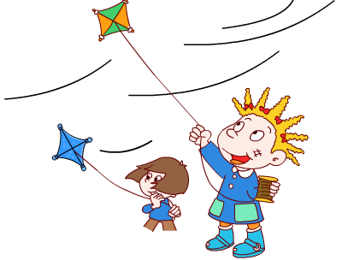
（ ） （ ）
III. Listen and complete the sentences. （听录音，填上所缺单词，补全句子）(10%)
1. In October 2003, Shenzhou V ________ into ________.
2. She was _________ . So she couldn't ________.
3. Why are you ___________ cups on your ________?
4. Are you going to go to___________school this __________?
5. He saw Chinese ___________ in _____________.
IV. Listen and choose. (听问句选择合适的答语) (10%)
( )1. A. There are 21 hours.
B. He spends about 21 hours.
C. About 21 hours.
( )2. A. They are 10 dollars.
B. There are 4.
C. It's ten yuan.
( )3. A. It's sunny.
B. It's going to be windy.
C. It rained.
( )4. A. The football team.
B. They go to the zoo.
C. They went to the station.
( )5. A. Because there is a snake.
B. Because he likes eating.
C. Because he is happy.
( )6. A. Yes, I brought a book.
B. No , we didn't .
C. Yes, I bought him a pen.
( )7. A. Yes, she has.
B. No , he has got a stamp album.
C. He's got a photo album.
( )8. A. They can help me .
B. He will help you .
C. I will help them.
( )9. A. Last September.
B. Next month.
C. I go there every day.
( )10. A. Yes, there was.
B. Of course there is .
C. There is a Chinatown in Russia
Ⅴ. Listen and judge.（请根据短文内容判断句子是否与短文内容相符，相符的用“√”表示,反之则用“X”表示）(10%)
( ) 1. Hellen was born in 1890 in America.
( ) 2. She was blind and deaf.
( ) 3. She couldn't see.She could hear .
( ) 4.She learned to listen and write.
( ) 5. She could talk , and she went around the world to tell her story.

Writing Part 笔答部分
Ⅵ. Reorder the words and write the sentences correctly. （请将所给单词重新排列，组成句子抄写在四线格中）(10%)
1. Amy / cola / bought / Lingling/ for /some

2. the / flying / birds/ all / away /are

3. is/twelve / it/ cents / dollars / twenty / and

4. are / from / where / kites / these

5.child / for / a / sleeps / eight / night / a / hours

VII Look and write. 看图补全句子，每空填一个单词。（10%）
- Sam has got some ______ and a ______.
2. Pandas _______ ________ .

3. She couldn't __________.
But she could _____________.

4. The _______ is ___________.

5. Look! The apples_______ _______
down the stairs.

Ⅷ. Read and choose. （读一读，选出合适的词语，并将其前面的字母标号填在题前的括号里）（10%）
( ) 1. What do you want to ________ ? An apple, please.
A. eating B. eat C. ate D. will eat
( ) 2. I _______ a very funny day last Sunday!
A. have B. has C. had D. having
( ) 3. Sam, I’ll ______ you. Me, too.
A. miss B. mess C. missing D. saw
( ) 4. I make lots of ___________ with English.
A．mistake B. friend C. cups D. mistakes
( ) 5. Amy likes ___.So she is going to _____at the party.
A. dance/dance B. dancing /danced C. dancing/dance
( ) 6. Our school starts nine o’clock.
A. in B. on C. at
( ) 7. you visit the UN building yesterday?
A. Do B. Does C. Did
( )8.I to a library last week and I some books.
A. went, read B. go, read C. went, reading
( ) 9. make so much noise!
A. Don’t B. Aren’t C. Haven’t
( ) 10. I’m ______. I want to eat a sandwich.
A. thirsty. B. tired C. hungry
Ⅸ. Read and judge. （读短文，用√和×判断短文后的句子是否正确）（5%）
Today is Daming’s birthday. Simon is going to make a birthday card for him. Simon’s mum is at the supermarket. She’s buying things for the party. But the bags are too heavy. There is a birthday cake. There is a special gift for Daming. They’re three balloons. They say, “Happy Birthday, Daming!” Daming will have a great party.
( )1. Daming will say ‘Happy birthday!’ to Simon.
( )2. Simon’s present will be a birthday card.
( )3. Mum is going to the bookstore and buy a book.
( )4. Daming will get a special gift from Simon’s mother.
( )5. They can eat a cake today.
Ⅹ. Read and choose. （读短文，选择正确答案，将其前面的字母标号填在题前的括号里） （10%）
Hello, I’m Mike. Peter and Mary are my friends. I’m twelve years old. I live in London. My favourite season is summer. Because I can visit lots of interesting places in summer.
Last summer holiday I had a good time. In July, Peter, Mary and I had a picnic in the countryside. We went there on foot. We spent about one hour. We took photos there. We were tired but very happy. Then we had Chinese food for lunch. The food was delicious! In the afternoon, we came back to London. We went to the library. We borrowed lots of books. I like the story of Helen Keller. She was a very famous woman.
This summer holiday I’m going to visit New York. I will see the Statue of Liberty. (自由女神像). That will be fun. What about you?
( ) 1. When did Mike have a picnic?
  - Last summer holiday in August. B. Last July.
C. Last Sunday.
( ) 2. How did Mike and his friends go to the countryside?
- They went there by car. B. They walked there.
C. They went to the countryside by bus.
( ) 3. Mike’s favourite season is not ______.
- Summer B. spring C. in July
( ) 4. Where is Mike going to go this summer holiday?
- He’s going to go to London. B. Library.
C. He is going to go to America.
( ) 5. What did Mike do after lunch?
- He went to America. B. He took photos.
C. He went to a library and borrowed many books.
Ⅺ.Composition 小作文（5%）
读了Mike的计划，相信你对暑假生活也有一些自己的想法和打算，写一写自己的计划。至少5个英语句子。
________________________________________________
________________________________________________
________________________________________________
________________________________________________

录音内容
Ⅰ.Listen and choose. （请选出你所听到的单词，并将其前面的字母标号填在题前的括号里） （10%）
- Here's your present.
- When Yang Liwei was a little boy , he wanted to go into space.
- She often plays the trumpet for her mum.
- In 2003 , Shenzhou took China's first person into space.
- Who gave it to your brother?.
- We want some meat and soup.
- They're going to play baseball after class..
- I didn't say cups. I said caps .
- Daming wrote a story about the picnic.
- How long is the street?
II. Listen and tick. (请根据听到的内容，在括号内用“√”划出相应的图片) （10%）
- This beautiful building is a museum. The clock is fifty meters high.
- Why is he sad? Because his kite flew in the tree.
- Thanksgiving is in November. It's a very important festival in America.
- Roll the paper like this.
- It's rainy(raining) . The children are jumping in the water.
III. Listen and complete the sentences. （听录音，填上所缺单词，补全句子）(10%)
- In October 2003,Shenzhou V flew into space.
- She was deaf. So she couldn't hear.
3. Why are you wearing cups on your heads?
4. Are you going to go to middle school this September?
5. He saw Chinese dancing in Chinatown.
IV. Listen and circle. (听问句选择合适的答语） (10%)
- How many hours did he spend in space?
- There are 21 hours.
- He spends about 21 hours.
- About 21 hours.
- How much are the oranges ?
- They are 10 dollars.
- There are 4.
- It's ten yuan.
- What was the weather like yesterday?
- It's sunny.
- It's going to be windy.
- It was rainy.
- Where did Mum and Daming go ?
- The football team.
- They go to the zoo.
- They went to the station.
- Why is Tom crying ?
- Because there is a snake.
- Because he likes eating.
- Because he is happy.
- Did you buy him a pencil?
- Yes, I brought a book.
- No , we didn't .
- Yes, I bought him a pen.
- Has Simon got a photo album ?
- Yes, she has.
- No , he has got a stamp album.
- He's got a photo album.
- Who can help me ?
- They can help me .
- He will help you .
- I will help them.
- When are you going to go to middle school?
- Last September.
- This weekend.
- I go there every day.
- Is there a Chinatown in Russia ?
- Yes, there was.
- Of course there is .
- There is a Chinatown in England.
Ⅴ. Listen and judge.（请根据短文内容判断句子是否与短文内容相符，相符的用“√”表示,反之则用“X”表示）(10%)
Module 8 Unit 1
X √ X X X

（此题由杨越、于蓬、毛德洁老师提供）

