2008--2009学年度第二学期五年级英语期末练习（二）
（时间：40分钟 满分：100分）

Listening Part 听力部分
Ⅰ. Listen and choose. 选出听到的单词、词组或句子，并将其前面的字母标号填在题前的括号里。（10%）
( )1. A. where | B. when | C. what | D. who
( )2. A. summer | B. autumn | C. spring | D. winter
( )3. A. heavy | B. light | C. broken | D. new
( )4. A. office | B. shop | C. factory | D. library
( )5. A. rain | B. windy | C. sunny | D. snow
( )6. A. funny | B. amazing | C. interesting | D. surprise
( )7. A. with my mouth |  | B. with my legs
C. with my hand |  | D. over my shoulder
( )8. A. by car |  | B. by plane
C. by train |  | D. by bus
( )9. A. from the air |  | B. in the sky
C. in a circle |  | D. on top of
( )10. A. had a picnic |  | B. climbed the mountain
C. took photos |  | D. sent an email
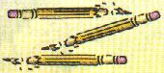
Ⅱ. Listen and tick. 听句子，在相应图片下面的括号里划“√”表示。（10%）
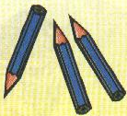
1. 2.

（ ） （ ） （ ） （ ）
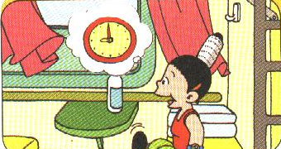
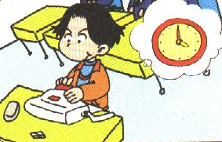
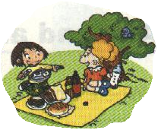
（ ） （ ） （ ） （ ）
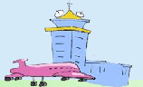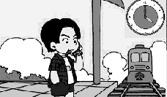
（ ） （ ）
Ⅲ. Listen and write. 听录音，填上所缺单词，补全句子。（10%）
- They ______ lots of jokes and we ________ a lot.
- I ______ I’ll _______ a toy car.
- I ______ fish and chips for ______.
- _______ you ______ me?
- _______ will we get there? ______ car.
Ⅳ. Listen and choose. 听问句，选答语。（10%）
 | C. Yes, we helped you.
( )3. | A. They are delicious. B. Yes, I will eat them.
 | C. Yes, I ate them.
( )4. | A. He went to Beijing.
 | B. He will go to Beijing.
 | C. Yes, he will.
( )5. | A. No, we are not.
 | B. No, we don’t.
 | C. No, we haven’t.
( )6. | A. I visited my friends.
 | B. I will visit my friends.
 | C. I’m going to visit my friends.
( )7. | A. Yes, we will get there.
 | B. By plane.
 | C. It will take five hours.
( )8. | A. I can go swimming.
 | B. I can play with the snow.
 | C. I can see the baby ducks.
( )9. | A. Yes, she had.
 | B. She had fish and rice.
 | C. She had dinner at 6 o’clock.
( )10. | A. Yes, he is.
 | B. He will go to Mount Tai.
 | C. Yes, he will.
( )1. | A. She was a flute player.
 | B. She worked in a hospital.
 | C. She played traditional Chinese music.
( )2. | A.Yes , I did. B. Of course I will.
V. Listen and judge. 听短文，判断句子是否符合短文意思，符合的用“√”表示， 不符合的用“×”表示。（10%）
( ) 1. They are going to see Stonehenge on Friday.
( ) 2. The place is six thousand years old.
( ) 3. They’ll see lots of very big stones.
( ) 4. They will get there by train.
( ) 5. It will take three hours.
Writing Part 笔答部分
Ⅵ. Reorder the words and write. 将所给单词组成句子，按照书写要求，用正确规范的形式写在四线格中。（10%）
1. of / big / lots / we / stones / will / see / very

2. the / you / videos / got / Harry Potter / have

3. will / three / it / hours / take

4. lots / jokes/ the / told / actors / of

5. in / what / you / bag / did / put / your

Ⅶ. Look and write. 看图补全句子，每空填一个单词。（10%）
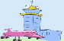1. ---- _______ will you go tomorrow?
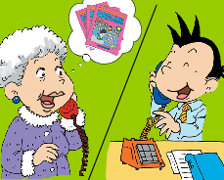---- I’ll go to the _________.

2. I _______ you English books.
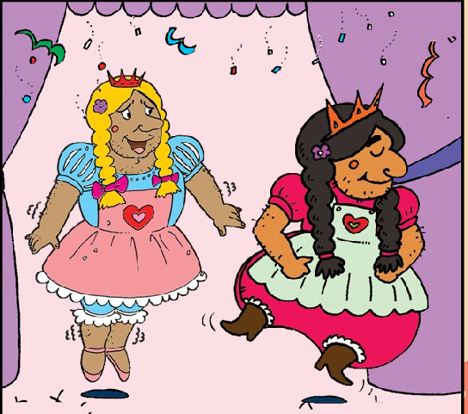
Did you ______ them?

3. The men _______ women’s ________.
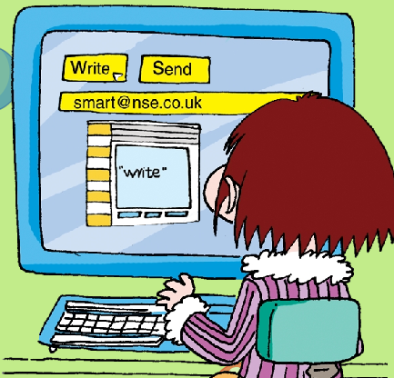
4. Now _______ _______ “Email”.

5.My grandma was a ________ before.
She ________ a bus.
Ⅷ. Read and choose. 读一读，选出最佳答案，将其前面的字母标号填在题前的括号里。（10%）
( ) 1. My father ____ a doctor before. He ____ in a hospital.
A. is, works B.was, works C. was, worked
( ) 2. What did Amy _____ for lunch?
A. has B. have C. had
( ) 3. ----____ you got Ma Liang videos?
---- No, we _____.
A. Have, haven’t B. Have, have C. Has, hasn’t
( ) 4. My favourite season is autumn. It’s _____.
A. warm B. cool C. cold
( ) 5. This black bag is _____. I can’t lift it.
A. light B. heavy C. small
( ) 6. Oh! Good! That will _____ fun.
A. is B.was C. be
( ) 7. Dad ___ at the office now. He ____ home at 6 o’clock.
A. was, is B. is, is C. is, will be
( ) 8. ----Will you _____ tomorrow?
----No, I ____.
A. go swimming, will B. go swimming, won’t
C. went swimming, didn’t
( ) 9. The ____ wore _____ shoes.
A. men, women’s B. man, women’s C. men, woman’s
( ) 10. ----_____ will she go there?
---- At seven o’clock.
A.What B. Where C. When
Ⅸ. Read and judge. 读短文，判断句子是否符合短文意思，符合的在括号里划“√”表示，不符合的划“×”表示。（5%）
Dear Cousin Daming,
How are you? We are getting ready for your visit. Dad put another bed in my room. Mum bought new chopsticks for you. And dad read a book about Chinese history. He is going to ask you questions. And we borrowed a bike for you. We will be together. That will be fun! Write soon.
From
Simon
( )1. Daming is going to go to China.
( )2. Simon is getting ready for Daming’s visit.
( )3. Dad read a book about American history.
( )4. They bought Daming a football.
( )5. Daming and Simon will be together.
Ⅹ. Read and choose. 读短文，选择正确答案，将其前面的字母标号填在题前的括号里。（10%）
Last summer holiday, Wangfei went to New York with his family. They went there by plane. It was sunny and warm in New York. They went to a children’s theatre. The show was very funny. Then dad drove them to a park.They had a picnic there. They ate sandwiches and sausages. Wangfei liked to eat them. After that they went to the zoo. They saw many animals there. Wangfei fed the monkeys with bananas.The monkeys ate them all. That was fun. They had a really good time together.
( )1. Wangfei went to _______ Last summer.
A. China B. America C. England
( )2. They went to New York ______.
A. by bus B. by train C. by plane
( )3. First, they ______, then they went to a park.
A. watched a show B. went to a zoo C. had a picnic
( )4. They _______ in the park.
A. played football B. fed the animals C. had a picnic
( )5.They took some _____ to feed the monkeys.
A. food and drink B. fruit C. sandwiches
Ⅺ. Composition.请仿照上文描述你的一次游玩的经历，可以写一写事情发生的时间、地点、当天的天气，你（们）去了哪里，你（们）做了什么事情以及你的感受等等。要求语句通顺，内容不少于5句话。（5%）
________________________________________________________
________________________________________________________
________________________________________________________
________________________________________________________
________________________________________________________
________________________________________________________

听力录音内容
Ⅰ. Listen and choose
1. When will you leave tomorrow?
2. My favourite season is spring. It’s warm.
3. This black bag is big and heavy.
4. I read some books in the library yeaterday.
5. Will it be windy in New York?
6. We took a helicopter ride. It was amazing.
7. I carry my bag over my shoulder.
8. I will go to Mount Tai by train next week.
9. Some stones are on top of others.
10.Yesterday we had a picnic at a place called Stonehenge.
Ⅱ. Listen and tick.
- Last summer I played on the beach.
- Look at these pencils. They’re broken.
- We are going to have a picnic in the park.
- He’s in the classroom. He’ll be home at four o’clock.
5. ---- Where will you go tomorrow?
---- I’ll go to the airport.
Ⅲ. Listen and write.
- They told lots of jokes and we laughed a lot.
- I think I’ll make a toy car.
- I had fish and chips for dinner.
- Will you help me?
- How will we get there? By car.
Ⅳ. Listen and choose.
- What was your grandma?
- Will you help me?
- I sent you some biscuits. Did you eat them?
- Where will he go tomorrow?
- Have you got the Snowwhite Videos?
- What did you do last weekend?
- How will we get there?
- What can you do in summer?
- What did Amy have for dinner yesterday?
- Will Daming go to Mount Tai Next week?
V. Listen and judge.
Module 6 Unit 1
此试题由朝城路小学刘惠提供

