2008-2009学年度第二学期一年级英语期末练习题（二）
School：__________ Class: ___________ Name: ___________ Assessment：____________


- Listen and number. (听一听，给图片排 序号。) （20%）
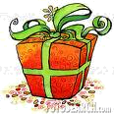
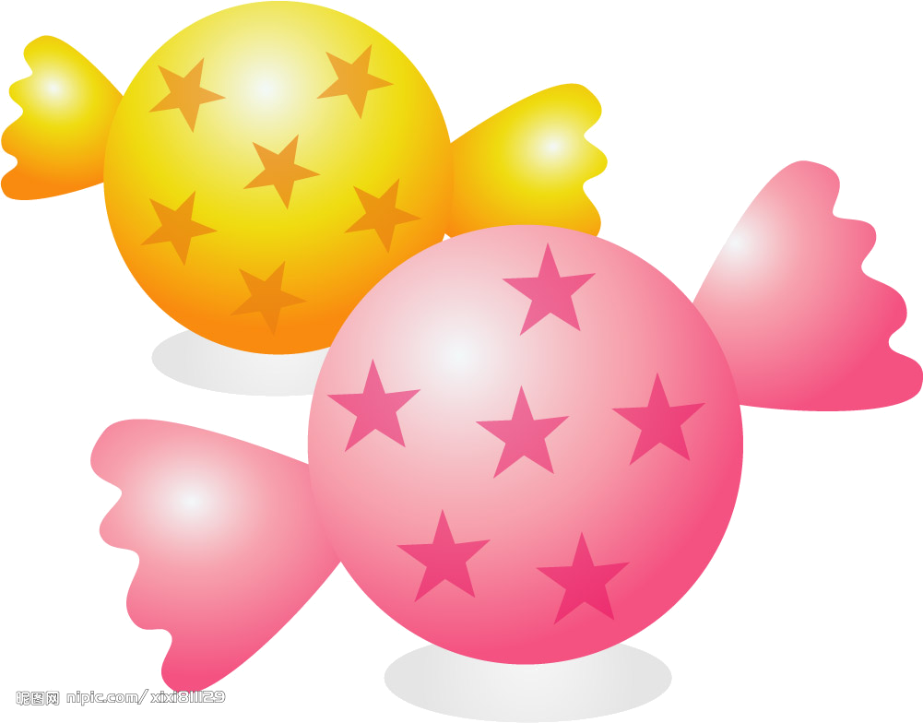
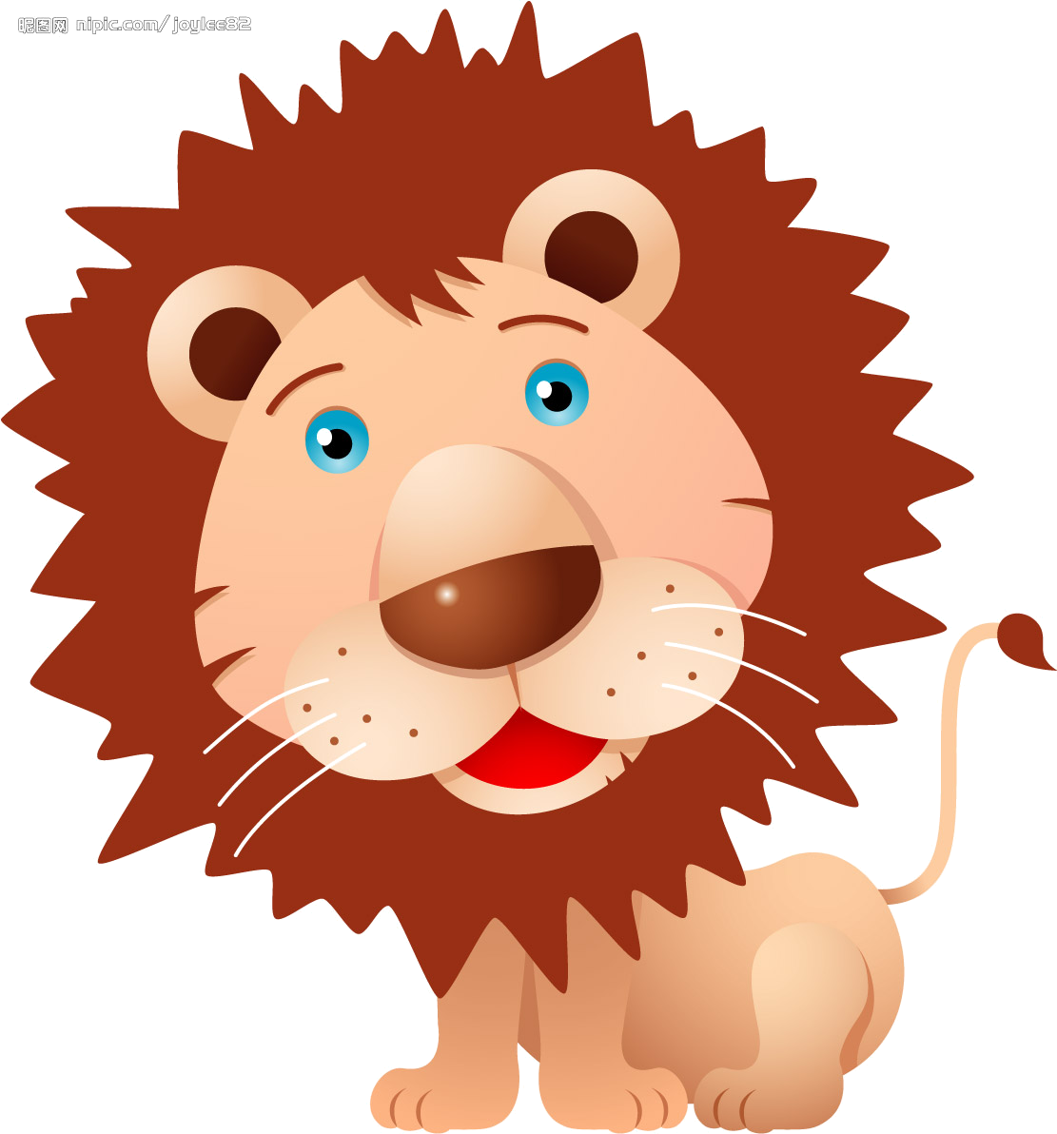

( ) ( ) ( ) ( ) ( )

- Listen and choose. ( 听一听，圈出你所听到的图片下面的字母标号。) （20%）

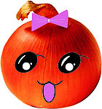
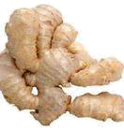
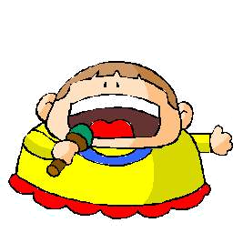
1. 2.

A B A B


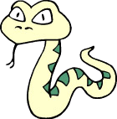
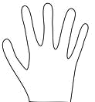
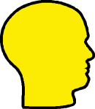
3. 4.

A B A B

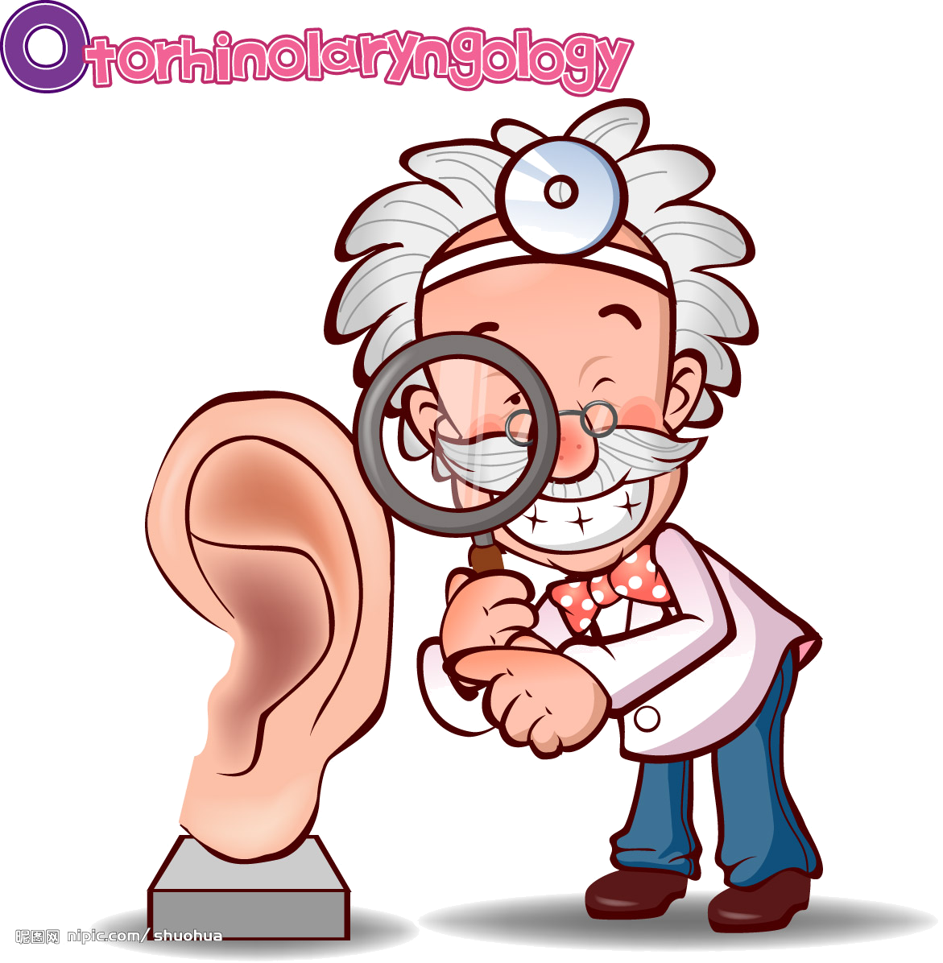
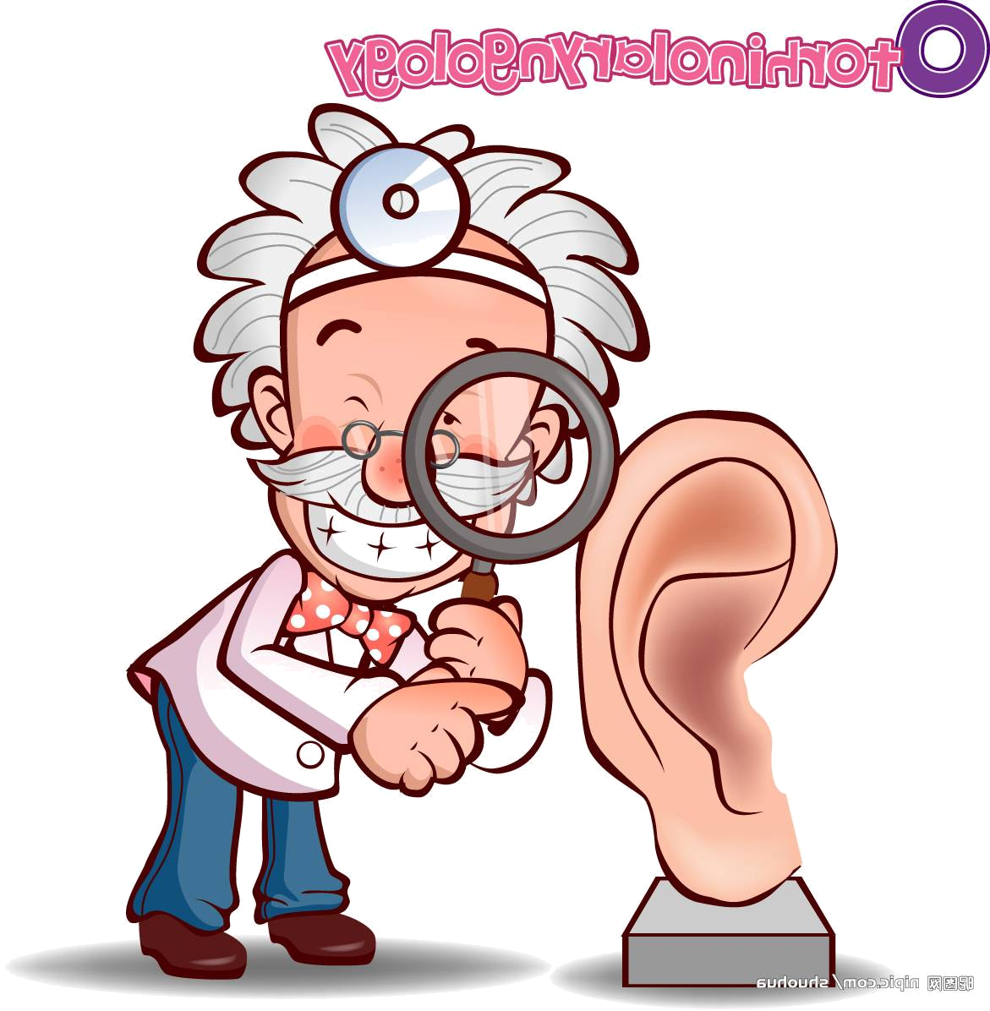
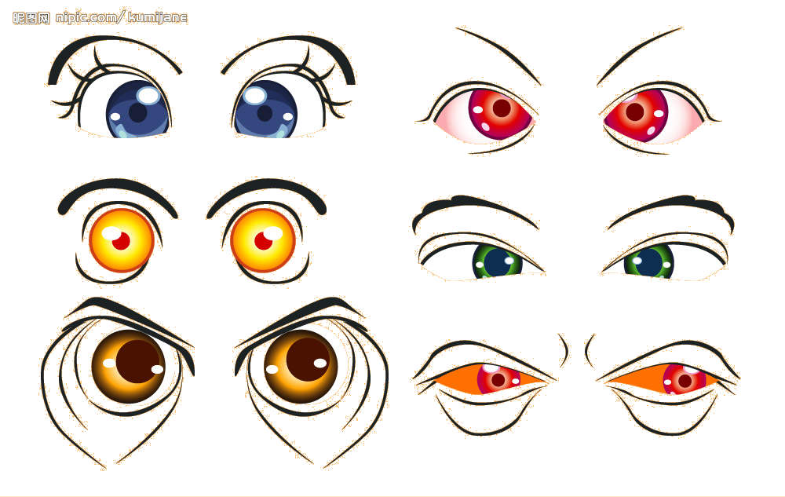
5.

A B

- Listen and circle. (听一听，圈单词。) （20%）
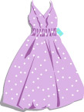
- My mother is a nurse.
This is __(her/ his) dress.

2. Let’s __(play football / paly basketball).
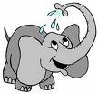

3.The elephant is __(big/ little).

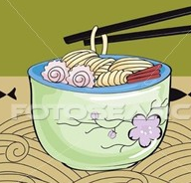
4. I don’t like___ ( noodles / rice ).


5. This is my____ (grandma / mother ).

IV．Listen and circle “A”or “B”. (听一听，圈出你所听到的句子前的字母标号 )

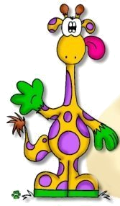
1. A. The giraffe is tall.
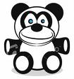
The panda is short.
B． The giraffe is short.
The panda is tall.
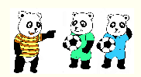
2. A. We like football.
B. They like football.

3. What’s your favourite colour ?
A . My favourite colour is blue.
B. My favourite colour is black.
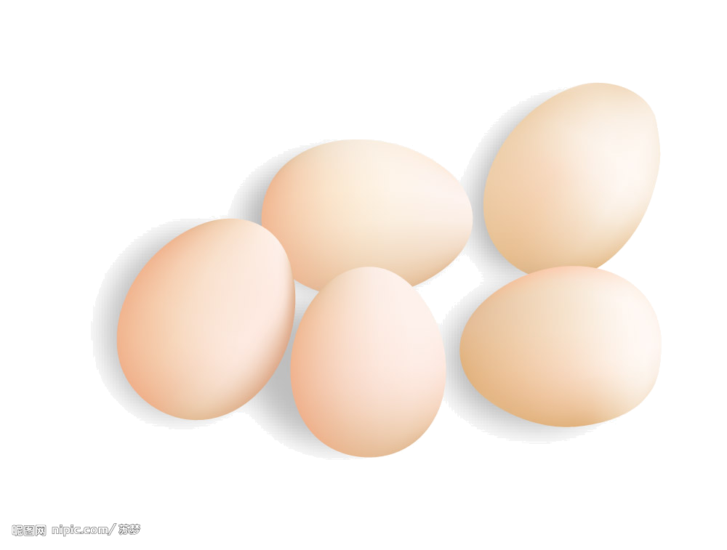
- What are these ?
  - These are legs.
  - These are eggs.

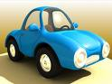
- Do you like cars ?
  - Yes, I do.
  - No, I don’t.

V．Listen and match. (听一听，连一连。)（20%）
Hi, I’m Amy. I like basketball. Hi, I’m Lingling. I like ping-pong. Hello, I’m Tom. My favourite sport is swimming. My mother is a teacher. This is her bag. My father is a driver. That is his bus.
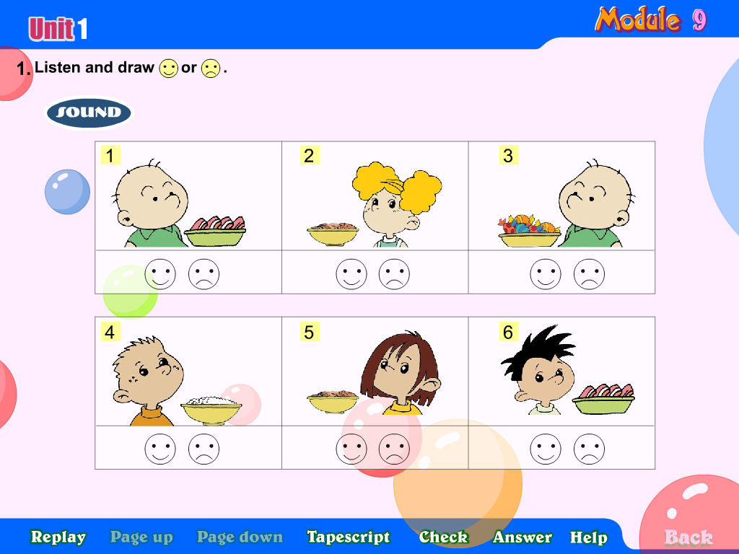



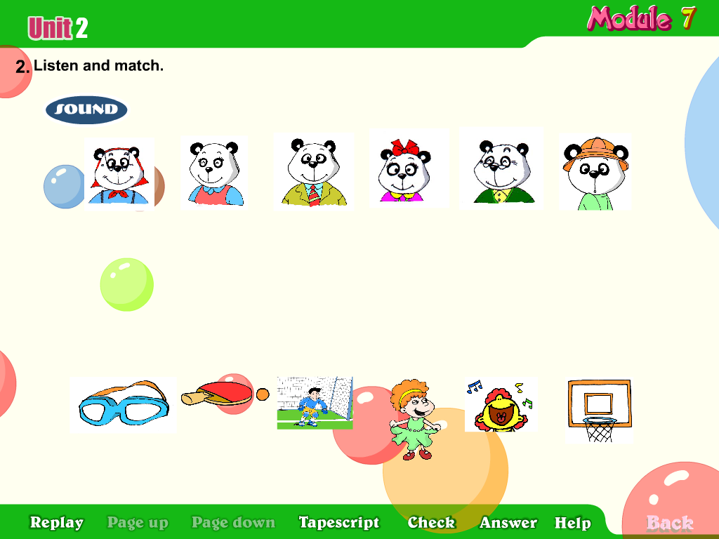

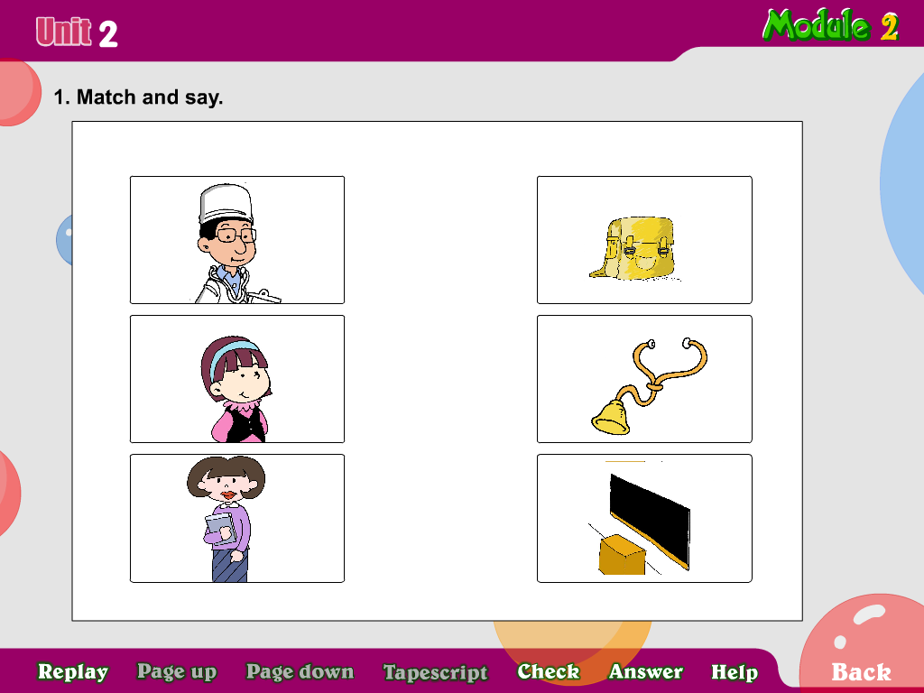
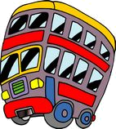

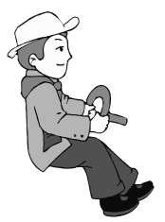

第一大题：Listen and number.
- I like sweets.
- This is my father. He’s a doctor.
- Here’s a present for you.
- My favourite sport is ping-pong.
- The lion is cute.

第二大题：Listen and choose.
- Let’s go swimming.
- I don’t like ginger.
- What’s your favourite animal ? A dog.
- This is my head.
- What are they ? They’re my ears.
.
第三大题：Listen and circle.
- My mother is a nurse. This is her dress.
- Let’s play football.
- The elephant is big.
- I don’t like noodles.
- This is my mother.

第四大题：Listen and circle “A”or “B”.
- The giraffe is tall. The panda is short.
- They like football.
- What’s your favourite colour ?
My favourite colour is black.
- What are these ?
These are eggs.
- Do you like cars ?
Yes, I do.

第五大题：．Listen and match.
Hi, I’m Amy. I like basketball. Hi, I’m Lingling. I like ping-pong. Hello, I’m Tom. My favourite sport is swimming. My mother is a teacher. This is her bag. My father is a driver. That is his bus.

此试题由榉园小学侯沁涵、潘家鑫提供

