2009--2010学年度第一学期六年级英语Module1-3综合练习(二)

Listening Part 听力部分
Ⅰ. Listen and choose. 选出听到的单词或词组，并将其前面的字母标号填在题前的括号里。（10%）
( )1. A. more | B. mask | C. moon | D. most
( )2. A. millons | B. years | C. metres | D. hundreds
( )3. A. one | B. wrote | C. were | D. went
( )4. A. album | B. building | C. surprise | D. collect
( )5. A. Australian | B. America | C. Australia | D. American
( )6. A. difficult | B. different | C. dangerous | D. dancing
( )7. A. thousands of |  | B. lots of
C. all of |  | D. more about
( )8. A. needs to sleep |  | B. wants to learn
C. liked to dance |  | D. needed to drink
( )9. A. fifteen kilometres |  | B. five metres
C. fifty metres |  | D. fifty kilometres
( )10. A. the Five-Finger Mountains |  | B. the Ming Tombs
C. Chinatown |  | D. the Great Wall
Ⅱ. Listen and tick. 根据录音内容，在相应图片下面的括号里划“√”表示。（10%）


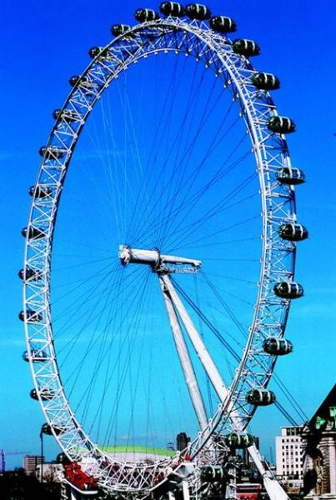
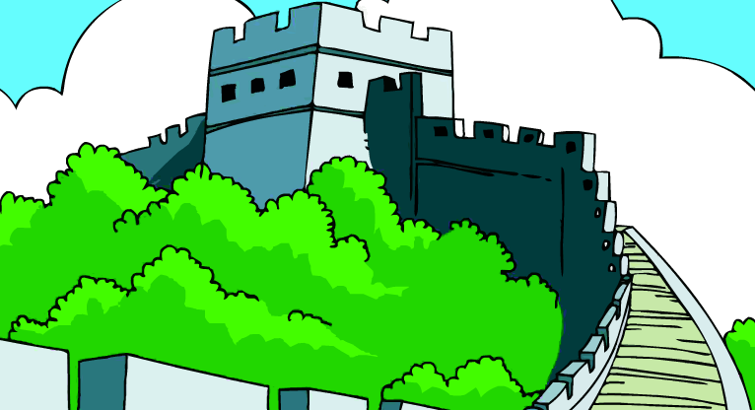
1. 2.

（ ） （ ） （ ） （ ）
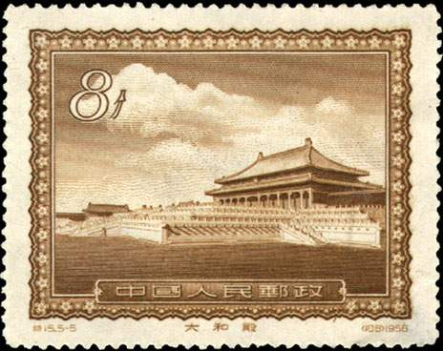
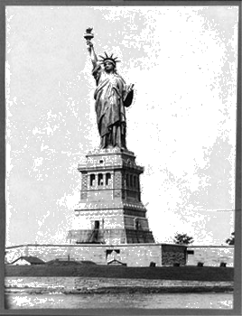
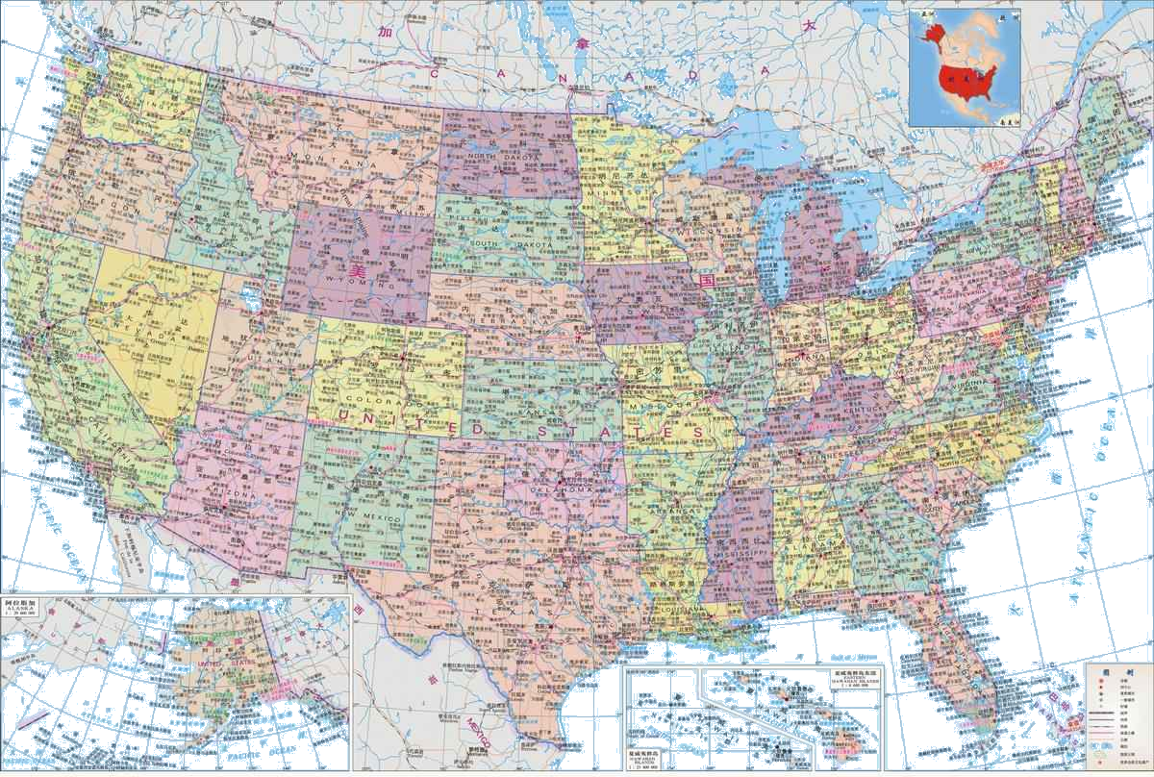
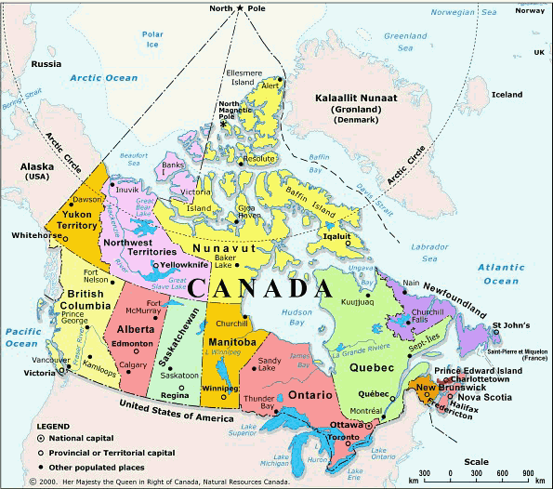
3. 4.

（ ） （ ） （ ） （ ）
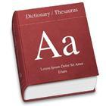
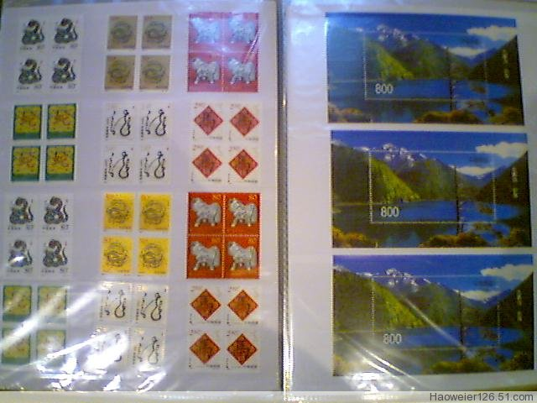
5.

（ ） （ ）
Ⅲ. Listen and choose. 听问句，选答语。（10%）
( ) 1. A. It’s twenty metres tall.
B. It’s twenty metres long.
C. It’s very far.
( ) 2. A. We were at the supermarket.
B. We sang and danced.
C. We ate Beijing duck.
( ) 3. A. I’ve got a desk.
B. He’s got a computer.
C. She’s got a chair.
( ) 4. A. Yes, it is.
B. Yes, there are.
C. Yes, there is a Chinatown in New York.
( ) 5. A. Yes, I’m putting my new stamps into my album.
B. I put my new stamps into my album.
C. I’m putting my new stamps into my album.
IV．Listen and complete. 听录音，补全短文。（10%）
Hello, I’m Ann. Collecting _________ is my favorite. Look, I’ve _______ some from China. They are about the _______ ________ and the big __________ in New York. They are really beautiful! What do you like to collect? Tell me about it, please!
V. Listen and judge. 听短文，判断句子是否符合短文意思,符合的用“√”表示， 不符合的用“×”表示。（10%）
（ ）1. Daming was in New York yesterday.
（ ）2. There is a big Chinatown in New York.
（ ）3. Daming didn’t eat any food in Chinatown.
（ ）4. There weren’t any shops in Chinatown.
（ ）5. Simon really wants to go to the Great Wall.
Writing Part 笔答部分
Ⅵ. Read and choose. 读一读，选出最佳答案，将其前面的字母标号填在题前的括号里。（10%）
( ) 1. The library is ____ my home. We can go there on foot.
A. near to B. in front C. far from D. next
( ) 2.There _________ Chinese people everywhere.
- be B. was C. is D. were
( ) 3. It’s a book _______ China. There is a picture __________ Hainan Island ________ it.
A. on, for, from B. about, of, in
C. 不填, in, about D. of, from, in
( ) 4. The bridge is ____ years old.
A. millions of B. million C. two millions D. thousand
( ) 5. The food was different _______ Chinese food in China.
- As B. of C. from D. for
( ) 6. ---What does she want to learn?
---She wants to learn _____
A. English B. Canada C. China D. America
( ) 7. ---Where ______ he go last Sunday?
---He _______ to London.
- do, go B. did, went C. does, goes D. will, going
( ) 8. _______ you visit me in China, we’ll go.
- When B. What C. How D. Why
( ) 9.Here are some stamps ________ America and Canada _________ you.
- for, of B. from, from C. from, for D. for, from
( ) 10. I’m hungry. I need _____________
A. eat B. to eat C. sleep D. sleeping
Ⅶ. Read and write. 看图补全句子，每空填一个单词。（10%）
1. Look at the ________ ________.
It’s __________ __________ li long.
2. We ate in _________ American ___________.
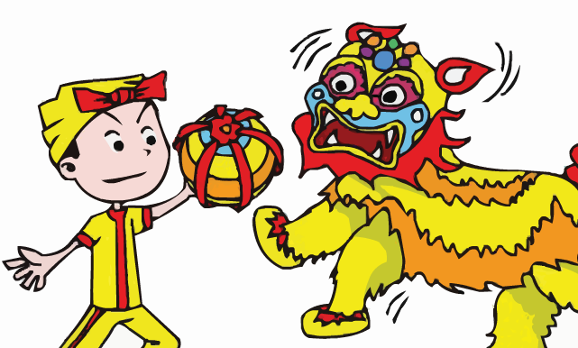
3. We saw _________ _________.
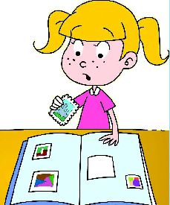
4. I’m putting my new _________ into my ________.

Ⅷ. Read and make sentences. 按要求完成句子。（10%）
1. is / the Great Wall / how long (连词成句)

2. is / there / in New York / a Chinatown (连词成句)

3. you / what / are / doing (连词成句)

4. It’s more than two thousand years old. (就划线部分提问)
_________ _________ is it?
5. Have you got any stamps from China? (请给出肯定回答)
_________, I _________.
Ⅸ. Read and judge. 读短文，判断句子是否符合短文意思，符合的在括号里划“√”表示，不符合的划“×”表示。（5%）
Dear Julie,
I wrote three emails yesterday. One to my mum. One to my grandma and one to my friend, Kate. I am very happy here in England. My new school id very nice. I have new friends too.
Ruby
( )1. Julie wrote three emails yesterday.
( )2. Kate is Ruby’s friend.
( )3. Ruby lives in England now.
( )4. Ruby’s school is old and dirty.
( )5. Ruby doesn’t have any friends in her new school.
Ⅹ. Read and choose. 读短文，选择正确答案，将其前面的字母标号填在题前的括号里。（10%）
Dear Amy,
I know you collect stamps. So I sent you these Chinese stamps. I hope you like them.
China made its first stamps in 1878. the first stamp was of a very big dragon. Behind the dragon there are clouds and waves. People all over the world like collecting stamps from China. Chinese stamps are famous because they are very beautiful. They also show China’s history, people, places and animals. Many stamps in China are children’s paintings. People like these stamps. The paintings show China and the children’s works are very, very good. I like collecting Chinese stamps. I have got lots of them.
Please write to me soon.
Yours,
Lingling
( )1. ______ sent ______ some Chinese stamps.
A. Amy, Lingling B. Lingling, Amy C. People, children
( )2. Chinese stamps are famous because __________.
A. they are very beautiful.
B. they show China’s history, people, places and animals
C. Both A and B.
( )3. ________ was on the first Chinese stamp.
A. A big dragon B. A children’s painting
C. Summer Palace
( )4. From this letter, we know many stamps in China are __________.
A. Chinese dancing B. children’s paintings C. coconut trees
( )5. The first Chinese _______ was from 1878.
A. painting B.letter C. stamp
Ⅺ. Composition. 写作（5%）
请你以My last weekend为题写一写你上周末是如何度过的。要求：语句连贯，表意清楚，字数为30-40个单词。
________________________________________________________
________________________________________________________
________________________________________________________
________________________________________________________________________________________________________________
Tapescript:
I. Listen and choose.
1. The moon is only 2,000 years old? C
2. There are hundreds of them here. D
3. I’m going to write two emails. One to my cousin and one to my teacher. A
4. It’s a beautiful building. B
5. It’s an American festival. D
6. This book is different from that one. B
7. We can’t walk all of it. C
8. He’s really tired. He needs to sleep. A
9. That river is about 50 kilometres long. D
10.We are going to the Five-Finger Mountains. A
II. Listen and tick.
1. ---Where did you eat?
---We ate in a Chinese restaurant.
2. ---What did you see?
---London Eye. It’s very high.
3. ---Where is the stamp from?
---It’s from China.
4. ---Where does your pen pal live?
---He lives in America.
5. ---What have you got in your room?
---I’ve got a stamp album.
1 1 2 1 2
III. Listen and choose.
1. How long is it? B
2. Where did you go last Sunday? A
3. What has he got in his room? B
4. Is there a Chinatown in New York. C
5. What are you doing? C
IV. Listen and complete.
Hello, I’m Ann. Collecting stamps is my favorite. Look, I’ve got some from China. They are about the Great Wall and the big Chinatown in New York. They are really beautiful! What do you like to collect? Tell me about it, please!
V. Listen and judge.
Vol. 11 Module 2 Unit 1
√ √ × × √

