I．Listen and number. (听录音，给图片排序。) 10%


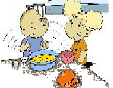

( ) ( ) ( )
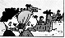

( ) ( )
II．Listen and tick. （听录音，选图片。）12%


1. 2.

( ) ( ) ( ) ( )
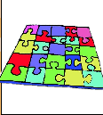
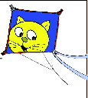
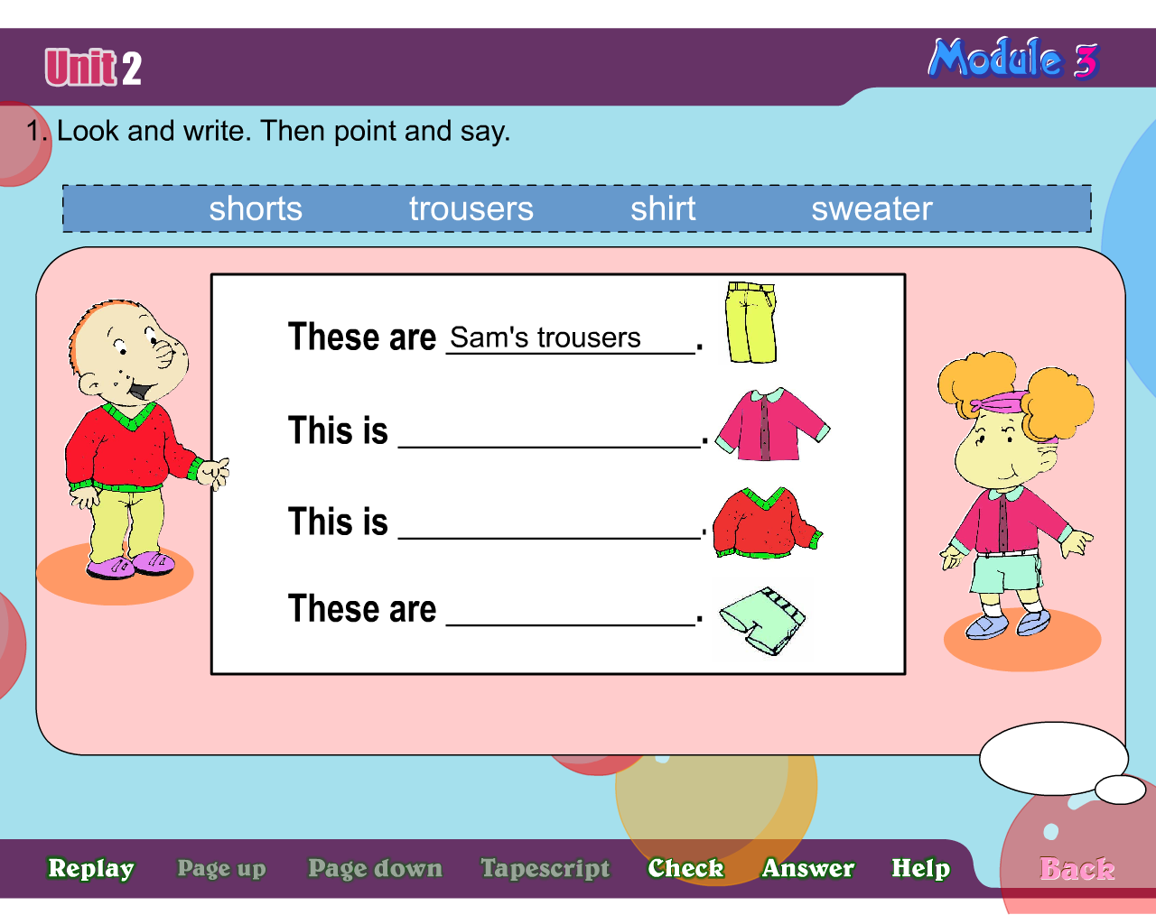
3. 4.

( ) ( ) ( ) ( )
5. 6.
( ) ( ) ( ) ( )
III. Listen and judge.（听录音，判断图画内容是否与图片一致。）（8%）
1. 2.

( ) ( )
3. 4.
these a knife and fork making
working reading shorts trousers

( ) ( )

IV． Listen and match.(听一听，连一连) （10%）
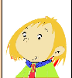
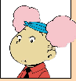



V． Listen and tick. (听一听，选一选。) （10%）
( )1、Amy wants noodles.
( )2、Chopsticks are hard for Chinese people.
( )3、A knife and fork is hard for Chinese people.
( )4、Amy isn’t hungry .
( )5、Amy can use a knife and fork .

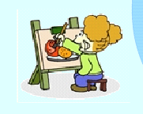
笔 试 部 分
Ⅵ. Read and number 按句子顺序给图片标序号(5%)
1、Lingling is eating noodles .She’s using chopsticks.
2、We’re making a cake.
3、What are these ? They are dragon boats.
4、These are Sam’s trousers .
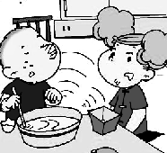
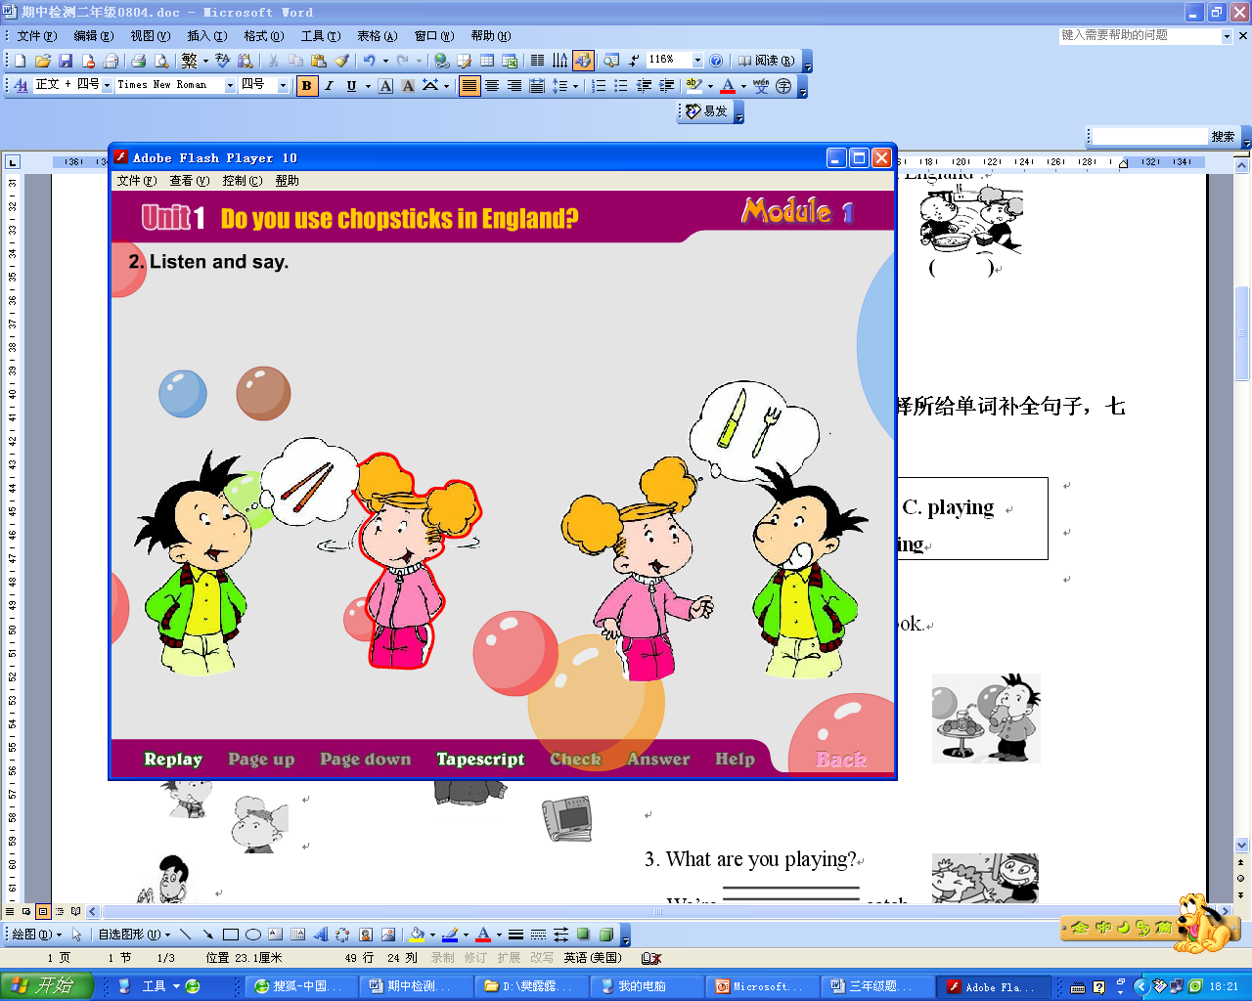
5、We use a knife and fork in England .

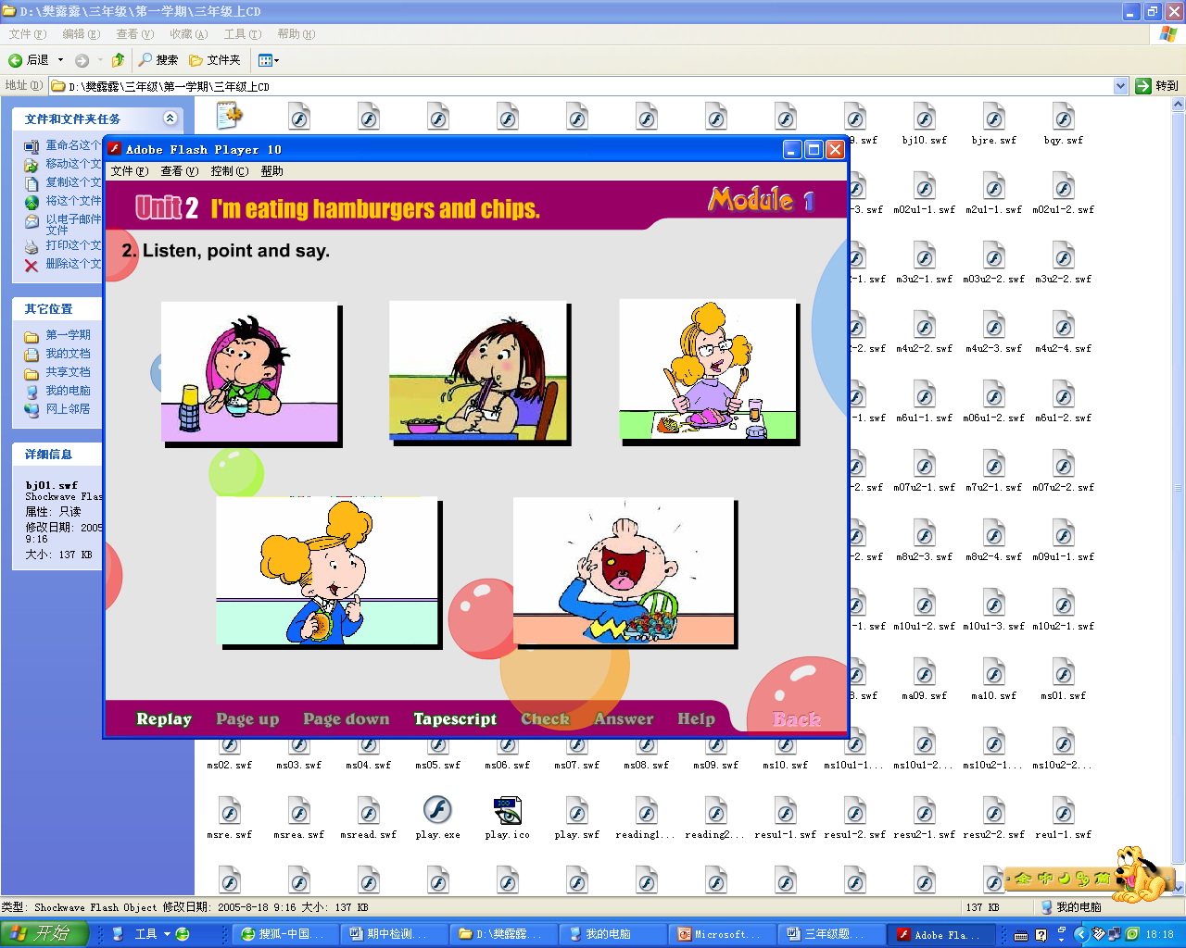
( ) ( ) ( )

( ) ( )
Ⅶ. Choose and write.(选择所给单词补全句子) (5%)
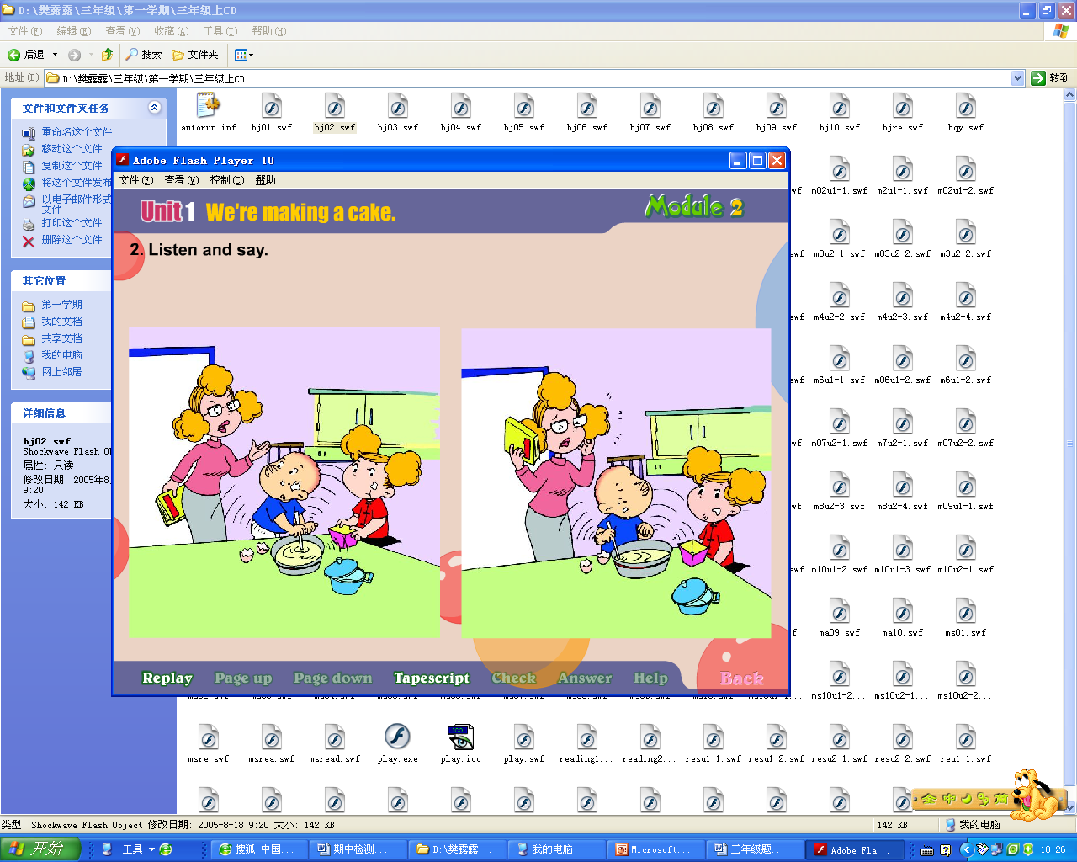
1. Please be quite ! I’m .

2. Is he a book ?
No, he isn’t .
3. What are those?
Those are Amy’s .

4. She’s using
.
5.What are ?
They are ducks .
Ⅷ. Read and copy the sentences.（用正确的形式抄写下列句子。）（5%）
1）do / you / use / chopsticks / in / england

2) we / use / a / knife / and / fork

3) no / we / don’t

4)these/ducks/are /very /naughty

5)please/be/quiet/I’m/working

X．Read and choose. (阅读短文，选择正确的答案，将字母的标号填在提前的括号里)
Hi, I’m Amy. I’m eight. At the weekends, I usually do my homework. Today is Sunday, but I’m not doing my homework. I’m flying a kite with Sam. My father is reading a newspaper. Is Ms Smart cooking? No, she isn’t. She is going shopping. My grandma is cooking now. How about my little brother Tom? Look, he is playing with his train. How happy he is.
( ) 1. Is Amy doing her homework today?
A. Yes, she is. B. No, she isn’t.
( ) 2. What is Sam doing?
A. He is flying a kite.
B. He is reading a newspaper.
( ) 3. What is Ms Smart doing?
A. She is cooking. B. She is going shopping..
( ) 4. Is my father reading a newspaper?
A. Yes, he is. B. No, he isn’t.
( ) 5. Is Tom sad?
A. Yes, he is. B. No, he isn’t.

Tapescript:
I．Listen and number. (听录音，给图片排序。)
1. What are those ?
They are dragon boats.
2. We’re making a cake .
3. These are Amy’s trousers .
4. I like hamburgers and chips . It’s English fast food.
5. Daming is eating rice .He’s using chopsticks.
II．Listen and tick. （听录音，选图片。）
- What is he doing ?
He’s drawing a picture .
- Amy is eating .
- What are you doing ?
We’re making a kite .
- These are Sam’s trousers
- What are these ? They are dragons .
- What’s she doing? She’s working.
III. Listen and tick or cross.
- She’s eating meat and chips .She’s using a knife and fork.
- This is Amy’s shirt .
- What are they doing ?They are eating.
- What are these ? They are boats .
IV． Listen and match.(听一听，连一连)
1.This is Sam’s sweater .
2. This is Lingling’s shirt .
3. These are Daming’s trousers .
4. These are Amy’s shorts .
5. This is doctor’s book .
V． Listen and tick. (听一听，选一选。)
Module1 Unit1 课文录音

