2009-2010学年度第一学期三年级英语Module 1-3综合练习（二）School______ Class ______ Name______ Assessment______
Listening Part 听力部分
Ⅰ. Listen and number. (听一听，排一排)(10%)
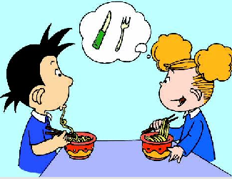
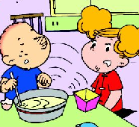
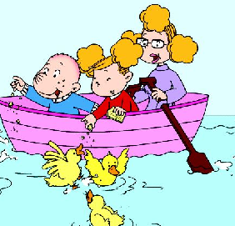
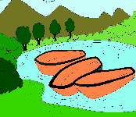
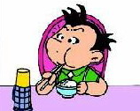

（ ） （ ） （ ） （ ） （ ）
Ⅱ.Listen and tick. (听一听，选一选。) (12%)
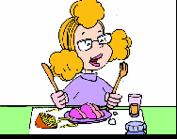

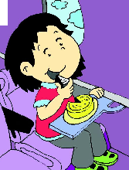
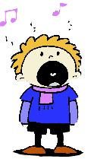
1． 2.

( ) ( ) ( ) ( )

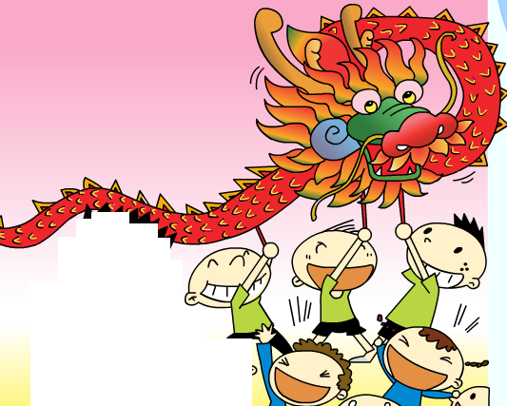
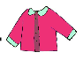
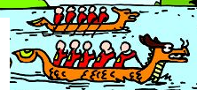
3. 4.

( ) ( ) ( ) ( )
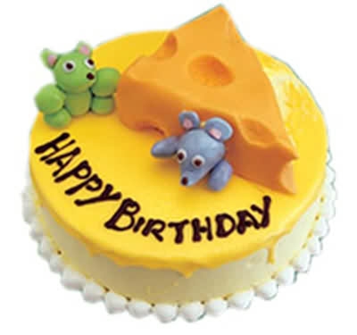
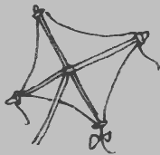
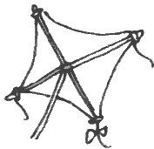
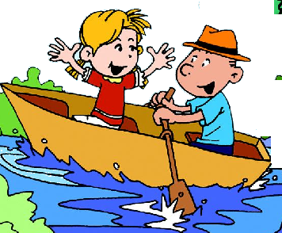
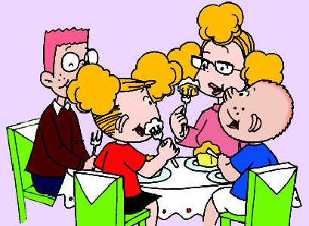
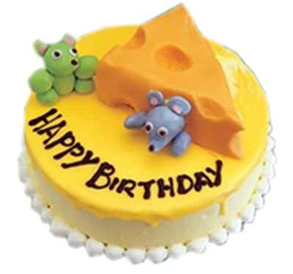
- 6.

( ) ( ) ( ) ( )
Ⅲ. Listen and judge.（听录音，判断图画内容是否与图片一致。）（8%）
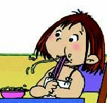

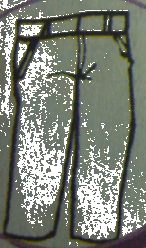
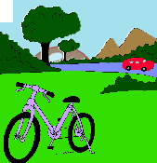

（ ） （ ） （ ） （ ）

Ⅳ. Listen and match.(听一听，连一连) （10%）
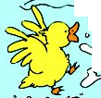

naughty
wet
using hands
English fast food

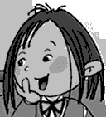
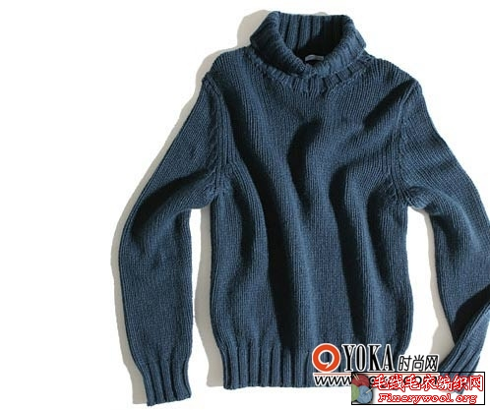
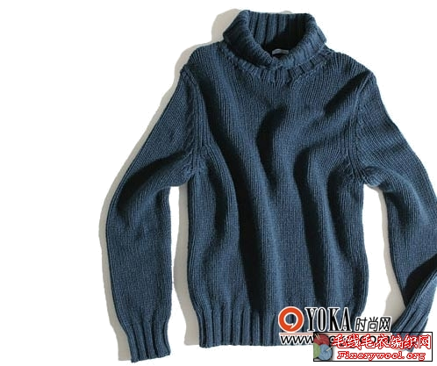

Ⅴ. Listen and tick. (听一听，根据短文内容在相应方框里划“√”) （10%）

 | 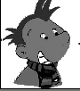 | 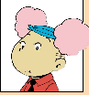

Writing part笔试部分
Ⅵ. Read and number .（按句子顺序给图片标序号）(5%)
1. Mum is watching TV and dad is listening to music.
2. ---Let’s make a cake for mum and dad!
---Yes, Good idea!
3. ---Do you use chopsticks in England?
---No, we don’t. They are hard for English people.
4. ---What are these?
---They are bags.
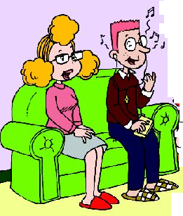
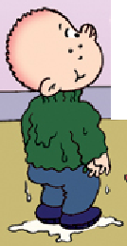
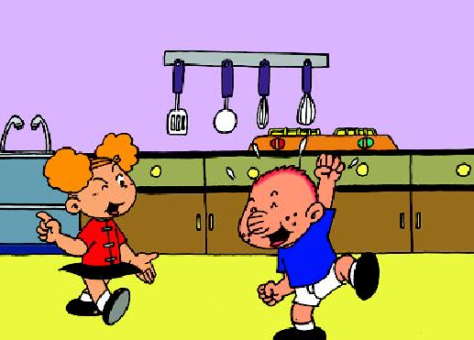
5. Sam’s clothes are wet.
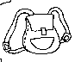
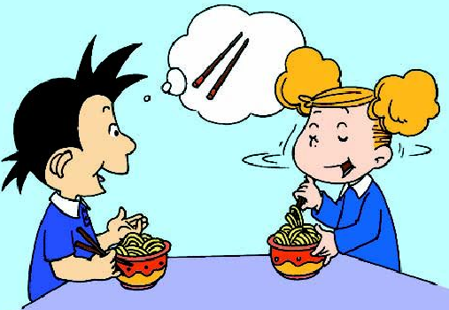

( ) ( ) ( ) ( ) ( )

Ⅶ. Choose and write.(选择所给单词补全句子) (5%)
dragon those these making use working they’re

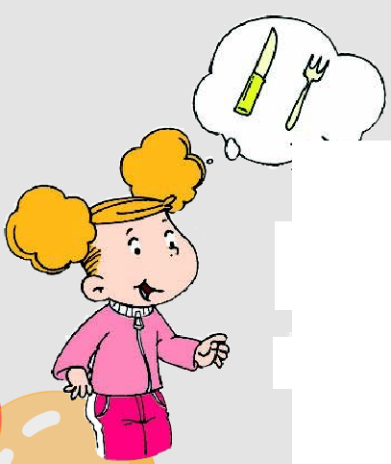
1. We a knife and fork.
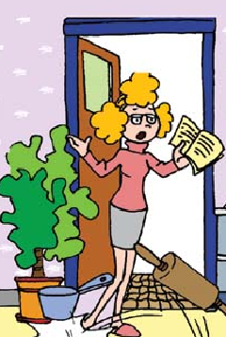
2. Please be quiet. I’m .
3. We’re ________ a cake.
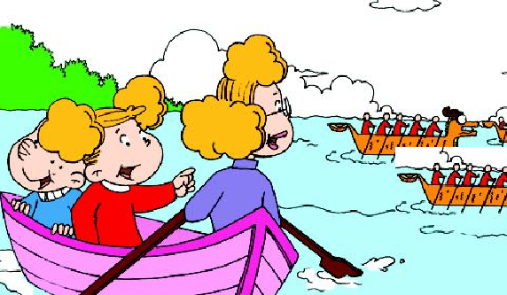
4. ---What are ________?
---They’re _______ boats.

Ⅸ. Read and copy the sentences.（用正确的形式抄写下列句子。）（5%）
- what are those 2. we’re making a cake

- we use a knife and fork 4. please be quiet

- do you use chopsticks in england

Ⅹ.Read and choose.(阅读理解) (5%)
Amy and Daming are having lunch. Daming is eating rice. He is using chopsticks. They are easy for Daming. Amy is eating noodles. She likes noodles. Because(因为)she likes Chinese fast food. But she can’t use chopsticks. Chopsticks are very difficult for Amy. She doesn’t use chopsticks in England. She uses a knife and fork.
1. Daming is eating______
A. rice B.noodles.
2. Does Amy like noodles?
A．Yes, she does. B. No, she doesn’t.
3. _______likes Chinese fast food.
A. Daming B. Amy
4. _______are very difficult for English people.
A. Chopsticks B.Fork
5. Knife and fork are _______ for Chines people.
A.easy B.difficult

Tapescript:
I.
- What are you doing? We are making a cake.
- We use a knife and fork.
- Daming is using chopsticks.
- Let’s feed the ducks.
- These are boats and those are trees.

II.
1. She’s eating a cake with her hand.
2、Look! The girl is running.
3.Those shorts are not wet.
4.They are doing dragon dancing. They’re very happy.
5. ---What are these?
---They’re kites.
6. ---What are they doing?
---They’re rowing a boat.

III.
1. They’re painting.
2. Those are trousers.
3. She is using chopsticks.
4. That is a bike and those are trees.

IV.
1. This duck is naughty.
2. Lingling is using her hands to eat sweets.
3. Father likes English fast food.
4. These sweaters are nice.

V. Module 1 Unit 2

