2009——2010学年度第一学期六年级英语Module6-8综合练习(一)（时间：40分钟）

Listening Part 听力部分
Ⅰ. Listen and choose. 选出听到的单词或词组，并将其前面的字母标号填在题前的括号里。（10%）
( )1. A. difficult | B. different | C. discuss | D. decide
( )2. A. and | B. answer | C. album | D. about
( )3. A. listening | B. watching | C. looking | D. tidying
( )4. A. said | B. saw | C. see | D. say
( )5. A. chocolate | B. chopsticks | C. choose | D. collect
( )6. A. speak | B. bookshelf | C. because | D. special
( )7. A. bamboo | B. basketball | C. book | D. biscuit
( )8. A. copy | B. city | C. clean | D. coconut
( )9. A. address | B. around | C. answer | D. awake
( )10. A. January |  | B. February
C. November |  | D. December

Ⅱ. Listen and tick. 根据录音内容，在相应图片下面的括号里划“√”表示。（10%）


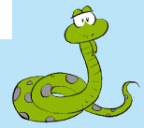

1. 2.

（ ） （ ） （ ） （ ）



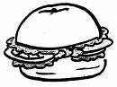
3. 4.

（ ） （ ） （ ） （ ）
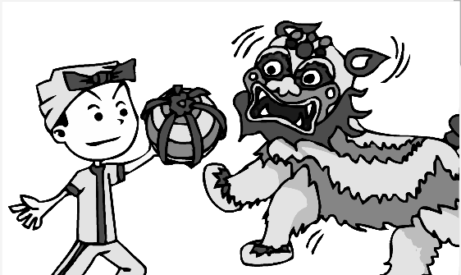

5.

（ ） （ ）

Ⅲ. Listen and choose. 听问句，选答语。（10%）
( ) 1. A. Pandas.
B. Watching TV.
C. Chinese kites.
( ) 2. A. It is awake at night.
B. It eats for eighteen hours a day.
C. It sleeps in the day.
( ) 3. A. He sleeps for five hours.
B. She eats for two hours.
C. I sleep for eight hours.
( ) 4. A. It’s very messy.
B. It’s small.
C. I’ve got some bamboo.
( ) 5. A. I watch TV.
B. I’m tidying my room.
C. He swims very well.
IV．Listen and judge. 听短文，判断句子是否符合短文意思,符合的用“√”表示， 不符合的用“×”表示。（10%）
（ ）1. Daming’s Grandma loves pandas and bamboo.
（ ）2. Pandas don’t eat for very long hours a day.
（ ）3. The CD-ROM says the snakes are deaf.
（ ）4. Snakes can hear the music and dance with it.
（ ）5. Daming and his Grandma are watching his new CD-ROM.
V. Listen and complete. 听录音，补全短文。（10%）
Hi, I’m Xiaofei. This is my _______. He _______ got a ________ kite. He _______ plays with it. This is my sister. She’s _______. I always help her.

Writing Part 笔答部分
- Read and choose. 读一读，选出最佳答案，将其前面的字母标号填在题前的括号里。（10%）
1. ---______________________
---It says that pandas love bamboo.
A. What does it say? B. What are you looking at?
C. Where does it live? D. What does it eat?
2. ---__________ do you swim?
--- I swim every week.
A. How long B. How often C. How old D. How tall
3. I study _________ and sleep _________.
A. at night, in the day B. in the day, at night
4. She’s got ________ kites. She plays with them ________.
A. a lot of, a lot B. a lot, a lot of
5. ---_________ does it sleep?
---It sleeps for eighteen hours a day.
A. When B. How old C. How long D. How often
6. Let’s _______ our room. Then we can play _______ in a _______ room.
A. tidy, well, tidy B. tidying, good, tidy
C. tidy, good, tidying D. tidying, well, tidy
7. A child sleeps _____ eight hours _____ night.
A. of, / B. for, a C. at. a D. from, /
8. This is fantastic! The underlined part can be replaced by ________. (划线部分可由那一项代替？)
A. great B.difficult C. messy D. important
9. Snakes are deaf. They can’t _______.
A. see B. here B. hear D watch
10. ---I can’t find my pencil!
---Don’t worry! ______________.
A. Good idea! B. I like your pencil.
C. I will help you. D. Let’s read.
- Look and write. 看图补全句子，每空填一个单词。（10%）
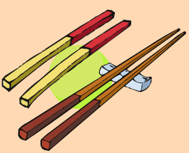
- I’ve got some C________ _________.


- _________ love _________.

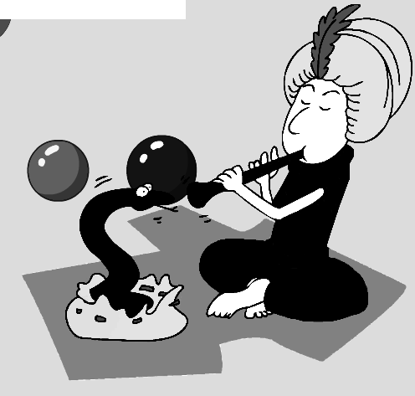
- ________ are ________.
They can’t hear music.
- Have you got a _______ about _________?

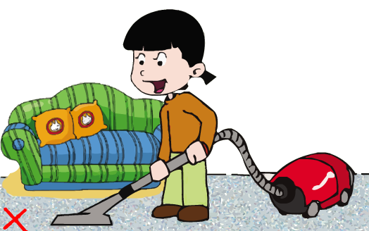
5. --- Do you often ________ your ________?
--- No, I don’t.
- Read and write. 按要求完成句子。（10%）
1. to my little brother / I / read stories / often (连词成句)

2. a day / They / eat / for twelve hours (连词成句)

3. My brother / a Chinese kite / has got (连词成句)

4. Do snakes love music? (请给出肯定回答)
______, they _______.
5. I swim every week. (就划线部分提问)
_______ _______ do you swim?
- Reading. 阅读理解。(共15%)
. Read and judge. 读短文，用“√”“×”判断句子是否符合短文意思。（5%）
Dear Laura,
Thank you for your letter. I haven’t got a book about America. But I have got some photos of New York. Daming sent them! Here in China, our school starts at eight o’clock. It finishes at half past four. What time do American schools start and finish?
Your friend,
Lingling
（ ）1. This letter is from Lingling.
（ ）2. Lingling has got some books about America.
（ ）3. School finishes at four o’clock in China.
（ ）4. Here in China, school starts at half past eight.
（ ）5. Daming sent photos of New York to Lingling.
.Read and choose. 读短文，选择正确答案。（10%）
American schools start in September after a long summer holiday. There are two terms(学期) in a school year: the first term is from September to January, and the second is from February to June. Most American children go to public schools(公立学校).
High school students take only four or five subjects at a time. They usually go to the same classes every day and they have an assignment for every class. After class they have many activities. After high school, many students go to college.
1. Most American children start school in ______________.
A. September B. February C. June D. January
2. How many terms do American children have each year?
A. One. B. Two. C. Three. D. Four.
3. Students in the high school have _______ subjects at a time.
A. four B. five C. six D. four or five
4. Which of the following is false (错误)?
A. In July American students don’t need to go to school.
B. High school students usually have the same classes every day.
C. American students don’t have homework for every class.
D. Most American children go to public schools.
5. After class students ___________.
A. do homework B. go back home
C. have many activities D. go to movies
- Composition.写作（5%）
What do you usually do at home? Do you often tidy your room? Do you often help your mother? 同学们，请介绍并描述一下你经常在家里做的事情。要求：内容充实，语句连贯。不少于30-40个单词。
___________________________________________________

___________________________________________________

___________________________________________________

___________________________________________________

___________________________________________________

___________________________________________________

___________________________________________________
Tapescript:
I. Listen and choose.
1. But they are very difficult for me. A
2. I will answer your questions about America. B
3. What are you looking at? C
4. What does it say about my favorite animals? D
5. You can choose some books. C
6. Do you often tidy your bookshelf? B
7. It says that pandas love bamboo. A
8. Qingdao is a beautiful city. B
9. A fox sleeps in the day and is awake at night. D
10. October comes before November. C
II. Listen and tick.
1. ---What’s the time?
---It’s half past nine.
2. It’s got a very long nose. It’s very strong and heavy. It sleeps for three hours at night. What animal is it?
3. ---Thank you for your book about America.
---You’re welcome. I hope you like it.
4. ---What have you got?
---I’ve got a sandwich. Do you want to eat it?
5. ---Does she often read stories to her brother?
---Yes, she does.
III. Listen and choose.
1. What animal do you love?
2. When does it sleep？
3. How many hours do you sleep a night?
4. Is it big or small?
5. What do you often do at the weekend?
IV. Listen and judge.
Module 7 Unit 1
V. Listen and complete.
Hi, I’m Xiaofei. This is my brother. He has got a Chinese kite. He often plays with it. This is my sister. She’s deaf. I always help her.

