市南区2009——2010学年度第一学期六年级英语综合练习(一)（时间：40分钟）

Listening Part 听力部分
Ⅰ. Listen and choose. 选出听到的单词或词组，并将其前面的字母标号填在题前的括号里。（10%）
( )1. A. bamboo | B. basketball | C. book | D.biscuit
( )2. A. city | B. clean | C. copy | D. coconut
( )3. A. listening | B. watching | C. looking | D. tidying
( )4. A. says | B. saw | C. said | D. see
( )5. A. chocolate | B. chopsticks | C. choose | D. collect
( )6. A. sorry | B. worry | C. merry | D.hurry up
( )7. A. line | B. left | C. right | D. around
( )8. A. tired | B. angry | C. thirsty | D. hungry
( )9. A. address | B. around | C. answer | D. awake
( )10. A. December |  | B. October
C. September |  | D. November

Ⅱ. Listen and tick. 根据录音内容，在相应图片下面的括号里划“√”表示。（10%）
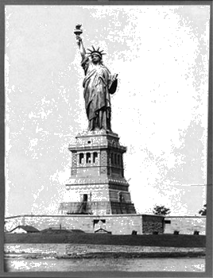
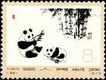

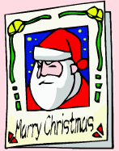
1. 2.

（ ） （ ） （ ） （ ）
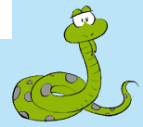

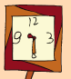
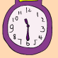
3. 4.

（ ） （ ） （ ） （ ）

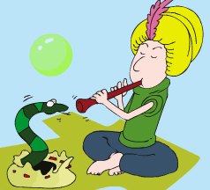
5.

（ ） （ ）

Ⅲ. Listen and choose. 听问句，选答语。（10%）
( ) 1. A. He’s going to read books.
B. She is reading books.
C. He reads books.
( ) 2. A. It plays at night.
B. It eats for eighteen hours a day.
C. It sleeps in the day.
( ) 3. A. I’ve got some Chinese chopsticks.
B. He’s got a kite.
C. Yes, I have.
( ) 4. A. I like jumping.
B. She likes walking.
C. He likes playing.
( ) 5. A. They want to go to the shop.
B. I want to go to the library.
C. Yes, I do.
IV．Listen and judge. 听短文，判断句子是否符合短文意思,符合的用“√”表示， 不符合的用“×”表示。（10%）
（ ）1. Simon and her mum never come to the park.
（ ）2. They want to have a pinic in the park.
（ ）3. Simon and Daming ate some hamburgers.
（ ）4. Mum forgot to bring any drinks.
（ ）5. Daming and Simon like to drink the water in the park.
V. Listen and complete. 听录音，补全短文。（10%）
Amy cleans her room every day. She doesn’t like _______ in a _______ room. But she doesn’t often _______ her _______. So she can’t _______ her books. Lingling will help her.

Writing Part 笔答部分
- Read and choose. 读一读，选出最佳答案，将其前面的字母标号填在题前的括号里。（10%）
（ ）1.How __________ is it? It’s five li.
A. many B. old C. long D. much
( ) 2. She can speak very________.
A. will B. good C. much D. well
( ) 3. _______ are you doing? I’m reading a book.
A. Why B. What C. When D. Where
( ) 4.Tom, Sam and I_______ have got Chinese stamps.
A. both B. are C. all D. is
( ) 5. We need _______ sleep every day.
A. on B. for C. of D. to
( ) 6. Can you tell________ more about American festivals?
A. he B. him C. she D. his
( ) 7. ____________ your ice-cream.
A. Here is B. Here are C. Is here D. Are here
( ) 8.We’ve got ___________ very tall and big buildings in Qingdao!
A. a lot of B. lot of C. a lot D. a lots of
( ) 9. --- _________ do you tidy your bookshelf?
--- Every day.
A. How long B. How old
C. How often D. How many
( ) 10. My little brother likes __________ his thumb.
A. suck B. sucking C. sucks D. sucked

- Look and write. 看图补全句子，每空填一个单词（10%）
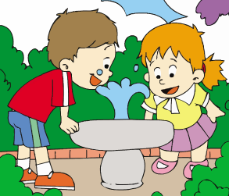
- It’s _____ to ________ this way.

- I often ______ ________ to my cousin.

(读故事)

- My brother ______ ______


a Chinese kite.
4. We give ________ and

send _______ at Christmas.
5. Do you want to ______ the UN ________?
- Read and write. 按要求完成句子。（10%）
1. like / does / Simon / football / playing (连词成句)

2. a day / they / eat / for twelve hours (连词成句)

3. bring / drinks / I / any / didn’t(连词成句)

4. Do Xiaoqiang like painting? (请给出肯定回答)
______, he _______.
5. The UN wants to make peace in the world.(就划线部分提问)
_______ does the UN want to do?
- Reading. 阅读理解。(共15%)
. Read and judge. 读短文，用“√”“×”判断句子是否符合短文意思。（5%）
Lingling has got a letter from her pen pal, Laura. Laura is Daming’s new friend. She is from New York. She has got long, red hair and blue eyes. She likes Chinese food and has got some Chinese food. Laura’s brother likes playing with kites a lot. And he has got a bird kite.
（ ）1. Lingling has got a letter from Daming.
（ ）2. Daming is Laura’s new friend.
（ ）3. Lingling has got long, red hair and blue eyes.
（ ）4. Laura likes Chinese food.
（ ）5. Laura’s brother likes playing with chopsticks.
.Read and choose. 读短文，选择正确答案。（10%）
On Christmas Eve ---the night before Christmas Day children are very happy. They put their stockings at the end of their beds before they go to bed. They want Father Christmas to give them some presents.
Mr Green tells his children that Father Christmas is a very kind man. He comes on Christmas Eve. He lands on top of each house and comes down the chimney into the fireplace and brings them a lot of present.
Christmas Day always begins before breakfast. The children wake up very early. They can’t wait to open the presents in their stockings. Then they wake up their parents and call: Merry Christmas!’’
Do you know what Christmas means? Christmas Day is the birthday of Jesus Christ. When Christ was born, many people gave him presents. So today, people still do the same thing to each other.
1. Christmas Eve is _____.
A . the night before December 24
B. the night after December 25
C . the night of December 25
D. the night of December 24
2. Father Christmas often puts the presents_____.
A. into children’s hats B. into children’s stockings
C. under children’s beds D. into children’s shoes
3. Father Christmas comes into the house through the___.
A. window B. front door C. chimney D. back door
4. On the morning of Christmas Day, children wake up their parents very early and say____.
A. Good morning! B. Happy New Year!
C. Best wishes for you! D. Merry Christmas!
5. “Father Christmas” means _________.
A. 圣诞爸爸 B. 圣诞雪橇 C. 圣诞礼物 D. 圣诞老人
- Composition.写作（5%）
作文：美国总统奥巴马来到我们中国访问，对于我们即将来临的春节非常感兴趣。请你为他介绍一下我们平时过年的习俗以及今年过春节的设想，也可以介绍一下以往春节中难忘的事情。字数30—40个单词。
___________________________________________________

___________________________________________________

___________________________________________________

___________________________________________________

___________________________________________________

Tapescript:
- Listen and choose.
- Pandas love bamboo. A
- This water is very clean. B
- What is he doing? He’s tidying his bookshelf. D
- It says snakes are deaf. A
- You can choose some books. Then we can read them together. C
- Hurry up and clean your shoes! D
- Turn left! B
- I’m thirsty. Let’s have a drink. C
- This is her address. You can write to her. A
- Thanksgiving is a very important festival. It’s in November.
D
- Listen and tick.
- We give presents on Christmas. 2
- This stamp is from China. 1
3. The elephant sleeps for three hours a night. 2
- What time is it? It’s half past nine. 1
5. Look! The snake is dacing. 2
III. Listen and choose.
1. What is he going to do? A
2. When does it sleep? C
3. What has he got? B
4. What does she like doing? B
5. Do you want to go to the library? C
IV. Listen and judge.
Module 10 Unit 1
V. Listen and complete.
Amy cleans her room every day. She doesn’t like playing in a messy room. But she doesn’t often tidy her bookshelf. So she can’t find her books. Lingling will help her.

