2009-2010市南区2009——2010学年度第一学期六年级英语综合练习(三)（时间：40分钟）

Listening Part 听力部分
Ⅰ. Listen and choose. 选出听到的单词或词组，并将其前面的字母标号填在题前的括号里。（10%）
( )1. A. parent | B. post | C. park | D. presents
( )2. A. room | B. bed | C. bookshelf | D. sofa
( )3. A. shop | B. restaurant | C. Chinatown | D. America
( )4. A. family | B. February | C. Easter | D. festival
( )5. A. England | B. Canada | C. Australia | D. English
( )6. A. sending | B. painting | C. tidying | D. reading
( )7. A. 25th of December |  | B. 24th of December
C. 25th of November |  | D. 26th of October
( )8. A. a birthday party |  | B. a birthday card
C. a birthday cake |  | D. a birthday present
( )9. A. make peace |  | B. love peace
C. make biscuits |  | D. make a cake
( )10. A. at night |  | B. in the day
C. in the morning |  | D. at the weekend
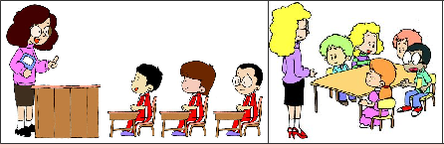

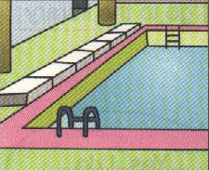


Ⅱ. Listen and tick. 听句子，在相应图片下面的括号里划“√”表示。（10%）
( ) ( )
1.
2.
3.
( ) ( ) ( ) ( )
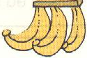
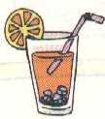
4. 5.

（ ） （ ） （ ） （ ）
Ⅲ. Listen and choose. 听问句，选答语。（10%）
( )1.A. It’s more than one metre high.
B. It’s more than ten thousand li long.
C. It’s more than 5,000 years old.
( )2. A. We ate in a Chinese restaurant.
B. We are going to eat in an English restaurant.
C. We are going to eat at half past 11.
( )3.A. He is going to go to the UN building.
B. He went there by car.
C. He went there last weekend.
( )4.A. Yes，they do.
B. Yes，she does.
C. Yes，it does.
( )5. A. Yes, we have.
B. No, he doesn’t have it.
C. Yes, she has.
IV. Listen and fill in the blanks. 听录音，填上所缺单词，补全句子或对话。(10分)
A: What are you doing?
B: I’m my new stamps into my .
I like stamps a lot.
A: What’s this stamp about?
B: It’s about Thanksgiving. Thanksgiving is my . __________ are together. We have a big , special dinner.
A: Oh, it’s nice. Who gave it to you?
B: Daming. He can .He has got some . He visited the UN last year.
V. Listen and judge. 听短文，判断句子是否符合短文意思,符合的用“√”表示， 不符合的用“×”表示。（10%）
( ) 1. The letter is from Daming.
( ) 2. Laura met Daming in New York.
( ) 3. Lingling has got long , rend hair.
( ) 4. Chinese chopsticks aren’t difficultfor laura.
( ) 5. New York is a very big city.
Writing Part 笔答部分
- Read and choose. 读一读，选出最佳答案，将其前面的字母标号填在题前的括号里。（10%）
( ) 1. Can you tell me _____ the Summer Palaca?
A. of B. to C. about D. in
( ) 2. ____ he got ____ stamps from China?
A. Have , any B. Has, any C. Has, lot D. Have, some
( ) 3. Do you live here ____ are you visiting?
A. and B. all C. of D. or
( ) 4. ---Look at the building. How old is it?
---It’s _______ years old.
A.two hundreds B. hundreds C. hundreds of D. hundred
( ) 5. We can write ____ Lingling _____ Chinese.
- to, in B. to, about C. about, of D. of, in
( ) 6. Last year I ____ to England.
And now I’m ____English.
A. go, learning B. went, learn
C. go, learn D. went, learning
( ) 7. A child for eight hours a night.
A. sleeps B. sleeping C. sleep D. eat
( ) 8. It’s fun _________
  - playing football B. to play football
C. play football D. played football
( ) 9. She ______. Let’s _____ together.
A. likes singing, sing B. like singing, sing
C. likes sings, sing D. like sings, sing
( ) !0. What do you say on Christmas? We say _____.
- Thank you. B. Happy New Year
C. Merry Christmas. D. You’re welcome.
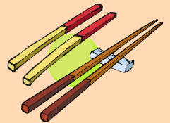
VII.Look and write. 看图补全句子，每空填一个单词。（10%）
1. I’ve got some _______ _______.
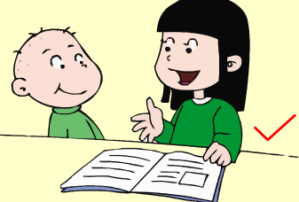
(中国筷子)
2. She often ______ _______ to her little brother.
（读故事）
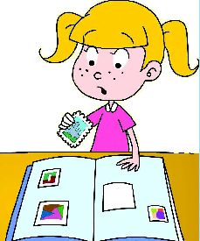
3. --- What are you doing?
--- I’m ______ my new stamps into my _______.
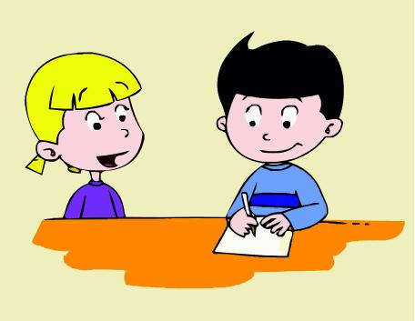
Hello!
4. She can ________ some ________.

5. Pandas eat for ______ ______ a day.
（12小时）

- Read and write. 按要求完成句子。（10%）
1. some / I’ve got / Chinese chopsticks (连词成句)

2. tell / me / you / Can / American festivals / about (连词成句)

3. make peace / The UN / wants to / in the world (连词成句)

4. Can I write to her? (请给出否定回答)
______, you _______.
5. He likes painting. (就划线部分提问)
_______ does he like?
- Reading. 阅读理解。(共15%)
. Read and judge. 读短文，用“√”“×”判断句子是否符合短文意思。（5%）
Lingling and Amy are in Amy’s room. Amy is tidying her room. She tidies her room every day. She thinks she can play well in a tidy room. She can’t play in a messy room. But she doesn’t often tidy her bookshelf. So it’s very messy. She can’t find her books. Lingling helps her to tidy her bookshelf. Now the books are tidy. Amy will choose some books, then they will read them together.
( )1.Amy is tidying her room.
( )2.Amy and Lingling like to play in a messy room.
( )3.Amy tidies her room every day.
( )4.Amy’s bookshelf is very clean.
( )5.Lingling is a helpful girl.
.Read and choose. 读短文，选择正确答案。（10%）
The Chinese New Year is the most important holiday for the Chinese people. It is the first day of the first lunar month. People prepare（准备） for the New Year about fifteen days.
It is an important time for the family. The younger people bow(鞠躬) to the older people. The Chinese call this Kou You or kowtow. This means to touch the ground with the forehead(前额).Then the older people give children presents of money in red envelopes(信封)。The family then goes to sleep.
In the morning people dress in their best clothes. Some people stay at home, others go out to pay a New Year call. They are very polite（有礼貌的） and do not use bad words. It’s the most important day of the year.
( )1. What is the most important holiday for the Chinese people?
A. The Chinese New Year. B. Christmas. C. Thanksgiving
( )2. How long do the Chinese people prepare for the New Year?
A.Ten days. B. About half a month. C. About a week.
( )3. For whom(谁) is this an important time?
A. The younger people. B. The older people.
C. The family.
( )4. After the younger people bow to the older people to show respect, the can get____.
A. some food B. some beautiful envelopes
C. some money in red envelopes
( ) 5. What does “pay a New Year call” mean?
A.安装新电话 B.付钱打电话 C.拜年
- Composition.写作（5%）
Write an email to your pen pal.
给你的笔友用英文一封信，介绍一下你喜欢做的事情，你平常在家里经常做的事情，以及你想做的事情。
What do you like doing?What do you usually do at home?
And what do you want to do?
要求：内容充实，语句连贯。字数30-40个单词。
___________________________________________________

___________________________________________________

___________________________________________________

___________________________________________________

___________________________________________________

___________________________________________________

录音内容及答案
I. Listen and choose.
1. At Christmas, people give presents and send cards. D
2. Do you often tidy your bookshelf？C
3. We ate noodles in a Chinese restaurant. B
4. Halloween is my favourite festival. D
5. Have you got a book about England? A
6. I like painting.What do you like doing？ B
7.Christmas is on the 25th of December. A
8. He is eating a birthday cake. C
9. The UN wants to make peace in the world. A
10.What do you do at the weekend？ D
II. Listen and tick.
1.In our class, children sit in lines. 1
2. – What do you often do at the weekend? -- 2
I often go swimming.
3. --Tell me more about this place. –
It’s a museum. The clock is fifty metres high. 2
4. – Do you bring any drinks? -- Yes. Here’s some orange juice.
2
5. Does the kangaroo like jumping? Yes, it jumps every day.
2
IV. Listen and choose.
- How long is the Great Wall?
- Where are we going to eat?
- When did Simon go to the UN building?
4. Do pandas love bamboo？
5. Has she got a Chinese bird？
V. Listen and fill in the blanks.
A: What are you doing?
B: I’m putting my new stamps into my album.
I like collecting stamps a lot.
A: What’s this stamp about?
B: It’s about Thanksgiving. Thanksgiving is my favorite. Families are together. We have a big , special dinner.
A: Oh, it’s nice. Who gave it to you?
B: Daming. He can speak Chinese. He has got some chopsticks. He visited the UN building last year.
V. Module 6 Unit1
出题人：贵州，朝城，定陶

