市南区2009——2010学年度第一学期六年级英语综合练习(十)（时间：40分钟）

Listening Part 听力部分
Ⅰ. Listen and choose. 选出听到的单词或词组，并将其前面的字母标号填在题前的括号里。（10%）
( )1. A. tell | B. tall | C. well | D. fell
( )2. A. next | B. need | C. near | D. nearly
( )3. A. eight | B. lake | C. ate | D. late
( )4. A. they | B. there | C. them | D. their
( )5. A. quite | B. quick | C. quiet | D. quit
( )6. A. any | B. many | C. tidy | D. sorry
( )7. A. millions of |  | B. hundreds of
C. thousands of |  | D. ten million
( )8. A. wear B. here |  | C. hair D. hear
( )9. A. in the day |  | B. in the tree
C. in the street |  | D. on the way
( )10. A. went B. won’t |  | C. want D. what


Ⅱ. Listen and tick. 根据录音内容，在相应图片下面的括号里划“√”表示。（10%）
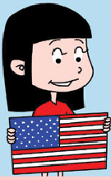

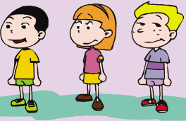
- 2

( ) ( ) ( ) ( )
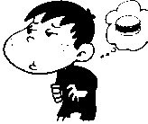


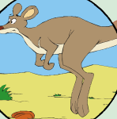
- 4.

( ) ( ) ( ) ( )
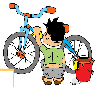

5.

( ) ( )
Ⅲ. Listen and choose. 听问句，选答语。（10%）
( ) 1. A. Yes, they are on the wall. B. Yes, there are.
C. No, there is a picture on the wall.
( ) 2. A. I’ve got a computer. B. Yes, I have.
C. No, I haven’t got a computer .
( ) 3. A. It’s ten thousand li tall .
B. It’s fifty metres tall. C. It’s five metres long.
( ) 4. A. Yes, he’s putting the new stamps into his album.
B. Yes, she is. C.. He’s putting his stamps into his album.
( ) 5. A. Yes , she can. B. She can write a letter.
C. Of course she is.

IV．Listen and judge. 听短文，判断句子是否符合短文意思,符合的用“√”表示， 不符合的用“×”表示。（10%）
( ) 1. Lingling is tidying her room.
( ) 2.The room is messy.
( ) 3. Amy tidy her bookshelf every day.
( ) 4. Children can play in a tidy room, but can’t play in
a messy room.
( ) 5. Lingling is helpful.
V. Listen and complete. 听录音，补全短文。（10%）
Daming and Simon _________ to a park. Simon and his mum ________ there often. They ________ a picnic. Simon _______ hungry and Daming ______ thirsty. Simon’s mum _____ the boys their sandwiches. The boys _________, “Thank you.” Simon’s mum ______ to bring any drinks. The boys ________ water. It _________ good.
Writing Part 笔答部分
VI. Read and choose. 读一读，选出最佳答案，将其前面的字母标号填在题前的括号里。（10%）
( ) 1. A child for eight hours a night.
A. sleeps B. sleeping C. sleep
( ) 2. Mr Smart ______ got _____ email from Tom.
A. was an B. has an
C. has a D. have an
( ) 3. There lots of books about America.
A. were B. is C. was D. have
( ) 4. Last week we to Haitian Hotel.
A. go B. ate C. went D. visited
( ) 5. --- did you do on Mid-Autumn Day?
--- I the bright moon and ate moon cakes.
A. What watch B. When watched
C. What watched D. Where watch
( ) 6. I’m . I want to eat a sandwich.
A. thirsty. B. tired C. hungry
( ) 7. What is Amy________? She’s ________ emails.
A. do… sends B. doing…sends C. doing…sending
( ) 8. ---Who is he? ---He’s my ____
A. cousin B. sister C. brothers D. aunt
( ) 9. We say thank you ______ all the good things.
A. at B. of C. for D. from
( ) 10. Our school starts nine o’clock.
A. in B. on C. at

VII. Look and write. 看图补全句子，每空填一词（10%）
1. There is a in New York.

We ate in a Chinese .
2. are together.

We have a big, dinner.
3. This is my sister.

She likes .
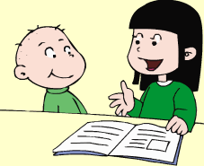

4. ---I often ______ ______ to my little______.

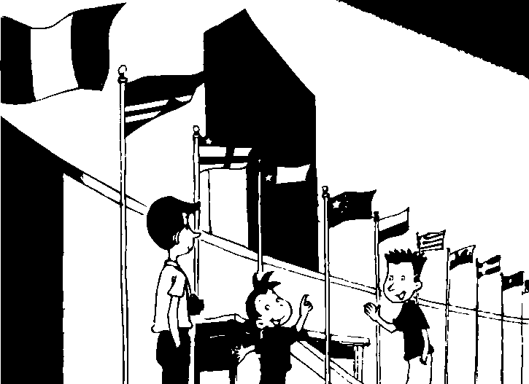
5. Do you want to _______ the UN ______?

Yes, I ______.

VIII. Read and write. 按要求完成句子。（10%）
1. . stories / to / I / my / read / little / brother(连词成句)

2. me / festivals / about / you/ Chinese / can / tell (连词成句)

3. American /an /I / pen pal/ want (连词成句)

4. Has he got a book about America? (请给出否定回答)
______, I _______.
5. Pandas eat bamboo for 12 hours a day. (就划线部分提问)
_______ _______do pandas eat a dayl?
IX. Reading. 阅读理解。(共15%)
. Read and judge. 读短文，用“√”“×”判断句子是否符合短文意思。（5%）
Simon is putting his new stamps into his album. These stamps are from Canada, England. And the old ones are from America. He hasn’t got stamps from China. Because Daming doesn’t send him letters. Daming doesn’t collect stamps. But he gets some American and Canadian stamps from Simon . And Simon gives him a book, too. Daming can make an album with this book. Now they can both have stamp albums.
( ) 1. Simon collects stamps.
( ) 2. The stamps from America and Canada are very old.

( ) 3. Simon can get Chinese stamps from Daming.
( ) 4. Simon gives Daming some stamp albums.
( ) 5. So Daming has some stamps from England.
.Read and choose. 读短文，选择正确答案。（10%）
Carol is from America. She can speak some Chinese because her mother is Chinese. She’s writing a letter to her cousin in China. It’s about her favourite festival. It’s Christmas. It’s on the 25th of December. People give presents and send cards. There are Christmas trees and lights everywhere. They will have a lot of fun.
( ) 1. What can Carol speak?
  - English.
  - Chinese.
  - Both A &B.
( ) 2. Where does her cousin live?
A. China. B. Canada. C. America.
( ) 3. When is Carol’s favourite festival?
- It’s in autumn.
- It’s on the 25th of December.
C. It’s in January.
( ) 4. Will Carol get a present on that day?
- Yes, he will.
- No, she won’t.
- Of course she will.
( ) 5. What can you see on that day?
- I can see Christmas trees and lights.
- They can see my cousin.
- She can sing a song.
- Composition. 写作（5%，假如你的朋友叫Mike,请你以My Friend为题，可以根据以下的提示写写你的朋友，语句连贯，30-40个单词。）
What’s your friend’s name?
What can he\she do?
What food does he / she love?
What does he / she like doing?

What does he / she often do at the weekend?
other things (其他的事情)

My Friend

2009-2010学年度第一学期
英语学科六年级期中测查听力材料
Tapescript:
I. Listen and choose.
1. Can you tell me, haven’t you got such buildings in China?
2.They need to help.
3. We ate in a restaurant.
4. There are some teachers.
5. Be quiet!
6. There are many big buildings!
7. There are millions of stones there!
8. What can you hear?
9. When does it sleep? In the day!
10. We want to go there!
A B C B C B A D A C

II. Listen and tick.
1. It wants to make peace.
2. don’t make so much noise!
3. I am hungry, here you are!.
4. It likes jumping! Guess what is it?
5. I like tidying my bike!.
2 1 2 2 1

III. Listen and choose.
1. Is there a map on the wall ?
2. Have you got a computer ?
3. How tall is the big building ?
4. Is your cousin tidy his new stamps?
5. What can she do?
C C B A B

IV. Listen and judge.
Module 8 Unit 1
× × × √ √

V. Listen and complete.
Daming and Simon went to a park. Simon and his mum come there often. They had a picnic. Simon was hungry and Daming was thirsty. Simon’s mum gave the boys their sandwiches. The boys said, “Thank you.” Simon’s mum forgot to bring any drinks. The boys drank water. It tasted good.

