市南区2009——2010学年度第一学期六年级英语综合练习(十四)（时间：40分钟）
（时间：40分钟 总分:100分）

Listening Part 听力部分
Ⅰ.Listen and choose. 请选出你所听到的单词或词组，并将其前面的字母标号填在题前的括号里。（10分）
( )1. A. send | B. sent | C. egg | D.sandwich
( )2. A. park | B. restaurant | C. theatre | D. museum
( )3. A.bamboo | B. baby | C.deaf | D. panda
( )4. A. Friday | B. Tuesday | C. Sunday | D. Monday
( )5. A. stamp | B. shirt | C. photo | D. story
( )6. A. 25th of December |  | B. 24th of December
C. 25th of November |  | D. 26th of October
( )7. A. make a cake |  | B. love peace
C. make biscuits D. make peace
( )8. A. row a boat B. jump high
C. climb the mountain D. play the violin
( )9. A. in the street B. in a tree
C. in a lake D. in the classroom
( )10. A. in the day B. in the morning
C. at night D. at the weekend
Ⅱ. Listen and tick. 请根据听到的内容用“√”勾出相应的
图片。(10分)
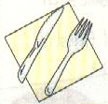
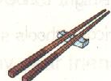
1. 2.
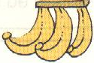

（ ） （ ） （ ） （ ）
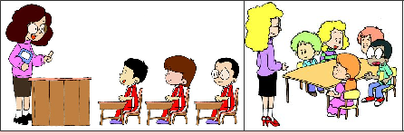

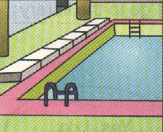


( ) ( )
3.
4.
5.
( ) ( ) ( ) ( )

Ⅲ. Listen and choose. 听问句，选答语。（10%）
( )1. A. He is swimming in the sea.
B. He went swimming last weekend.
C. He often goes swimming.

( ) 2. A. I went to Chinatown yesterday.
B. I go swimming.
C. I saw Chinese dancing.
( ) 3. A.He sleeps at night.
B.He sleeps at nine o’clock.
C. He sleeps for eight hours a day.
( ) 4. A. We have a big special dinner.
B. I sang and danced.
C. I’m climbing a high mountain.
( ) 5. A.He is tall and strong.
B.He likes pandas.
C. He likes playing computer games.

IV. Listen and judge. 听短文，判断句子是否符合短文意思,符合的用“√”表示， 不符合的用“×”表示。（10%）
（ ）1.This is a letter from New York.
（ ）2. Lingling has got long, red hair.
（ ）3. Laura likes Chinese food.
（ ）4. Daming has got a Chinese kite.
（ ）5. Laura is from New York.

Ⅴ. Listen and fill in the blanks.
Dear Lingling，
Thank you for your letter. I have got a Chinese stamp. There is a _______ in it. It’s eating _______. It’s so lovely. And I have got an American stamp for you. It’s a picture of the UN________. It tells us that people in the ________want _________ .
Your friend,
Laura
Writing Part 笔答部分
- Read and choose. 读一读，选出最佳答案，将其前面的字母标号填在题前的括号里。（10%）
1. What did you see? I ______ Chinese ________.
A. see, dance B. see, dancing
C. seeing, dance D. saw, dancing
2. The Great Wall is more than two thousand years ________.
A. old B. long C. tall D. big.
3. Have you got _____ stamps from America?
A. a B. any C. lot D. an
4. ______ your father like _______? No, he doesn’t.
A. Do … sing B. Does … singsing
C. Do … singing D. is … singing
5. How long does it sleep? _________.
A. It likes sleeping. B. It sleeps in the day.
C. Ten hours. D.At night.
6. It’s fun to _________ this way.
A. played football B. eat food C. drank water D. singing songs
7. Let’s ______ together. It’s a good idea.
A. reading boos B. watch TV C. went swimming D. playing
8. Sam’s brother doesn’t often _______.
A. tidy his room B. tidies his room
C. tidying his room D. tidied his room
9. I’m from ________. But I can speak _____.
A. English, Chinese B. England, China
C. China, English D. Chinese, England
10. I can write _____ Amy _______English.
A. in, to B. to, from
C. for, in D. to, in

- Look and write. 看图补全句子，每空填一个单词。（10%）
- ---Do you often _______ your room?
-- Yes, I _______.


- --- This water is _________.
--- It’s ________ to drink this way.

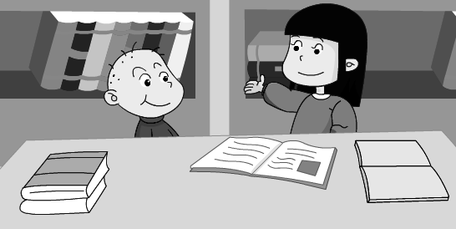
- I often _________ __________ to my little
brother.

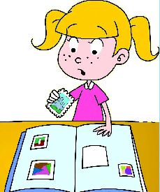
- --- What are you doing?
--- I’m ______ my new stamps into my _______.
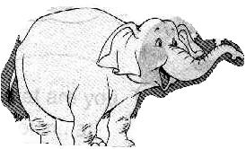
5. --- How _______ _______ it sleep?
--- It sleeps for eighteen hours a day.

- Read and write. 按要求完成句子。（10%）
1. snakes / do /music/ love (连词成句)

2. has got /Amy’s brother /a / kite/ Chinese (连词成句)

3. write/her /can/you/ to / in Chinese(连词成句)

4. Can you tell me about American festivals? (请给出肯定回答)
______, I _______.
5. Pandas love bamboo. (就划线部分提问)
_______ do pandas love?
- Reading. 阅读理解。(共15%)
. Read and judge. 读短文，用“√”“×”判断句子是否符合短文意思。（5%）
A child sleeps for eight hours a night.
A baby sleeps for sixteen hours a day.
A fox sleeps in the day and is awake at night.
（ ）1. Children sleep for eight hours a night.
（ ）2. A baby sleeps for six hours in the day.
（ ）3. A baby is awake for eight hours a day.
（ ）4 .A fox only sleeps in the day.
（ ）5. A fox doesn’t sleep at night.
.Read and choose. 读短文，选择正确答案。（10%）
Spider
There are lots of different spiders. There are big ones and small ones ,fat ones and thin ones. Some are brown, some are black, some are orange and some are red. Spiders live in parks and streets.They live in the trees and mountains … You can see them everywhere(到处).They have eight eyes and eight legs. They like eating insects(昆虫类).Some of them even(甚至)can eat birds or snakes. They usually eat one or two meals a month. Sometimes they can’t eat even for two months. Spiders are good or bad for humans（人类）. Some people have pet spiders.
1. The spiders aren’t_____.
A. different B. difficult C.the same D. some
2. How many eyes do spiders have ?
A. Eighteen B. Eight. C. Eighth. D. Eighty
3. Spiders have different ___________.
A. bodies B. children C. colours D. arms
4. They like eating____________.
A. birds B. snakes C. insects D. frogs
5. They have one or two meals________.
A. a year B. a day
C. a week D. a month
- Composition.写作（5%）
What do you usually do at the weekkend? Do you often tidy your room? Do you often help your mother? 同学们，请介绍并描述一下你经常在周末做的事情。要求：内容充实，语句连贯。不少于30-40个单词。
___________________________________________________

___________________________________________________

___________________________________________________

___________________________________________________

___________________________________________________

___________________________________________________

___________________________________________________

六年级英语综合练习题参考答案
Ⅰ.Listen and choose.
1. Daming sent Lingling photos of New York. B
2. We ate in a restaurant. B
3. Pandas love bamboo. A
4. Where did you go last Tuesday? B
5. This is my favourite story. D
6. Christmas is on the 25th of December. A
7. The UN wants to make peace in the world. D
8. It’s fun to row a boat. A
9. It lives in a tree. B
10. A fox sleeps at night. C

II. Listen and tick.
1. – What have you got? -- I’ve got a knife and fork.
2. – Do you bring any drinks? -- Yes, I bring some orange juice.
3. In our class, children sit in line.
4. – What do you often do at the weekend? -- I often play computer games.
5. --Tell me more about this place. – It’s a museum. The clock is fifty metres high.

III. Listen and choose.
1. What does he often do on the weekends? C
2.Where did you go yesterday? A
3.How long does it sleep？ c
4. What do you do on Christmas? a
5.What does he like doing? c

IV. Listen and judge.
Module 6 Unit 1
√ × √ × √
Ⅴ. Listen and fill in the blanks.
Dear Lingling，
Thank you for your letter. I have got a Chinese stamp. There is a panda on it. It’s eating bamboo. It’s so lovely. And I have got an American stamp for you. It’s a picture of the UN building. It tells us that people in the world want peace.
Your friend,
Laura

