2009-2010学年度第一学期三年级英语期末综合练习
School______ Class ______ Name______ Assessment______
Listening Part 听力部分
Ⅰ. Listen and number. (听一听，排一排)(10%)



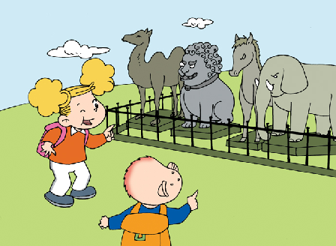


( ) ( ) ( ) ( ) ( )

Ⅱ. Listen and tick. (听一听，选一选。) (12%)


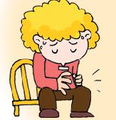
- 2.

（ ） （ ） ( ) ( )





3. 4.

（ ） （ ） ( ) ( )

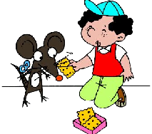


5. 6.

( ) ( ) ( ) ( )

Ⅲ. Listen and judge.（听录音，判断听到的内容是否与图片一致。）（8%）





1. 2. 3. 4.

（ ） （ ） （ ） （ ）

Ⅳ. Listen and match.(听一听，连一连) （10%）
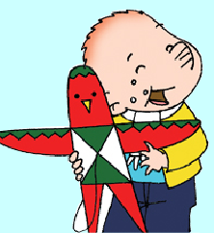

My father is a driver.

I’ve got a new kite.


There are three cats.

Have you got a test today?

Ⅴ. Listen and draw “√”.（请根据听到的内容在相应的表格里画“√”。）（10%）
 | stomach ache. | cough | cold
Peter
Amy
Sam
Lingling
Daming

Writing Part笔试部分

Ⅵ. Read and number .（按句子顺序给图片标序号）(5%)
1. There are two camels.
2. These are shorts.
3. Have you got a cold?
4. This bird can fly.
5. I’m going to see Sun Wukong.





( ) ( ) ( ) ( ) ( )

Ⅶ. Choose and write.(选择所给单词补全句子) (5%)

biscuits, , high jump, stomache ache, pet, camel


1. Amy is going to do _________ .

2. Have you got a _________?
Yes, I have.
- There is a ________.

- She’s got a ________fish.


- Can I have these _________? Yes, you can.

Ⅸ. Read and copy the sentences.（用正确的形式抄写下列句子。）（5%）
1. can I have an ice cream please

2. how many people are there in your family

3. i am going to run a race

4. are you going to go to hong kong

5. sam and amy’s clothes are wet

Ⅹ. Read and choose.(阅读理解) (5%)
Hello, I’m Daming. I am going to go to Hainan with my Mum tomorrow. We’re going to go by plane. And I’m going to swim in the sea. But my mother can’t swim. She’s ill. She’s got a cold. She is going to visit my grandma. On Friday, we are going to visit the zoo. There are lots of animals here.
( ) 1. Where is Daming going?
A: He is going to go to Hainan. B: He is going to go to Hong Kong.
( ) 2.What is Daming going to do?
A: He is going to swim. B: He is going to skate.
( ) 3. Is Daming’s mother going to swim, too?
A: Yes, she is. B: No, she isn’t.
( ) 4. What is his mother going to do?
A: She is going to go shopping. B: She is going to visit grandma.
( ) 5. Is Daming going to visit the zoo?
A: Yes, he is. B: No, he isn’t.

Tapescript:
Ⅰ. Listen and number. (听一听，排一排)(10%)
1. there are stone animals here.
2. Are you going to go to HongKong? Yes.
- this bird can’t fly.
- we use a knife and fork in England.
- She’s got a jigsaw puzzle.
Ⅱ.Listen and tick. (听一听，选一选。) (12%)
1. My mother is a nurse.
2. Has he got a cold? No ,he hasn’t. He has got a stomach ache.
3. Amy is going to do high jump.
4. These ducks are very naughty.
5. Li jie has got a pet, It's a mouse.
6. Can I have a drink, please? Yes, here you are.
Ⅲ. Listen and judge.（听录音，判断听到的内容是否与图片一致。）（8%）
1. I can swim in this puddle.
- Now we’ve got a jigsaw puzzle.
3.Have you got a headache? No, I haven’t.
- I’v got a jigsaw puzzle.
Ⅳ. Listen and match.(听一听，连一连) （10%）
1..My father is a driver.
2. I’ve got a new kite.
3. There are three cats.
4. Have you got a test today?

V.
Peter doesn’t go to school. He has got a stomach ache. Where’s Amy? She’s ill. She’s got a cold.
How about Sam? Has he got a cold, too? Yes, he has. But Lingling got a cough. Has daming got a cough, too? No, he hasn’t. He has got a stomach ache.

