市南区2009——2010学年度第二学期六年级英语综合练习(M1-3)(一)（时间：40分钟）

Listening Part 听力部分
Ⅰ. Listen and choose. 选出听到的单词或词组，并将其前面的字母标号填在题前的括号里。（10%）
( )1. A. want | B. want to | C. wants | D.what
( )2. A. peace | B. please | C. place | D. play
( )3. A. cook | B. cola | C. cake | D. copy
( )4. A. word | B. work | C. walk | D. wall
( )5. A. night | B. high | C. light | D. naughty
( )6. A. question | B. quiet | C. queen | D. quickly
( )7. A. have a picnic |  | B. get wet
C. in all |  | D. lots of
( )8. A. orange juice |  | B. hamburgers
C. sausages |  | D. sandwiches
( )9. A. thirsty B. three |  | C. thirty D. third
( )10. A. hungry B. angry |  | C. shin D. sing

Ⅱ. Listen and tick. 根据录音内容，在相应图片下面的括号里划“√”表示。（10%）

1. 2. $ 3. 25 $7.35

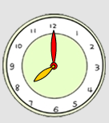
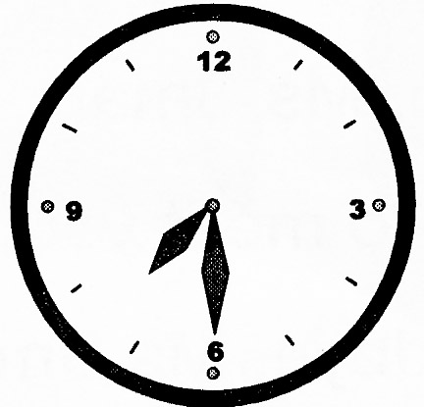
（ ） （ ） （ ） （ ）
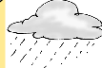

3.

（ ） （ ） （ ） （ ）

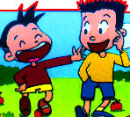
5.

（ ） （ ）
Ⅲ. Listen and choose. 听问句，选答语。（10%）
( ) 1. A. .Simon went to the park with his mother.
B. Daming went to the park.
C. We had a picnic in the park
( ) 2. A.They were hungry.
B. We were wet and angry.
C. They ate our sandwiches
( ) 3. A. It’s going to be sunny.
B. It’s sunny.
C. It was sunny.
( ) 4. A. In the park.
B. At half past seven.
C. We’re going to eat meat.
( ) 5. A.I want some noodles.
B. We want hamburgers too.
C. Cola, please.
IV．Listen and judge. 听短文，判断句子是否符合短文意思,符合的用“√”表示， 不符合的用“×”表示。（10%）
（ ）1. Lingling went to a park on Saturday.
（ ）2. They took sandwiches for their picnic.
（ ）3. They didn’t get wet.
（ ）4. The ducks had their picnic.
（ ）5. They were angry with the ducks.
V. Listen and complete. 听录音，补全短文。（10%）

I ______ a funny day yesterday. I _______ to the park with my friends. First we _______ some photos. Then we ______ our cakes. Later it ________. We ran quickly under a tree.
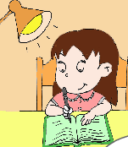
Writing Part 笔答部分
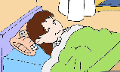
- Read and choose. 读一读，选出最佳答案，将其前面的字母标号填在题前的括号里。（10%）
1. The hamburgers are four_______ and twelve______.
A. dollar, cents B. dollar, cent
C. dollars, cents D. dollars, cent
2. Simon ______some meat, but I ______ some fish.
A. want, wants B. want , want
C. wants , wants D. wants , want
3. What do you want ______?
A. eat B . to eat C. eating D. eats
4. We are going to________ the lake.
A. walks on B. walk around
C. walked to D. walking over
5. We are going to go to school ___ 8 o’clock____ the morning.
A. on…in B. in …at C. at…in D. of…in
6. ---What’s the weather going to be like tomorrow?
---It’s_______ sunny.
A. going to B. going to be C. can D. will
7. There _____ a big lake. There _____ many ducks.
A. is, was B. was, were C. was, is D. were, was
8. Look! The boys _______ basketball.
A. playing B. are playing
C. plays D. is going to play
9. Let’s ______ the tree. It’s dry there.
A. go B. go under C. went to D. going into
10. Yesterday, we ______ a picnic.
A. are having B. have C. has D. had
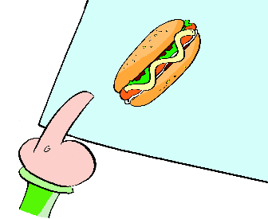
- Look and write. 看图补全句子，每空填一个单词。（10%）
- I ______ a hot dog, ________.
(想要) （请）

- It’s thirteen ______ and twenty-five_______.
(美元) (美分)

- we’re going to _____ at half past ___________.
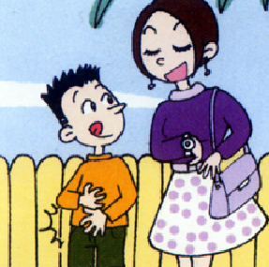
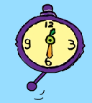
（吃）

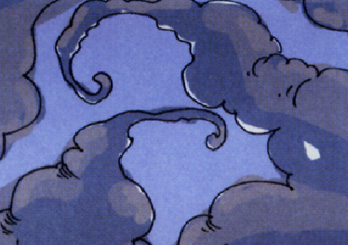
- Look. It’s going to _______ _______.
（下雨）（马上）

- There was a big _______ and there were lots of ______.
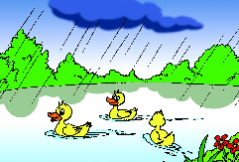
（湖） （鸭子）

- Read and write. 按要求完成句子。（10%）
1. in, the, weather, going to, what’s, like, Beijing, be (连词成句)

2. go, going to, swimming, when, we, are (连词成句)

3. a , I, want, and, cola, some, soup(连词成句)

4. Is it going to be windy? (请给出否定回答)
______, it _______.
5. It’s five yuan and fifty fen? (就划线部分提问)
_______ ______ is it?
- Reading. 阅读理解。(共15%)
. Read and judge. 读短文，用“√”“×”判断句子是否符合短文意思。（5%）
In the photo, the sun is shining. The birds are singing in the trees. We are having our picnic. My mother is taking photos. My father is reading a book. The dog is playing with a ball. The ducks are eating our sandwiches.
（ ）1. It is a fine day.
（ ）2. We are singing.
（ ）3. Father is taking photos.
（ ）4. The ducks are eating sandwiches.
（ ）5. The dog is sleeping.
.Read and choose. 读短文，选择正确答案。（10%）
My name’s Sally. Yesterday was my birthday. My mother bought me a big birthday cake and cooked delicious food for me. I invited my friends to my party. After having a meal, we sang songs and played games together. In the afternoon, we went to the park. We took lots of pictures and fed the ducks. In the evening, my grandfather and grandmother came to my house. We had a big dinner. My grandparents gave me a toy plane. I liked it very much. I was very happy.
( )1. Mum bought ______ for Sally.
A. a toy plane B. a big birthday cake C. a hamburger D. a big dinner
( )2. Sally and her friends__________.
A. cooked meals B. played football C. sang and danced D. sang and played games
( )3. Sally and her friends __________ in the park.
A. fed the ducks B. sang and played games
C. took many photos D. both A and C
( )4. Sally’s grandparents gave her a _______.
A. toy plane B. toy doll C. toy house D. toy car
( )5. What didn’t Sally do?
A. She didn’t cook meals.
B. She didn’t sing songs.
C. She didn’t feed the ducks.
D. She didn’t play with her friends.
- Composition.写作（5%）
同学们的周末一定过得很丰富吧？那么下一个周末你计划做什么呢？请写一下，让大家分享一下吧！ 30-40 个单词。

___________________________________________________

___________________________________________________

___________________________________________________

___________________________________________________

___________________________________________________

Tapescript:
I
  - I want a hamburger. (A)
  - A sandwich, please. (B)
  - How much is a cola? (B)
  - Let’s walk around the playground. (C)
  - Little Tom is very naughty. (D)
  - They ran quickly to the boy. (D)
  - We’re going to have a picnic tomorrow. (A)
  - I had sausages and eggs and bread for breakfast. (C)
  - The food is thirty dollars and five cents. (C)
  - I’m very angry with the naughty cat. (B)
II.
- What do you want? I want rice.
- The cola is seven dollars and thirty –five dollars.
- Tomorrow it’s going to snow.
- I do my homework at half past seven.
- I like taking photos.
III.
1. What did you do yesterday? (C)
2, What did they do? (B)
3. What’s the weather going to be like in Shanghai? (A)
4. When are we going to eat? (B)
5.What do you want to drink?(C)
IV. Module 3 Unit 1
V.
I __had_ a funny day yesterday. I _went to the park with my friends. First we _took__ some photos. Then we __ate__ our cakes. Later it _rained__. We ran quickly under a tree.

青岛莱芜一路小学 于秀霞 赵玲 张艳霞

