2009-2010学年度第二学期三年级英语Module 1-3综合练习School______ Class ______ Name______ Assessment______
Listening Part 听力部分
Ⅰ. Listen and number. (听一听，排一排)(10%)




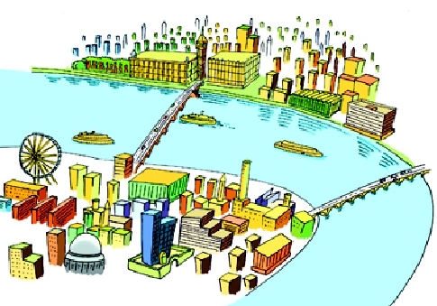

（ ） （ ） （ ） （ ） （ ）
Ⅱ.Listen and tick. (听一听，选一选。) (12%)

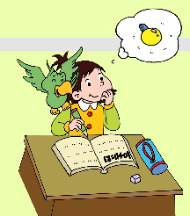
1． 2.
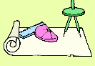


( ) ( ) ( ) ( )
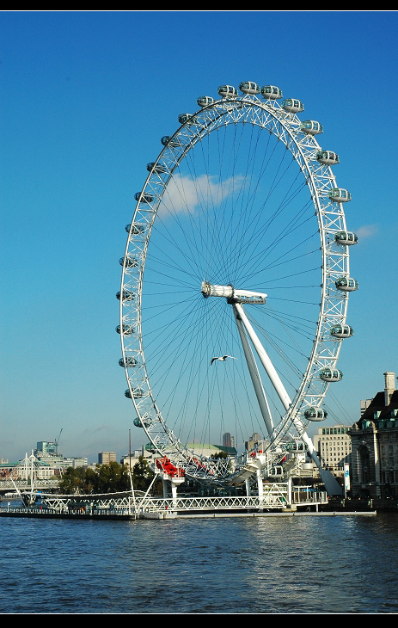



3. 4.

( ) ( ) ( ) ( )

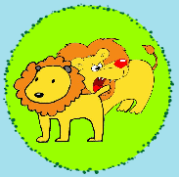
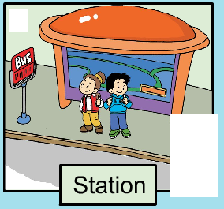
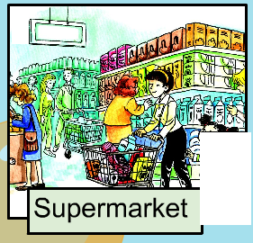
- 6.

( ) ( ) ( ) ( )
Ⅲ. Listen and judge.（听录音，判断听到的内容是否与图片一致。）（8%）

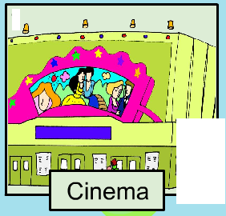


（ ） （ ） （ ） （ ）

Ⅳ. Listen and match.(听一听，连一连) （10%）


shy
lots of
in the countryside
about London


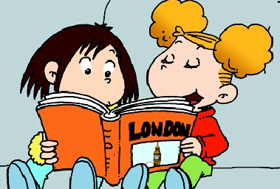

Ⅴ. Listen and draw “√”.（请根据听到的内容在相应的表格里画“√”表示。）（10%）
 | 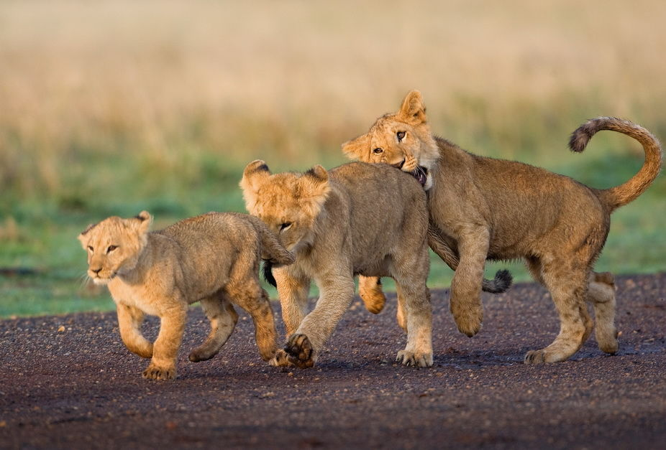 | 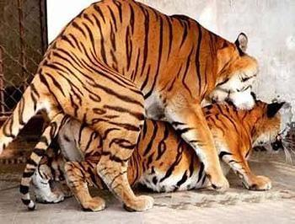 | 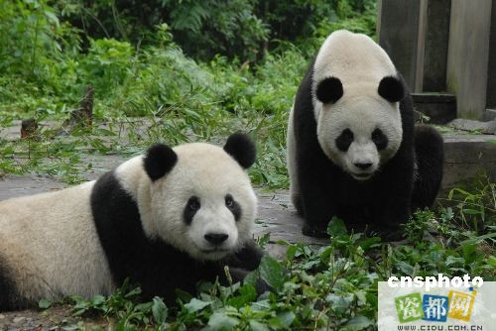 | 


Writing part笔试部分
Ⅵ. Read and number .（按句子顺序给图片标序号）(5%)
1. I will go to the supermarket this weekend.
2. ---What’s ten plus one?
---It’s eleven.
3. ---Look at this big wheel.
---It’s the London Eye.
4. ---Will you see pandas?
---Yes, we will.

5. This boy is naughty.


( ) ( ) ( ) ( ) ( )

Ⅶ. Choose and write.(选择所给单词补全句子) (5%)

lions wide what tigers tall won’t quiet

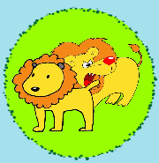
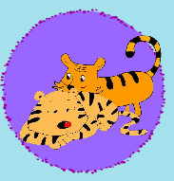
1. We will see and .
2. This river is very .

3. But he’s a bit .

4. ---Will you go?
---No, I .

Ⅸ. Read and copy the sentences.（用正确的形式抄写下列句子。）（5%）
- no i won’t 2. will sam go too

- and it’s very long 4. this is big ben

- he’s very clever

Ⅹ.Read and choose.(阅读理解) (5%)
Hi, I’m Sarah. I’m a tall girl. Look! This is my school. It’s big. These are my friends. Tom is short. And he is clever. He can make e-cards. Mary is helpful. But she’s a bit shy. John is naughty and very loud. We will go to the countryside this weekend. We will see lots of trees and animals there!
1. Sarah is ______.
A. nice B.tall.
2. ______ is naughty.
A．Tom B. John
3. Tom _______.
A. can make e-cards B. a bit shy
4. Mary will ______ this weekend.
A. help people B. go to the countryside
5. Sarah and her friends will see lots of ______ this weekend.
A. trees and animals B.people and flowers

Tapescript:
I.
- This is Xiaoyong. He’s very clever.
- River Thames is very wide and long.
- Big Ben is very tall.
- We’ll see lions and tigers.
- ---Will you go too, Daming?
---No, I won’t.

II.
1. This is Maomao. She always helps people.
2. This little girl can’t do her English.
3. Tower Bridge can open.
4. There is a phone here.
5. ---What will you see on the farm?
---Cows. I will see lots of cows.
6. ---Will you go to the park?
---No, I won’t. I’ll go to the station.

III.
1. This boy can make e-cards.
2. Let’s go to the zoo.
3. I will see lots of elepants there.
4. What’s twelve plus twenty-one?

IV.
1. We will see lots of pigs.
2. Lingling is shy.
3. My grandpa lives in the countryside.
4. This book is about London.

V. Module 3 Unit 1

