市南区2009——2010学年度第二学期六年级英语期中综合练习(M1-5)(一)（时间：40分钟）

Listening Part 听力部分
Ⅰ.Listen and choose. （请选出你所听到的单词，并将其前面的字母标号填在题前的括号里） （10%）
( )1. A.saw | B. says | C. said | D. see
( )2. A. want to | B. wanted to | C. what to | D. went to
( )3. A. her | B. heard | C. hand | D. here
( )4. A. erhu | B. pipa | C. piano | D.trumpet
( )5. A. weren’t | B.were | C. was | D. wasn’t
( )6. A. windy | B. sunny | C. snowy | D. rainy
( )7. A. restaurant |  | B. supermarket
C . museum |  | D. theatre
( )8. A. shining |  | B. singing
C . watching |  | D. raining
( )9. A. a birthday party |  | B. a birthday card
C . a birthday present |  | D. a birthday cake
( )10. A. thirty |  | B. thirsty
C .thirteen |  | D. three
II. Listen and tick. (请根据听到的内容，在括号内用“√”划出相应的图片) （10%）
1. 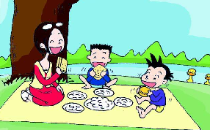 2. 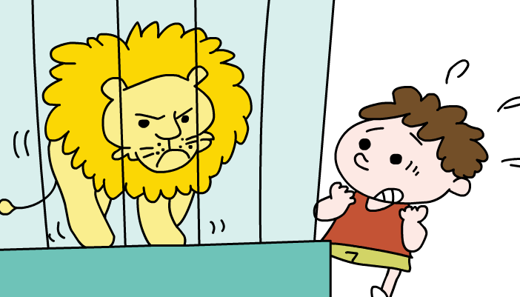 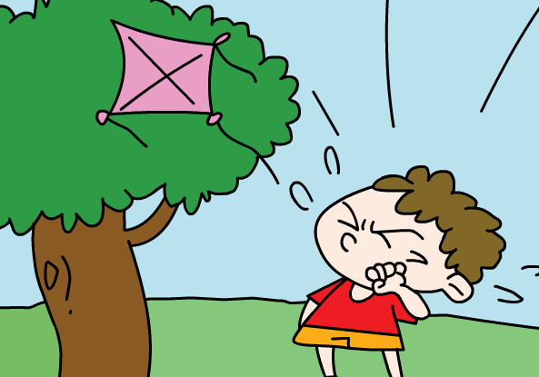
（ ） （ ） （ ） （ ）
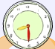
3. 4. 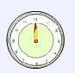
（ ） （ ） （ ） （ ）
5.  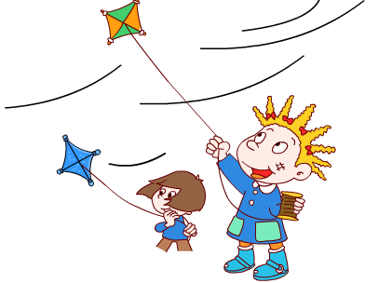
（ ） （ ）
III. Listen and choose. (听问句选择合适的答语) (10%)
( )1. A. They are 10 dollars.
B. There are 4.
C. It's ten.
( )2. A. It's sunny.
B. It's going to be windy.
C. It rained.
( )3. A. The football team.
B. They go to the zoo.
C. They went to the station.

( )4. A. Yes, I bought a book.
B. No , we didn't .
C. Yes, I bought him a pen.
( )5. A. Last September.
B. Next month.
C. I go there every day.
IV. Listen and judge.（请根据短文内容判断句子是否与短文内容相符，相符的用“√”表示,反之则用“X”表示）(10%)
( )1. Daming will say ‘Happy birthday!’ to Simon today.
( )2. Simon’s present will be a birthday card.
( )3. Mum is going to the bookstore and buy a book.
( )4. Daming will get a special present from Simon’s mother.
( )5. Simon helped hold the balloons.
V. Listen and complete the sentences. （听录音，填上所缺单词，补全句子）(10%)
Today Daming is ______a birthday_____. He is playing his _____ . He has to stop. Because the _______ ______.*

笔答部分
- Read and choose. 读一读，选出最佳答案，将其前面的字母标号填在题前的括号里。（10%）
1. I want _______ meat and _______ sandwich.
A. a, a B. some, an
C. some, a D. some, any
2. Tomorrow it’s going to ________.
A. windy B. hot C. snow D. sunny
3. Then Daming started __________ .
A. play B. to play C. playing D.played
4. We were angry ____ the ducks!
A. in B. to C. and D. with
5. Oh,no! I can’t _______ them all.
A. carrying B. carry C. carried D. carries
6. What a mess! Who can help_____?
A. her B.she C. his D. he
7. Daming is playing his trumpet, but then the dog ____.
A. running B. run in C. runs in D. run to
8. Now the dogs ________ with the trumpet.
A. singing B. are singing
C. sings D. sang
9. Those naughty ducks went to our picnic and ______all the sandwiches.
A. eat B. ate C. is eating D. eats
10. Look at the hot dogs. They ______ good.
A. looks B. looking C. looked D. look


- Look and write. 看图补全句子，每空填一个单词。（10%）

- All the __________ are _________ _________.
（气球） （飞走）
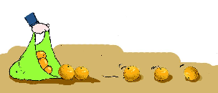
- The ________ are __________
(桔子) （掉）


- I _________ some ________.
（照了） （照片）

- It’s thirteen ______ and twenty-five_______.
(美元) (美分)

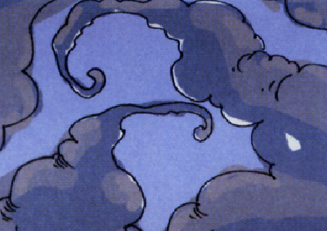
5. It’s going to _______ soon.
(下雨)

- Read and write. 按要求完成句子。（10%）
1. at, are, We, going to, eat , past, half, twelve (连词成句)

2. sun, photo, this, shining, the ,is, in (连词成句)

3. There was, and, a big lake, ducks, lots of (连词成句)

4. What’s a hot dog? Is it a dog? (请给出否定回答)
______, it _______.

5. I can help you! (就划线部分提问)
_______ can help me?

- Reading. 阅读理解。(共15%)
. Read and judge. 读短文，用“√”“×”判断句子是否符合短文意思。（5%）
Oh dear! I can’t carry them all.
Look at the eggs.
And the apples are falling down the stairs.
Now, the cola is falling, too.
What a mess! Who can help me?
( ) 1. The apples are falling.
( ) 2. The cola isn’t falling.
( ) 3. I made a mess.
( ) 4. I can carry the eggs and the apples.
( ) 5. I’m carrying a lot of things, but I can’t carry them all.
.Read and choose. 读短文，选择正确答案。（10%）
Last night Tom had a wonderful dream. Tom dreamt he was an astronaut. He flew into the sky in a spaceship. It was very dark outside. He could see the stars and the moon. He was very excited. He flew to the moon. He came out of his spaceship and walked on the moon. He felt very good. He spent six hours on the moon. When he came home he was famous. He made a video. Everyone could see him on TV.
( )1. What was Tom in his dream?
A. A Martian. B. A driver.
C. An astronaut.
( )2. Where did Tom fly?
- He flew into the sky.
- He flew on to the Mars
- He flew to the sun.
( )3. What did he make when he came home?
- He made a plane.
- He made a paper spaceship.
- He made a video.
( )4. What does he hope?
- He hopes he will be an astronaut someday.
- He hopes he will be famous someday.
- He hopes he will fly to the sun someday.
( )5. Which one isn’t true?
A. In the dream he could see the stars and the moon.
B. He spent sixty hours on the moon.
C. He flew into the sky in a spaceship.

- Composition.写作（5%）
同学们的周末一定过得很丰富吧？天气怎样？心情好吗？请写一下你上个周末的故事，让大家分享一下吧！ 30-40 个单词。

___________________________________________________

___________________________________________________

___________________________________________________

___________________________________________________

___________________________________________________

Tapescript:
一．Listen and choose.
1. The sky says “ Happy birhtday.”
2.I want to eat a sandwich,please.
3. Here's your present.
4. He is playing the trumpet,but then the telephone rings.
5. There was a big lake in the park.
6. Tomorrow it’s going to be sunny in Qingdao.
7. They're going to buy things at the supermarket.
8. In this photo, the sun is shining.
9. Simon is making a birthday card.
10. How much are these hot dogs?
They are thirty dollars.
二．Listen and tick.
1.I can’t carry them all.We will help you. Thank you.
2. What did he do? He flew a kite in the park.
3. What a mess! All the balloons are flying away.
4. When are they going to eat ? At twelve o’clock.
5. It's rainy(raining) .
The children are jumping in the water.
三．Listen and choose.
1. How much are the oranges ?
2. What was the weather like yesterday?
3. Where did Mum and Daming go ?
4. Did you buy him a pencil?
5. When are you going to go to the school?
四．Listen and judge.
Module4 Unit1
五．Listen and complete the sentences.
Today Daming is having a birthday party. He is playing his trumpet. He has to stop. Because the telephone rings.

青岛贵州路小学 王凯萍 张蓓蓓

