市南区2009——2010学年度第二学期六年级英语期中综合练习(M1-5)(二)（时间：40分钟）

Listening Part 听力部分
Ⅰ.Listen and choose. （请选出你所听到的单词，并将其前面的字母标号填在题前的括号里） （10%）
( )1. A. wants | B. won’t | C.What’s | D. went
( )2. A. thirteen | B. thirty | C. fifteen | D. fifty
( )3. A. dry | B. try | C. my | D. wet
( )4. A. pizza | B.hamburger | C. hot dog | D. sandwich
( )5. A. rainy | B. snowy | C. windy | D. sunny
( )6. A. take | B. took | C. talk | D. told
( )7. A. went | B. want | C. what | D. wet
( )8. A. have a look B. have a seat
C. have a picnic D. have a drink
( )9. A. singing B. snowing
C. speaking D. shining
( )10. A. walk through B. sit around
C. walk around D. walking around
II. Listen and tick. (请根据听到的内容，在括号内用“√”划出相应的图片) （10%）
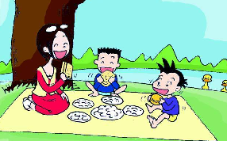

1. 2. 2. $ 5.25 $7.85
（ ） （ ） （ ） （ ）



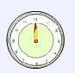
3. 4.
（ ） （ ） （ ） （ ）

5.

（ ） （ ）
III. Listen and choose. (听问句选择合适的答语) (10%)
( ) 1. A.It’s 100 meters
B. It’s 100 years old.
C. It’s 100 dollars.
( ) 2. A. She’s playing the piano.
B. No, he didn’t.
C. They are jumping.
( )3. A. The football team.
B. We go to the zoo.
C. They went to the station.
( )4. A. Yes, I bought a book.
B. No , we didn't .
C. Yes, I bought him a pen.
( ) 5. A. No, he didn’t.
B. Yes, she does.
C. Yes, I am.
IV．Listen and judge. 听短文，判断句子是否符合短文意思,符合的用“√”表示， 不符合的用“×”表示。（10%）
（ ）1. Daming’s mum is at the supermarket.
（ ）2. Daming is going to have a Chinese birthday.
（ ）3. Simon is going to give Daming a birthday card.
（ ）4. Mum can carry all the things.
（ ）5. All the balloons are in the sky now.
V. Listen and complete. 听录音，补全短文。（10%）
Tomorrow will be Daming’s birthday. He’s going to _______ a birthday party. Simon’s mum bought many things for the party. But she _______ carry them all. Daming will ______ her. But that’s too late. Look! All the balloons are ________ away. And the oranges are ______ .
Writing Part 笔答部分
- Read and choose. 读一读，选出最佳答案，将其前面的字母标号填在题前的括号里。（10%）
( )1. _______ are we going to go to the party? At 11:30.
A. What B. When C. Where D. Who
( )2. Everyone _____ ,“ Happy birthday, Daming!”
A. say B. saying C. see D. says
( )3. Look! All the oranges ____ falling down. And the cola ______ falling, too.
A. am, is B . are, is C. is, are D. are, is
( )4. I’m listening to music, but then the door ______.
A. opens B. is opening C. opened D. open
( )5. ---Who can help me?
--- _________
A. Sorry, I can. B. I will help you.
C. Yes, please! D. No, I can’t.
( )6. ---What’s the weather ______ tomorrow?
---It’s going to be sunny.
A. going to like B. going to be like
C. like D. 不填
( )7. Daming and Simon _____ some photos last weekend.
A. is taking B. took C. takes D. take
( )8. We are having our picnic. And the ducks _____ us.
A. watched B. watching
C. are watching D. watches
( )9. Daming can help ______.
A.I B. she C. her D. he
( )10. ____ is this pen? It’s five dollars and twenty cents.
A. How many B. How long C. How much D. What

Ⅶ. 看图补全句子，每空填一个单词。（10%）
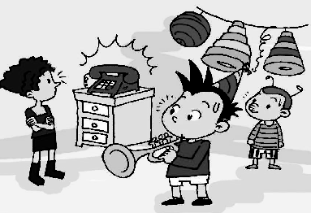
- He is ________ the trumpet, but
Then the telephone ________ .
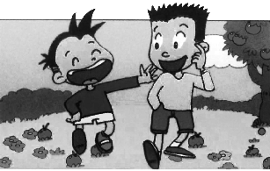
- I ______ a ________ day on Saturday.

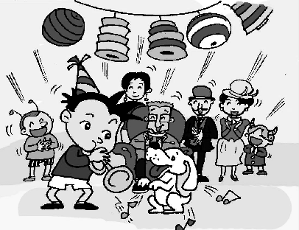
- Daming is _______ a ___________
party now.

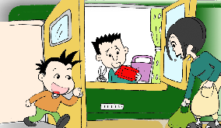
- Who can _________ me?
_________ , I can’t.

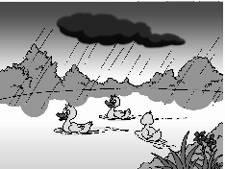
- There _____ a big lake and there
________ lots of ducks then.

Ⅷ.Read and write. 按要求完成句子。（10%）
1. in, the, weather, going to, what’s, like, Beijing, be (连词成句)

2. falling, all, oranges, are, the (连词成句)

3. is, playing, the, trumpet, then, telephone, the, he, but, rings(连词成句)

4. Do you want some cola? (请给出肯定回答)
______, please.
5. We’re going to eat at 12 o’clock. (就划线部分提问)
_______ _______ we going to eat?

Ⅸ.Reading. 阅读理解。(共15%)
. Read and judge. 读短文，用“√”“×”判断句子是否符合短文意思。（5%）
I’m in a train. I’m looking out of the window. It is raining. The pigs are sleeping under the tree. People are carrying umbrellas. A man is wearing a big hat and a raincoat and boots. Children are jumping in the water. Then the train goes into a tunnel. It is very dark. Then we come out of the tunnel. It isn’t raining. The sun is shining. Children are playing in a park. Then the train arrives at the station.
( ) 1. I’ m at the station.
( ) 2. A man wears a hat and carries an umbrella.
( ) 3. It’s raining, children don’t want to get wet.
( ) 4. The train goes past a tunnel.
( ) 5. First it is rainy, then it’s sunny.
.Read and choose. 读短文，选择正确答案。（10%）
Dear Sam,
I enjoy my holiday here in New York. Last Sunday, I had a very funny day with my cousin Simon. It was a fine day. The sun was bright. The sky was blue. We went to a park. It was near to our house, so we walked there. There were many children in the park. And there was a big pond. We wanted to go fishing in the pond. At first, had a picnic in the park. And I took some photos. Then we walked around the pond and tried to find a good place to sit. Then we sat down and started to fish. I waited and waited. Suddenly(突然), the fishing pole(鱼竿) was shaking. A big fish! I was so happy! Then we went home. We had fish soup that night.
Did you have a funny day, too? Please write about it to me.
Love from,
Daming
( ) 1. When did Daming have a funny day?
  - Last Saturday. B. Last Sunday
C. This Sunday.
( ) 2. How did they go to the park?
- They went there by car. B. They went there by bus.
C. They walked there.
( ) 3. What did they see in the park?
- Lots of animals. B. A big lake. C. A big pond.
( ) 4. What did they do in the park?
- They went fishing in the park.
- They had a picnic in the park.
C. Both A and B.
( ) 5. Which is not true(真实的) according to the letter?
- Daming is in America now.
- Daming went to the park with Sam.
C. Daming took some photos in the park.
- Composition.写作（5%）
同学们的周末一定像上文中的Daming一样过得很愉快吧？请写一下，和大家分享一下你曾经度过的愉快的一天的经历吧！ 30-40 个单词。
A Funny Day
___________________________________________________

___________________________________________________

___________________________________________________

___________________________________________________

___________________________________________________
听力内容：
一．Listen and choose.
1.What’s a hot dog?
2.This book is fifteen yuan.
3.Let’s go under the tree. It’s dry there.
4.---What do you want?
---I want a sandwich,please
5.Tomorrow it’s going to be windy in Dalian.
6.Daming took a hamburger for the picnic.
7. It’s raining now and we are wet.
8. Please have a seat and have your favourite food.
9.The sun is shining on the sea.
10. I’m going to walk around the UN building.

二．Listen and tick.
1.---I can’t carry them all.
---We will help you.
---Thank you.
2. The cola is seven dollars and eighty –five cents.
3. ---What’s the weather going to be like in Harbin?
---It’s going to be snowy.
4. When are they going to eat ? At twelve o’clock.
5. We went to a park yesterday. We had a good time.
三．Listen and choose.
1. How old is this stamp?
2. What are the boys doing?
3. Where did Mum and Daming go ?
4. Did you buy him a pencil?
5. Are you going to go to school?
四． M4U1
五．
Tomorrow will be Daming’s birthday. He’s going to have a birthday party. Simon’s mum bought many things for the party. But she can’t carry them all. Daming will help her. But that’s too late. Look! All the balloons are flying away. And the oranges are falling.

