市南区2009——2010学年度第二学期六年级英语期中综合练习（三）（时间：40分钟）

Listening Part 听力部分
Ⅰ. Listen and choose. 选出听到的单词或词组，并将其前面的字母标号填在题前的括号里。（10%）
( )1. A. be hot | B. windy | C. snow | D. rainy
( )2. A. weren’t | B. were | C. was | D. wasn’t
( )3. A. wants to | B. wanted to | C. what to | D. went to
( )4. A. word | B. work | C. walk | D. wall
( )5. A. dream | B. driver | C. dress | D. drink
( ) 6. A. get wet | B. be wet | C. get up | D. get ready
( )7. A. a birthday party |  | B. a birthday card
C. a birthday cake |  | D. a birthday present
( )8. A. How many |  | B. How much
C .How long |  | D. How old
( )9. A. flying B. having |  | C. going D. shining
( )10. A. sing songs |  | B watch TV
C. read books |  | D. falls asleep

Ⅱ. Listen and tick. 根据录音内容，在相应图片下面的括号里划“√”表示。（10%）


1. 2. $ 5 25 $7.85

（ ） （ ） （ ） （ ）
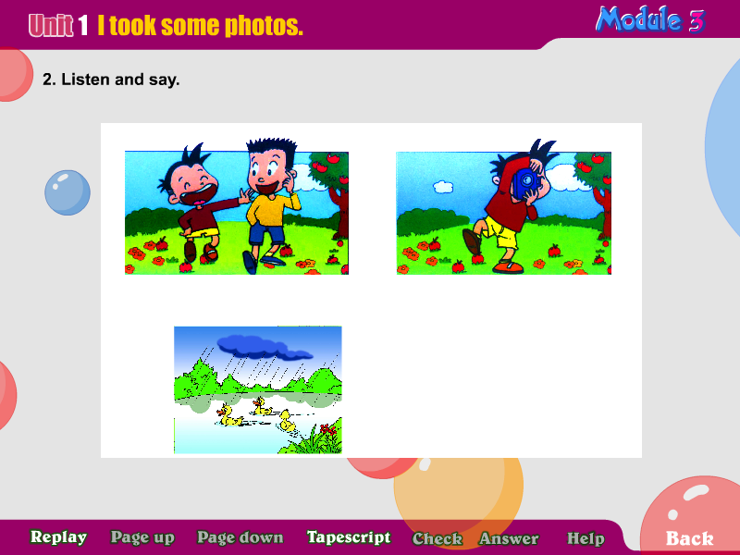
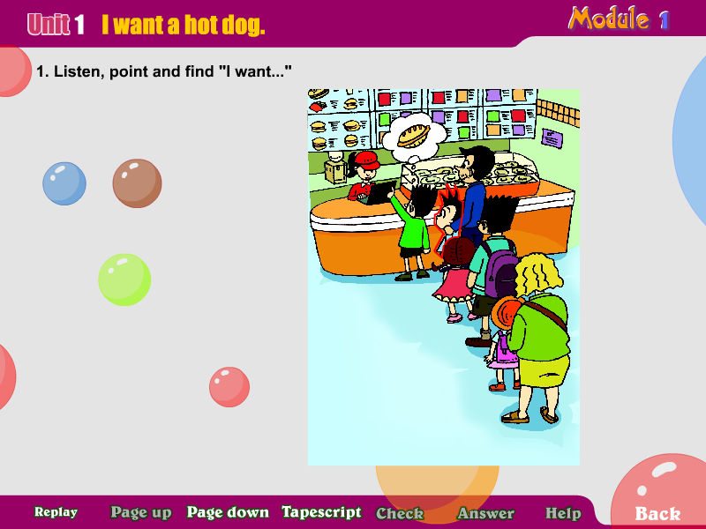
3.

（ ） （ ） （ ） （ ）
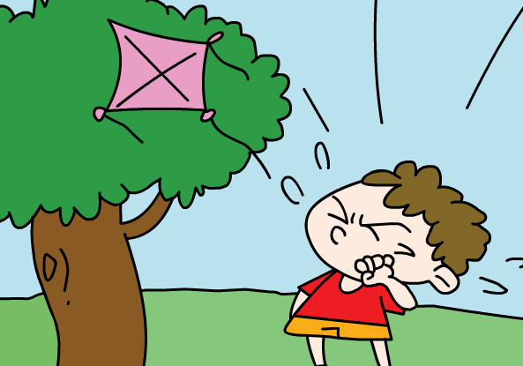
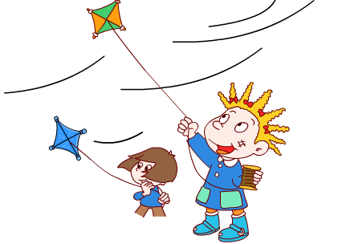
5.

（ ） （ ）
Ⅲ. Listen and choose. 听问句，选答语。（10%）
( ) 1. A. He’s playing the piano.
B. No, he didn’t.
C. They are jumping.
( ) 2. A. I ate at 12:30.
B. I’m going to eat at 12:00.
C. I will eat at 9:00.
( ) 3.A. You are welcome.
B. Thank you!
C. I don’t know.
( ) 4. A. Yes, I had.
B. Yes, I did.
C. I had a very funny day.
( ) 5. A. I’m watching TV.
B. The telephone rings.
C. It’s dancing.

IV．Listen and judge. 听短文，判断句子是否符合短文意思,符合的用“√”表示， 不符合的用“×”表示。（10%）
（ ）1.Daming is having a birthday party.
（ ）2.Daming’s friends and teachers are there.
（ ）3.Daming is playing the trumpet, but then the telephone rings.
（ ）4. His friends don’ t love Daming’s music show.
（ ）5. The dog is singing with the piano.
V. Listen and complete. 听录音，补全短文。（10%）
The _______ is going to be sunny. in Qingdao. I am _____ to go to the park with my friends. First we are going to walk _______ the lake and see the ducks. Then I’m going to take some ______.At noon, we are going to have a _____ there.
Writing Part 笔答部分
- Read and choose. 读一读，选出最佳答案，将其前面的字母标号填在题前的括号里。（10%）
( ) 1. The hot dog is five_______ and twelve______.
A. dollar, cents B. dollar, cent
C. dollars, cents D. dollars, cent
( ) 2.---What does she _____ to eat?
---She _____eat some rice.
A. wants /want B. want/wants to
C. what /wants to D. wanted/want
( ) 3. What do you want ______?
A. eat B. to eat C. eating D. eats
( ) 4.We are going to ____ a film.
A. watched B. see C. looking D. saw
( ) 5. Amy likes ___.So she is going to _____at the party.
A. dance/dance B. dancing /danced
C. dancing/dance D. dance/dance
( ) 6.I fell ____ the bike.
A. in B. of C. down D. on
( ) 7. She’s _______ TV, but then her dog ______ in.
A. watch, run B. watches, running
C .watches, runs D. watching, runs
( ) 8.Look! He is ______ a picture.
A .draw B. drawing C. draws D. drew
( ) 9. He ____ to school at eight every morning.
A. go B. went C. going D. goes
( ) 10. They didn’t ____ their homework.
A . do B. did C. done D. doing

- Look and write. 看图补全句子，每空填一个单词。（10%）
- I ______ a cola, ________.
(想要) （请）

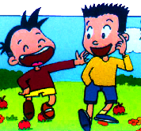
- I ______a very _______ day.
(度过了) （有趣的）

- -I can’t ______them all. Who can_____ me?
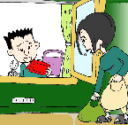
（提，拿） （帮助）
-Sorry, I can’t.

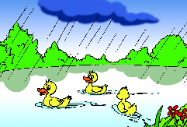
- Look. It’s going to _______ _______.
（下雨）（马上）

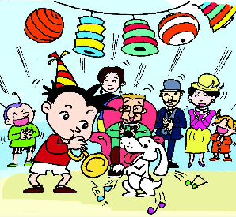
- Daming is _______ a ___________ party.
（举办） （生日）

- Read and write. 按要求完成句子。（10%）
1. going, we, eat, at, half, twelve, past, are, to (连词成句)

2. sun, shining, the, is, sea, on, the (连词成句)

3. weather, what, going, be, Beijing, to, in, like, the, is (连词成句)

4. Can you help me? (请给出否定回答)
______, I_______.
5. Daming is playing the trumpet. (就划线部分提问)
_______ is Daming ______?
- Reading. 阅读理解。(共15%)
. Read and judge. 读短文，用“√”“×”判断句子是否符合短文意思。（5%）
I am in a train. I am looking out of the window. It is raining. The pigs are sleeping under the tree. People are carrying umbrellas. A man is wearing a big hat and a raincoat and boots. Children are playing in the water. Then the train goes into a tunnel. It is very dark. Then we come out of the tunnel. It isn’t raining. The sun is shining, Children are playing in a park. Then the train arrives at the station.
（ ）1. The sun is shining all the day.
（ ）2. A man is carrying umbrella and wearing boots.
（ ）3. Children are playing in the sea.
（ ）4. The train goes into a tunnel.
（ ）5.The train arrives at the station at last.
.Read and choose. 读短文，选择正确答案。（10%）
Ben is going to visit his grandparents in New York next week. He wants to give some presents to them. Yesterday he went shopping with his parents. In the shop, he bought a blue sweater and black trousers for his grandfather and some good books for his grandmother. Then he bought a Chinese kite for his cousin Sam. It’s a very big bird. Both his parents thought they were very good presents. His cousin also liked the kite very much. Ben was very happy.
( )1.Where are Ben’s grandparents?
A. In London B. In New York. C. In Nanjing.
( )2.What did Ben do yesterday?
- He visited his grandparents.
- He went shopping with his friends.
- He went shopping with his parents.
( )3. How many people went shopping yesterday?
A. One. B. Two. C. Three.
( )4. He bought________ for his grandmother.
A. a blue sweater B. black trousers C. some books
( )5. How many presents did Ben buy?
A. Two B. Three C. Four

- Composition.写作（5%）
同学们的周末一定过得很丰富吧？那么这个周末你计划做什么呢？天气将怎样，是要出游还是将呆在家里，你将做些什么呢？请写一下，让大家分享一下吧！ 30-40 个单词。

___________________________________________________

___________________________________________________

___________________________________________________

___________________________________________________

___________________________________________________

Tapescript:
I
  - It’s going to be rainy tomorrow .(D)
  - There were lots of monkeys in the park. (B)
  - We wanted to have a picnic in the park. (B)
  - Let’s walk around the playground. (C)
  - What do you want to drink?. (D)
  - John didn’t want to get wet. (A)
  - Simon is making a birthday card for Daming. (B)
  - How much is the food in all? (B)
  - In this photo, the sun is shining. (D)
  - He is watching TV, but then his sister falls asleep. (D)
II.
- What do you want? I want some rice.
- The cola is seven dollars and eighty –five dollars.
- The apples are falling down the stairs..
- I had a very funny day last Sunday.
- Look at my kite. It’s in the tree.
III.
1. What are the boys doing? (C)
2, When are you going to have lunch? (B)
3. Here is your hot dog. (B)
4. Did you have a funny day yesterday? (B)
5. What happens when you are watching TV? (B)
IV. Module 5 Unit 1
V.
The weather is going to be sunny. in Qingdao. I am going to go to the park with my friends. First we are going to walk around the lake and see the ducks. Then I’m going to take some photos. At noon, we are going to have a picnic there.

新世纪学校 逯扬、李卉

